DAVID ARNOLD

daverno@au1.ibm.com

Abstract

Instructions to show how to build and optionally run and test custom images/containers for IBM Cloud Pak for Integration components using RHOS core services  
A Tekton pipeline example is also included  
Thanks to Adrian Gigante(RedHat) and Do Nguyen(IBM) for their input in getting this all running

IBM Middleware custom Image Builds

Building, running and testing ICP4i custom images on RHOS 4.2 and Codeready

Contents

Building and running MQ custom image on RHOS instance 7

Instructions to build MQ custom images on RHOS instance 7

Credentials and logins 7

C:\openshift>oc login --token=GSTHvr3N9uq08Y9itBtqxktdiB8ZXEvFrnRJ1kVuO30 --server=https://api.cluster-4bfc.4bfc.sandbox890.opentlc.com:6443 7

C:\openshift>oc projects 8

C:\openshift>oc project da-mq 8

YAML for create of input image stream 8

C:\openshift>oc create -f c:\openshift\data\build-mq-custom.yaml 8

Observe the “input” imagestream 9

C:\openshift>oc adm policy add-scc-to-user anyuid -z default 9

C:\openshift>oc new-build https://github.com/DAVEXACOM/ibm-mqadvanced-server-tls-build.git 9

Observe the Build config that is created 10

Observe the build log 10

Observe the “output” image stream 11

Creating a “New App” – running up a container From the custom image 11

C:\openshift>oc new-app ibm-mqadvanced-server-tls-build --env LICENSE=accept 11

C:\openshift>oc status 12

Testing the custom image 12

C:\openshift>oc expose svc/ibm-mqadvanced-server-tls-build 12

C:\openshift>oc get routes 12

Connecting to MQ queue manager 12

If OCP 4.1 is like 4.2 we need to modify the route for MQ TLS traffic 12

C:\openshift\oc get routes 12

Create route for TLS 13

C:\openshift>oc get routes 14

Get the Queue Manager name 15

An MQSC file to create CLNTCONN in CCDT 15

runmqsc -n < CUSTOMIMAGE.mqsc 16

type c:\programdata\ibm\mq\AMQCLCHL.TAB 16

set MQSSLKEYR=C:\Program Files\IBM\MQ\arnold 16

runmqsc -c ibmmqadvancedservertlsbuild1mn26b 16

Build and running MQ custom images on CodeReady on a laptop 18

Setup for codeready on windows 18

Create directory for codeready 18

Set the path to new directory 18

Create Hyper-V virtual network switch 18

Download and install code ready 19

Extract to c:\codeready 19

Install code ready 19

Start code ready 20

Using code ready 21

Logging into codeready 21

access the OpenShift cluster via the oc command 24

crc oc-env to set up the command line path 24

Build, run and test IBM Middleware on code ready 25

C:\codeready>oc projects 25

C:\codeready>oc project da-mq2 25

YAML for create of input image stream 26

C:\codeready>oc create -f c:\openshift\data\build-mq-custom.yaml 26

Observe the “input” imagestream 27

C:\codeready>oc adm policy add-scc-to-user anyuid -z default 28

C:\codeready>oc adm policy add-scc-to-user anyuid -z default 28

C:\codeready>oc new-build https://github.com/DAVEXACOM/ibm-mqadvanced-server-tls-build.git 29

Observe build in the Web console 29

Observe the Build config that is created 30

Observe the build log 30

Observe the “output” image stream 31

Creating a “New App” – running up a container From the custom image 31

C:\openshift>oc new-app ibm-mqadvanced-server-tls-build --env LICENSE=accept 31

C:\openshift>oc status 32

Testing the custom image 32

C:\openshift>oc expose svc/ibm-mqadvanced-server-tls-build 32

C:\openshift>oc get routes 32

Connecting to MQ queue manager 33

OCP 4.1 is like 4.2 so we need to modify the route for MQ TLS traffic 33

C:\openshift\oc get routes 33

Create route for TLS 33

C:\openshift>oc get routes 35

Get the Queue Manager name 36

An MQSC file to create CLNTCONN in CCDT 36

runmqsc -n < CUSTOMIMAGE.mqsc 37

type c:\programdata\ibm\mq\AMQCLCHL.TAB 37

set MQSSLKEYR=C:\Program Files\IBM\MQ\arnold 37

runmqsc -c ibmmqadvancedservertlsbuild1mn26b 37

Stopping codeready (virtual machine) 38

Building and running MQ and ACE Custom images on RHOS (ICP4i) 39

MQ custom from certified base image on RHOS 39

oc login --token=WM4a6Lj9Vj67U626gJ8Z897Cijr-OnjG-KcVxPhPk1Q --server=https://api.cloudpak.ocp4.cloudnativekube.com:6443 39

oc project da-build-project 39

oc create -f c:\openshift\data\build-mq-custom.yaml 39

oc adm policy add-scc-to-user anyuid -z default 39

oc new-build https://github.com/DAVEXACOM/ibm-mqadvanced-server-tls-build.git 39

oc new-app ibm-mqadvanced-server-tls-build --env LICENSE=accept 39

oc expose svc/ibm-mqadvanced-server-tls-build 39

oc status 39

oc create -f c:\openshift\data\create-mq-route.yaml 39

oc get routes 40

CLNTCONN Channel definition 40

runmqsc -n < CUSTOMIMAGE.mqsc 41

Observe the AMQCLCHL.TAB 41

set MQSSLKEYR=C:\Program Files\IBM\MQ\arnold 41

runmqsc -c ibmmqadvancedservertlsbuild147zgm 41

Adding a webhook for the MQ custom image build 41

Push MQSC file change to Github 42

Observer triggered build in RHOS 43

Observer Pod has updated based on the new build 44

Test the new MQ deployment for new queues 44

Obtain the queue manager name in latest build 44

Open command prompt as administrator 45

CLNTCONN Channel definition 45

Check the AMQCLCHL.TAB 45

Build and Run ACE Microservice 1 from SoE on RHOS 47

Creds for ICP4i 47

Github/dockerhub 47

Code for ACE Microservice1 47

Code for ACE Liveliness probe 47

Building the ACE MS1 image 48

Observe the image stream 48

Observe the build 48

Testing the running application 50

Changing the route 7600 to 7800 for target port 51

Test the deployed Liveliness probe service 51

Alternative – using oc create to create the route instead of expose 52

Test the liveliness probe service again 53

Create a webhook to trigger builds 53

Create webhook in github 54

Push a README.MD update to Test trigger fires 55

Build and run ACE Microservice 2 from ACE SoE on RHOS 56

Creds for ICP4i 56

Github/dockerhub 56

Code for ACE Microservice2 56

Code for ACE Liveliness probe 56

Deploying to RHOS 56

Review image streams 57

Review builds 58

Review service 58

Review deployment config 58

Test the services 61

Test the liveliness probe in the MS2 container 61

Test microservice 2 in the MS2 container 62

http://ibm-ace-mqc-soe-ms2-build-da-build-project.apps.cloudpak.ocp4.cloudnativekube.com/microservice2/v1/message 62

Create the webhook trigger in Github 62

Get Webhook details from the build config 63

Create webhook in github 63

Update Microservice2 and trigger a new build 64

Git client rescan – pick up the change 66

Push to github 67

Observe webhook fire in github 67

Observe new build in RHOS 68

Retest the ACE MS2 service 69

New Version of Container via Deployment Configuration – Rolling trigger on image change 70

Test the rest service 70

Connecting ACE MS1 to ACE MS2 in the cluster 71

Cluster IPs for ACE microservices 72

K8s DNS names for ACE microservices 72

Public IP for ACE microservice 1 – rest requesst 72

Calling ms2 from ms1 72

Test ACE MS2 calling ACE MS2 74

http://ibm-ace-mqc-soe-ms1-build-da-build-project.apps.cloudpak.ocp4.cloudnativekube.com/microservice1/v1/message 74

{"Messages":["Hello From Test Client"]} 74

OpenShift Pipelines - Tekton 76

Catalog 76

Pipeline operator 76

Tekton ACE Example 77

Example Environment 77

GIT Repos for Tekton ACE Artifacts 77

GIT Repos for ACE microservice to be tested 77

Tekton YAML files to be used 77

Resources 77

Tasks 78

Pipeline 78

PipelineRun 78

Deployment Config YAML 78

Commands to create/replace(update)/delete artifacts in Tekton on RHOS 78

Creating the Service and Routes 79

tt ace ms2 service 79

Tt ace ms2 route 79

Exploring the RHOS environment 80

Tekton dashboard -resources 80

Tekton dashboard -tasks 81

Tekton dashboard -pipeline 81

Tekton dashboard -pipeline-run 81

RHOS Console 82

Service 82

Route 83

Image Stream 83

Deployment - Config PipelineRun Created 84

Pod - PipelineRun Created 85

Testing ACE Micro Service 2 85

# Building and running MQ custom image on RHOS instance

## Instructions to build MQ custom images on RHOS instance

## Credentials and logins

OpenShift 4.1 cluster, 1 master + 2 nodes running in AWS Sydney with root access.

Openshift Master Console: [http://console-openshift-console.apps.cluster-4bfc.4bfc.sandbox890.opentlc.com](https://urldefense.proofpoint.com/v2/url?u=http-3A__console-2Dopenshift-2Dconsole.apps.cluster-2D4bfc.4bfc.sandbox890.opentlc.com_&d=DwMFaQ&c=jf_iaSHvJObTbx-siA1ZOg&r=X5y_z5011GMCzINf2gZrepZyuCHEmJ9mSODdoqZBqTM&m=55KHFirHTzKJFrw2K15kFllscVOyNzhqwuInW28qYt4&s=ea9RIC4oPZjE0ojYKwQw0__c1oU3nfdxjymmYY0xQPc&e=)

Openshift API for command line 'oc' client: [https://api.cluster-4bfc.4bfc.sandbox890.opentlc.com:6443](https://urldefense.proofpoint.com/v2/url?u=https-3A__api.cluster-2D4bfc.4bfc.sandbox890.opentlc.com-3A6443_&d=DwMFaQ&c=jf_iaSHvJObTbx-siA1ZOg&r=X5y_z5011GMCzINf2gZrepZyuCHEmJ9mSODdoqZBqTM&m=55KHFirHTzKJFrw2K15kFllscVOyNzhqwuInW28qYt4&s=lMzJ7lCID5pKoNg9rp6ass70V1xQnqr4FF-T4gtT_o0&e=)

Download oc client from [https://mirror.openshift.com/pub/openshift-v4/clients/ocp/4.1.20/openshift-client-linux-4.1.20.tar.gz](https://urldefense.proofpoint.com/v2/url?u=https-3A__mirror.openshift.com_pub_openshift-2Dv4_clients_ocp_4.1.20_openshift-2Dclient-2Dlinux-2D4.1.20.tar.gz&d=DwMFaQ&c=jf_iaSHvJObTbx-siA1ZOg&r=X5y_z5011GMCzINf2gZrepZyuCHEmJ9mSODdoqZBqTM&m=55KHFirHTzKJFrw2K15kFllscVOyNzhqwuInW28qYt4&s=btB1bQrJImSMxEHFw2uxQkvUxYALMQ-MqhuSL17NIBM&e=)

This cluster has authentication enabled. You can use 'admin' with password 'r3dh4t1!' to access your cluster

### C:\openshift>oc login --token=GSTHvr3N9uq08Y9itBtqxktdiB8ZXEvFrnRJ1kVuO30 --server=https://api.cluster-4bfc.4bfc.sandbox890.opentlc.com:6443

The server uses a certificate signed by an unknown authority.

You can bypass the certificate check, but any data you send to the server could be intercepted by others.

Use insecure connections? (y/n): y

Logged into "https://api.cluster-4bfc.4bfc.sandbox890.opentlc.com:6443" as "admin" using the token provided.

You have access to the following projects and can switch between them with 'oc project <projectname>':

default

kube-public

kube-system

* openshift

Using project "openshift".

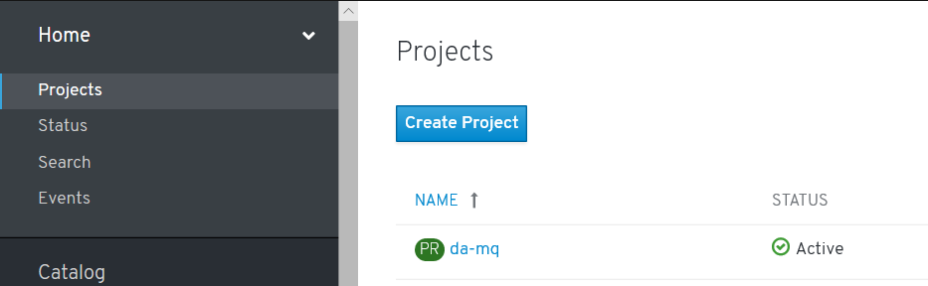

### C:\openshift>oc projects

You have access to the following projects and can switch between them with 'oc project <projectname>':

da-mq - Dave Arnold MQ

default

kube-public

kube-system

* openshift

etc

Using project "openshift" on server "https://api.cluster-4bfc.4bfc.sandbox890.opentlc.com:6443".

### C:\openshift>oc project da-mq

Now using project "da-mq" on server "https://api.cluster-4bfc.4bfc.sandbox890.opentlc.com:6443".

### YAML for create of input image stream

apiVersion: v1

kind: ImageStream

metadata:

name: ibm-mqadvanced-server-integration

spec:

tags:

- name: "9.1.3.0-r4-amd64"

from:

kind: DockerImage

name: davexacom/ibm-mqadvanced-server-integration:9.1.3.0-r4-amd64

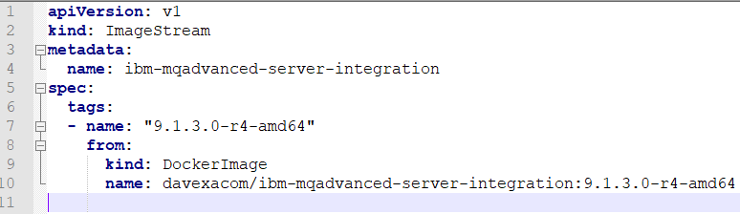

### C:\openshift>oc create -f c:\openshift\data\build-mq-custom.yaml

imagestream.image.openshift.io/ibm-mqadvanced-server-integration created

### Observe the “input” imagestream

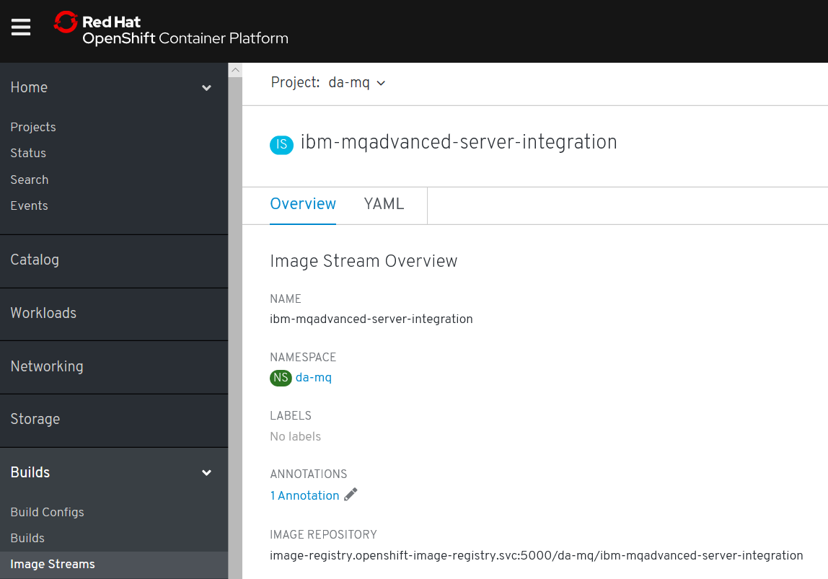

### C:\openshift>oc adm policy add-scc-to-user anyuid -z default

scc "anyuid" added to: ["system:serviceaccount:da-mq:default"]

[note: above allows the MQ container to run as root]

### C:\openshift>oc new-build https://github.com/DAVEXACOM/ibm-mqadvanced-server-tls-build.git

--> Found image ee41039 (3 months old) in image stream "da-mq/ibm-mqadvanced-server-integration" under tag "9.1.3.0-r4-amd64" for "ibm-mqadvanced-server-integration:9.1.3.0-r4-amd64"

IBM MQ Advanced Server

----------------------

Simplify, accelerate and facilitate the reliable exchange of data with a security-rich messaging solution — trusted by the world’s most successful enterprises

Tags: mq messaging

* A Docker build using source code from https://github.com/DAVEXACOM/ibm-mqadvanced-server-tls-build.git will be created

* The resulting image will be pushed to image stream tag "ibm-mqadvanced-server-tls-build:latest"

* Use 'start-build' to trigger a new build

--> Creating resources with label build=ibm-mqadvanced-server-tls-build ...

imagestream.image.openshift.io "ibm-mqadvanced-server-tls-build" created

buildconfig.build.openshift.io "ibm-mqadvanced-server-tls-build" created

--> Success

### Observe the Build config that is created

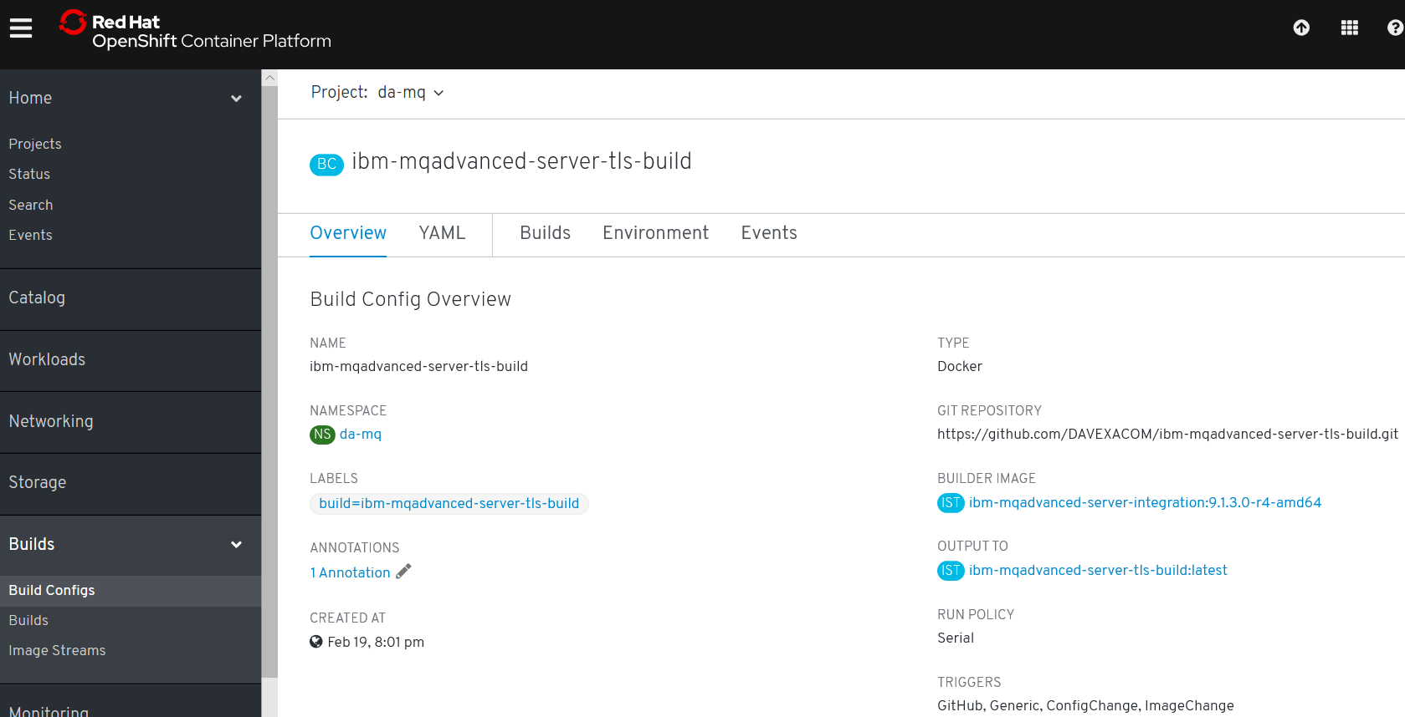

### Observe the build log

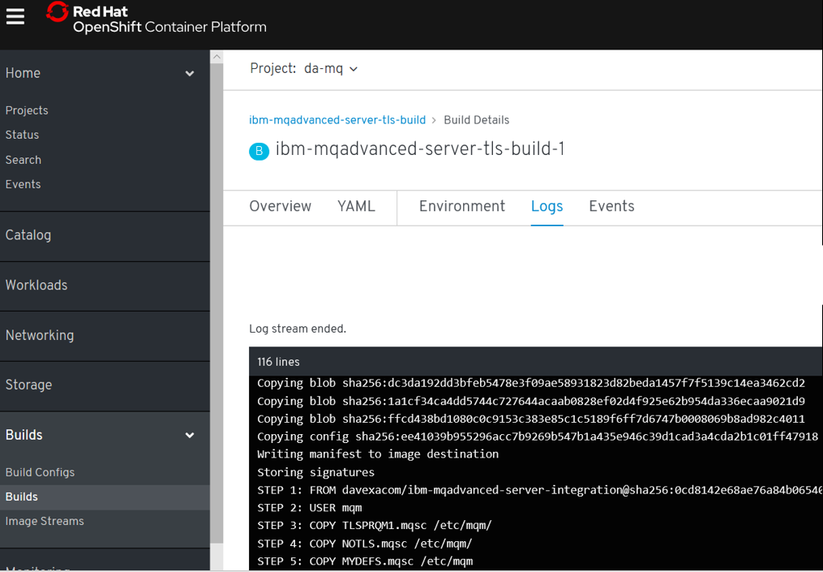

### Observe the “output” image stream

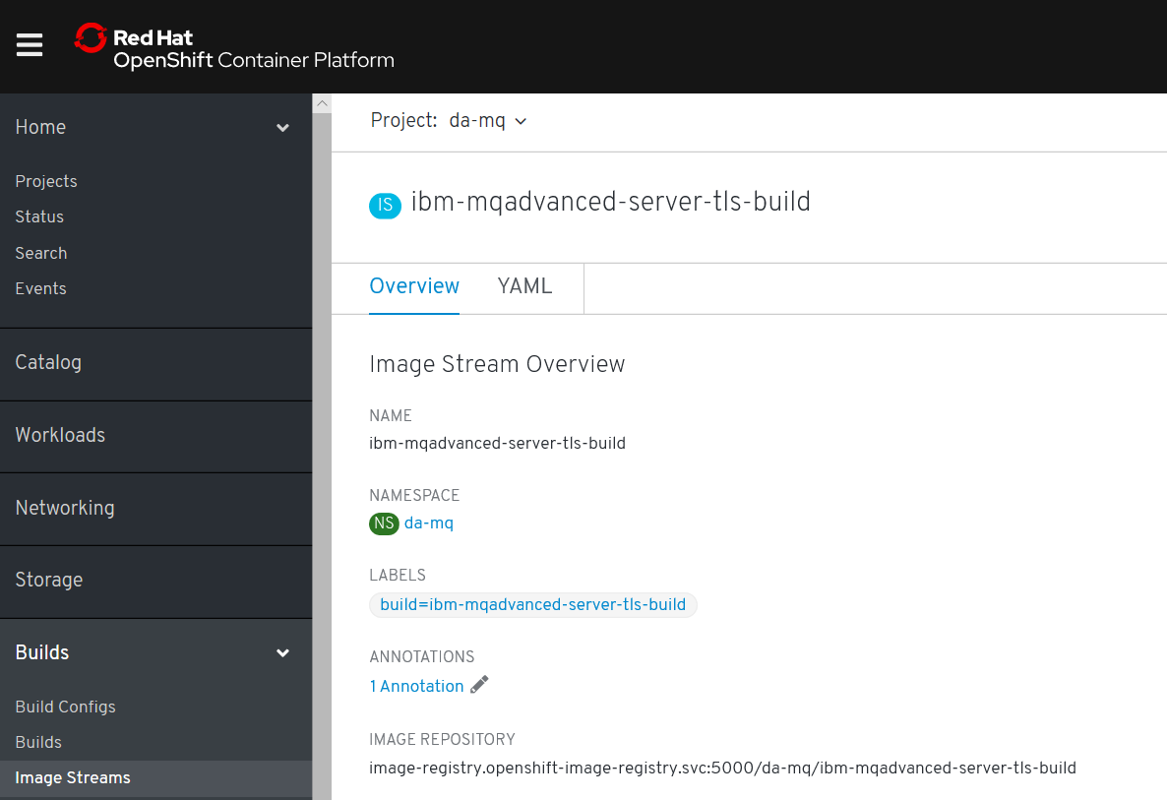

## Creating a “New App” – running up a container From the custom image

### C:\openshift>oc new-app ibm-mqadvanced-server-tls-build --env LICENSE=accept

--> Found image 2306b71 (3 minutes old) in image stream "da-mq/ibm-mqadvanced-server-tls-build" under tag "latest" for "ibm-mqadvanced-server-tls-build"

IBM MQ Advanced Server

----------------------

Simplify, accelerate and facilitate the reliable exchange of data with a security-rich messaging solution — trusted by the world’s most successful enterprises

Tags: mq messaging

* This image will be deployed in deployment config "ibm-mqadvanced-server-tls-build"

* Ports 1414/tcp, 9157/tcp, 9443/tcp will be load balanced by service "ibm-mqadvanced-server-tls-build"

* Other containers can access this service through the hostname "ibm-mqadvanced-server-tls-build"

--> Creating resources ...

deploymentconfig.apps.openshift.io "ibm-mqadvanced-server-tls-build" created

service "ibm-mqadvanced-server-tls-build" created

--> Success

Application is not exposed. You can expose services to the outside world by executing one or more of the commands below:

'oc expose svc/ibm-mqadvanced-server-tls-build'

Run 'oc status' to view your app.

### C:\openshift>oc status

In project Dave Arnold MQ (da-mq) on server https://api.cluster-4bfc.4bfc.sandbox890.opentlc.com:6443

svc/ibm-mqadvanced-server-tls-build - 172.30.48.136 ports 1414, 9157, 9443

dc/ibm-mqadvanced-server-tls-build deploys istag/ibm-mqadvanced-server-tls-build:latest <-

bc/ibm-mqadvanced-server-tls-build docker builds https://github.com/DAVEXACOM/ibm-mqadvanced-server-tls-build.git on istag/ibm-mqadvanced-server-integration:9.1.3.0-r4-amd64

deployment #1 deployed 22 minutes ago - 1 pod

## Testing the custom image

### C:\openshift>oc expose svc/ibm-mqadvanced-server-tls-build

route.route.openshift.io/ibm-mqadvanced-server-tls-build exposed

### C:\openshift>oc get routes

NAME HOST/PORT PATH SERVICES PORT TERMINATION WILDCARD

ibm-mqadvanced-server-tls-build ibm-mqadvanced-server-tls-build-da-mq.apps.cluster-4bfc.4bfc.sandbox890.opentlc.com ibm-mqadvanced-server-tls-build 1414-tcp None

## Connecting to MQ queue manager

### If OCP 4.1 is like 4.2 we need to modify the route for MQ TLS traffic

### C:\openshift\oc get routes

NAME HOST/PORT PATH SERVICES PORT TERMINATION WILDCARD

ibm-mqadvanced-server-tls-build ibm-mqadvanced-server-tls-build-da-mq.apps.cluster-4bfc.4bfc.sandbox890.opentlc.com ibm-mqadvanced-server-tls-build 1414-tcp None

Networking->routes->create route-> then there is a form

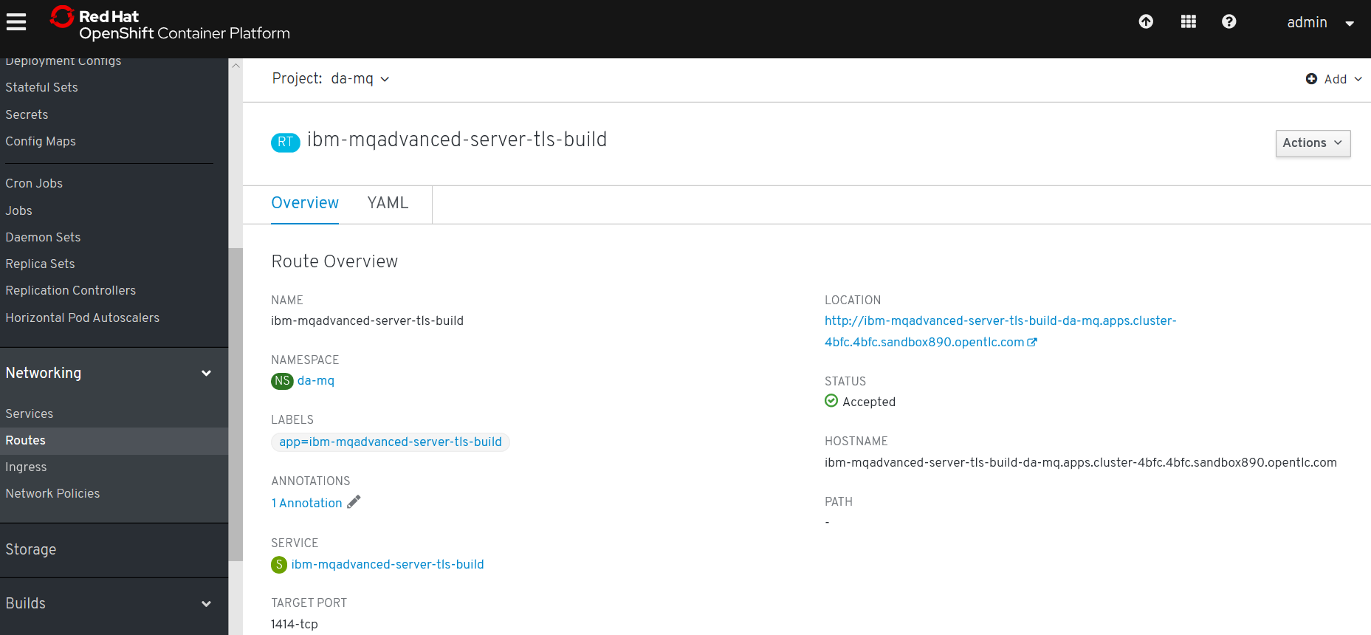

### Create route for TLS

**Tick the TLS secure route and set passthrough. Leave Insecure Traffic unset**

OCP 4.1

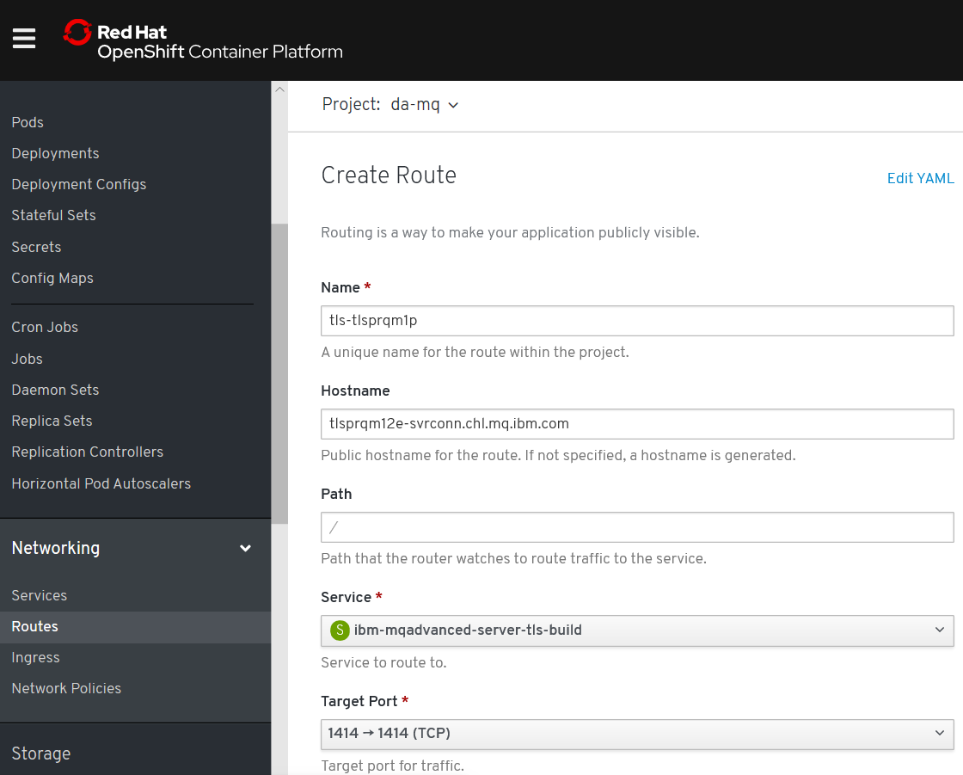

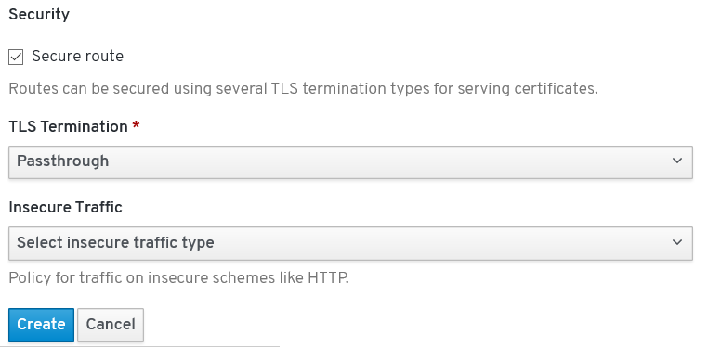

kind: Route

apiVersion: route.openshift.io/v1

metadata:

name: tls-tlsprqm1p

namespace: da-build-project

labels:

app: ibm-mqadvanced-server-tls-build

spec:

host: tlsprqm12e-svrconn.chl.mq.ibm.com

subdomain: ''

to:

kind: Service

name: ibm-mqadvanced-server-tls-build

weight: 100

port:

targetPort: 1414-tcp

tls:

termination: passthrough

wildcardPolicy: None

### C:\openshift>oc get routes

NAME HOST/PORT PATH SERVICES PORT TERMINATION WILDCARD

ibm-mqadvanced-server-tls-build ibm-mqadvanced-server-tls-build-da-mq.apps.cluster-4bfc.4bfc.sandbox890.opentlc.com ibm-mqadvanced-server-tls-build 1414-tcp None

tls-tlsprqm1p tlsprqm12e-svrconn.chl.mq.ibm.com ibm-mqadvanced-server-tls-build 1414-tcp passthrough None

### Get the Queue Manager name

The queue manager name can be obtained from the new application log

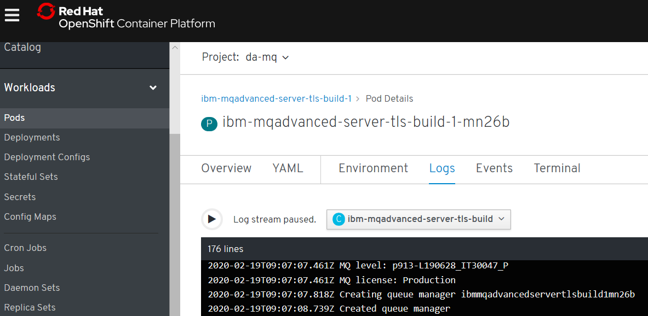

### An MQSC file to create CLNTCONN in CCDT

Depending on the level of OCP will determine the exact CONNAME/PORT (1414 or 443)

DEFINE CHANNEL(TLSPRQM1.SVRCONN) +

CHLTYPE(CLNTCONN) +

TRPTYPE(TCP) +

CONNAME('ibm-mqadvanced-server-tls-build-da-mq.apps.cluster-4bfc.4bfc.sandbox890.opentlc.com(443)') +

CERTLABL('ibmmqarnold') +

QMNAME(' ibmmqadvancedservertlsbuild1mn26b') +

SSLCIPH(ANY_TLS12) +

REPLACE

### runmqsc -n < CUSTOMIMAGE.mqsc

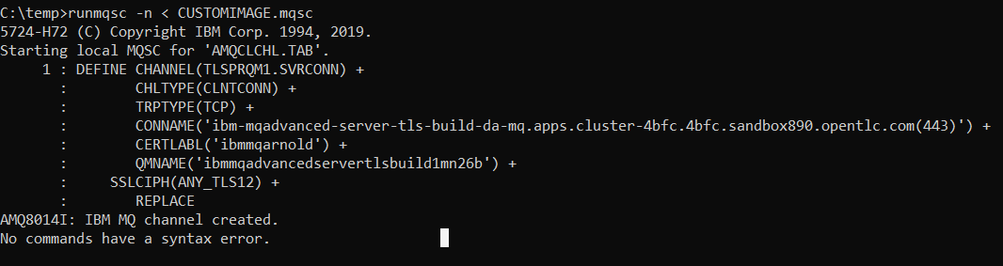

### type c:\programdata\ibm\mq\AMQCLCHL.TAB

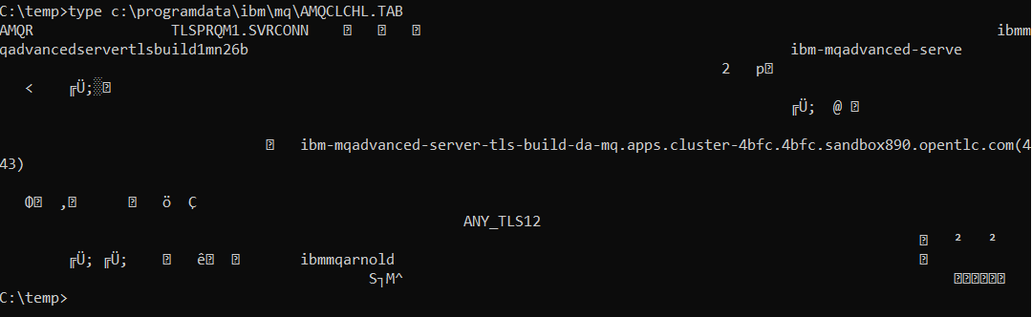

### set MQSSLKEYR=C:\Program Files\IBM\MQ\arnold

[note: connecting over TLS so need to set the keystore location]

You will need the client side (your laptop with MQ on it) keystore files that match those baked into the image. Ge them from Github below.

<https://github.com/DAVEXACOM/Exploring-ICP4i-RHOS/tree/master/MQ%20TLS%20and%20Custom%20Layer%20Image-311and42/clientside%20TLS%20files>

### runmqsc -c ibmmqadvancedservertlsbuild1mn26b

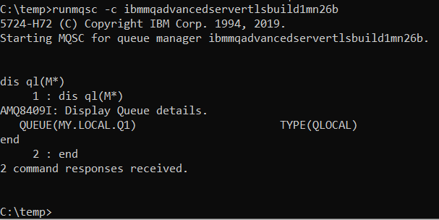

# Build and running MQ custom images on CodeReady on a laptop

<https://access.redhat.com/documentation/en-us/red_hat_codeready_containers/1.6/html/getting_started_guide/index>

## Setup for codeready on windows

### Create directory for codeready

Md c:\codeready

### Set the path to new directory

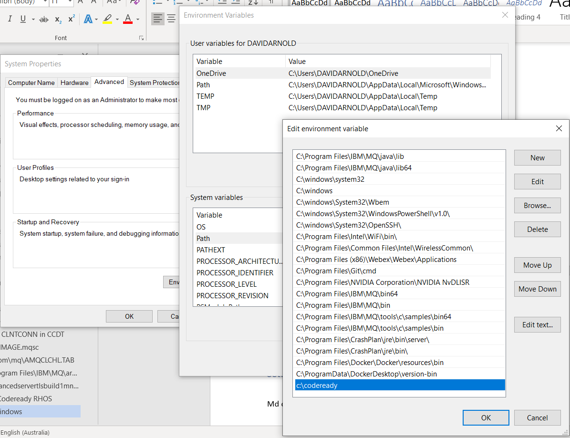

### Create Hyper-V virtual network switch

The networking can be a bit of a pain. The Hyper-V virtual switch can hijack the wifi adapter connection for the rest of the machine and you lose all connectivity off box. So you can get from the host machine to the cluster but to nothing of box. Consider the following post.

<https://www.groovypost.com/howto/share-an-ethernet-or-wireless-network-connection-with-hyper-v-in-windows-10/>

External network switch called crc

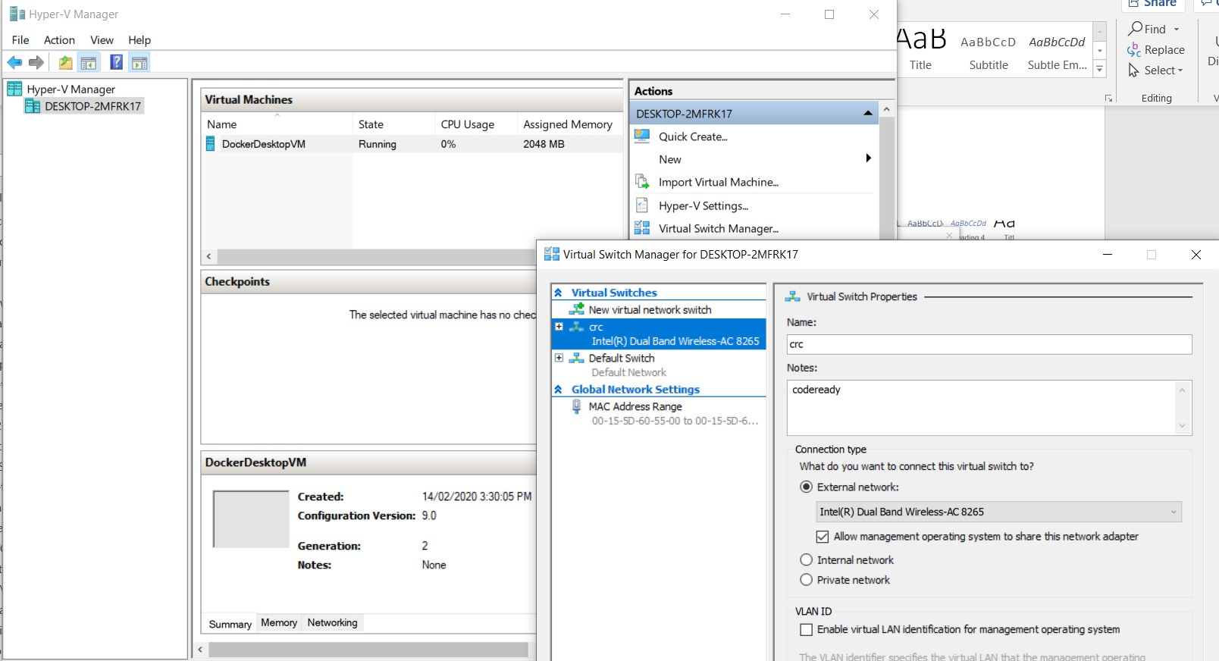

## Download and install code ready

<https://cloud.redhat.com/openshift/install/crc/installer-provisioned>

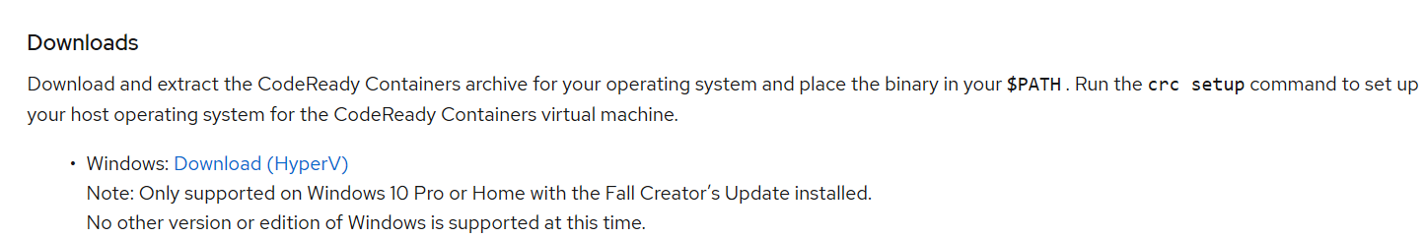



### Extract to c:\codeready

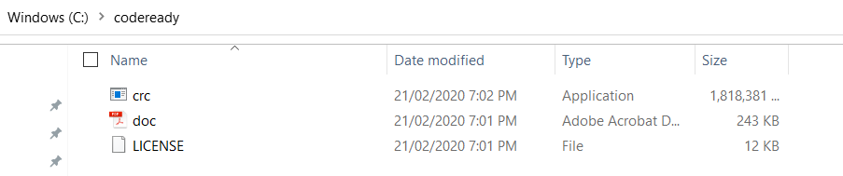

### Install code ready

Crc setup

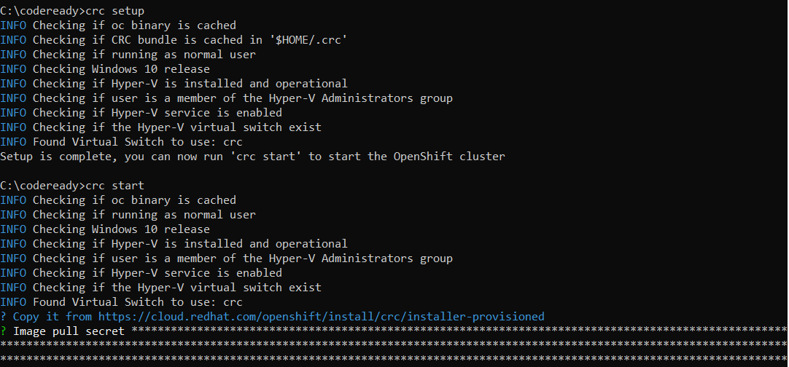

### Start code ready

Crc start or crc start –log-level debug

Get the key from below or you can download is from there and keep it locally

<https://cloud.redhat.com/openshift/install/crc/installer-provisioned>

make sure you say yes at the pop up

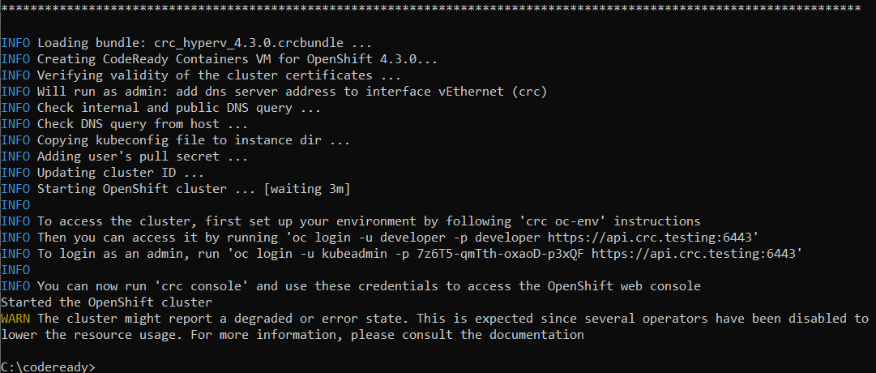

Above is the log for a new cluster starting for the first time

Below is the log for a cluster that already exists being started

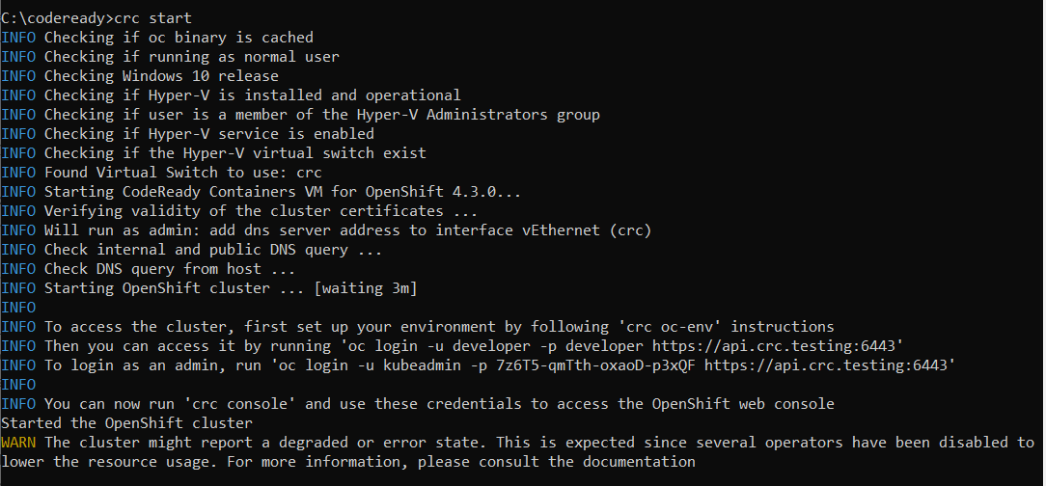

From the crc start output

Then you can access it by running 'oc login -u developer -p developer https://api.crc.testing:6443'

INFO To login as an admin, run 'oc login -u kubeadmin -p 7z6T5-qmTth-oxaoD-p3xQF https://api.crc.testing:6443'

## Using code ready

<https://access.redhat.com/documentation/en-us/red_hat_codeready_containers/1.6/html/getting_started_guide/using-codeready-containers_gsg>

### Logging into codeready

Get the credentials for the codeready instance

C:\codeready\crc console –credentials

C:\codeready>crc console --credentials

To login as a regular user, run 'oc login -u developer -p developer https://api.crc.testing:6443'.

To login as an admin, run 'oc login -u kubeadmin -p 7z6T5-qmTth-oxaoD-p3xQF https://api.crc.testing:6443'



Start the Web UI console

C:\codeready>crc console

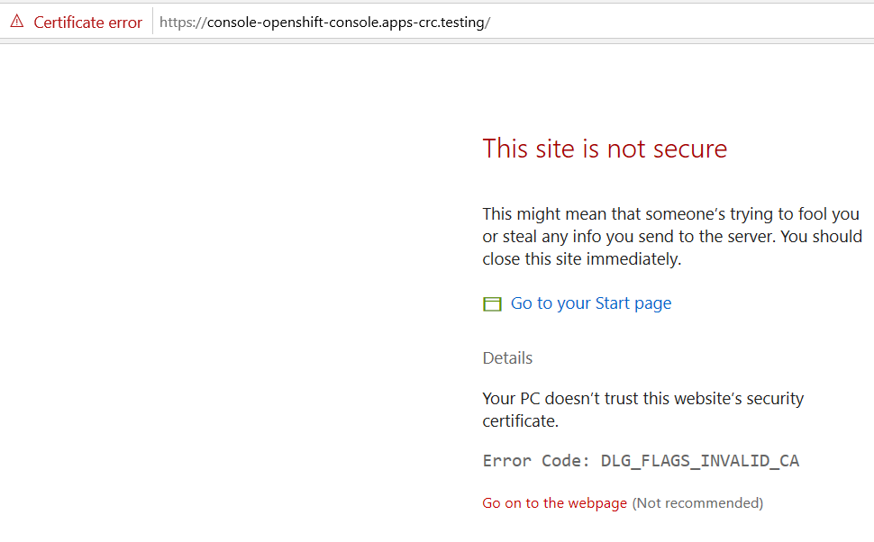

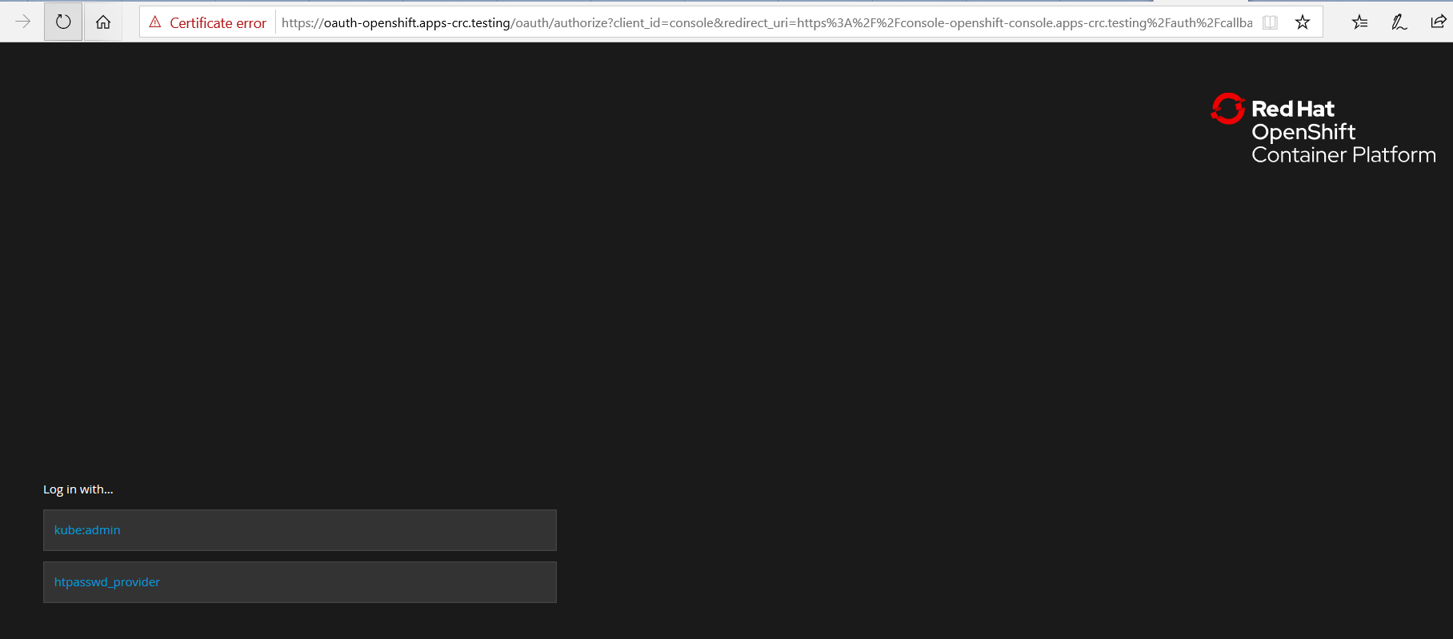

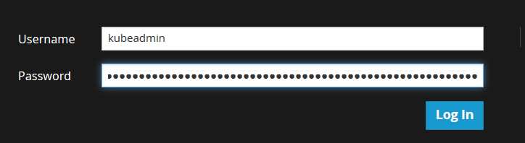

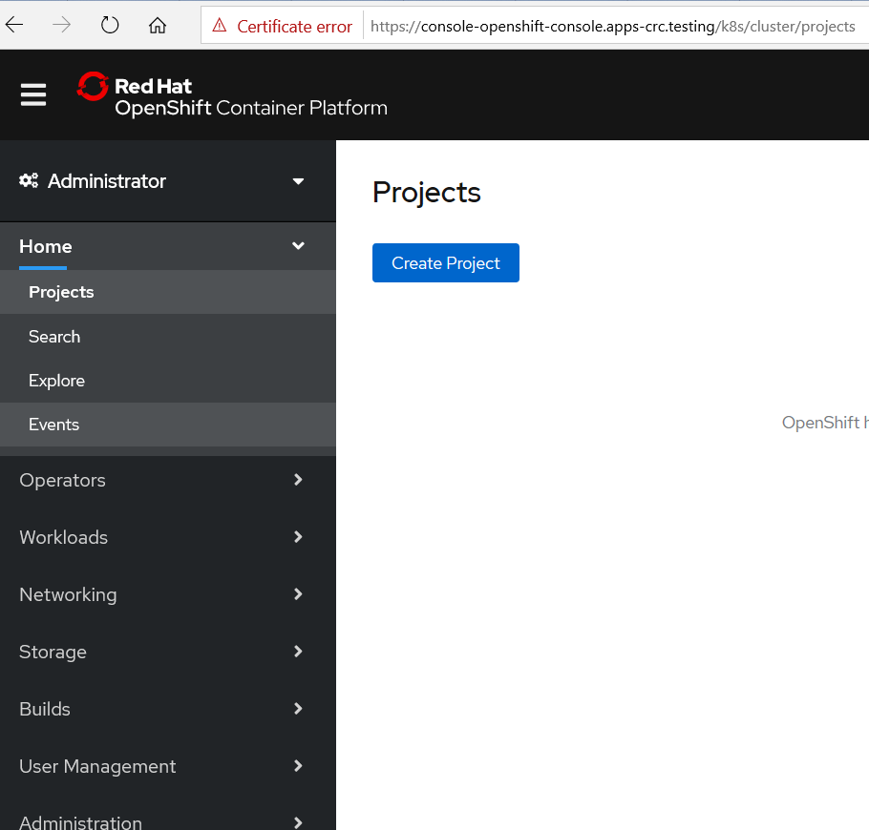

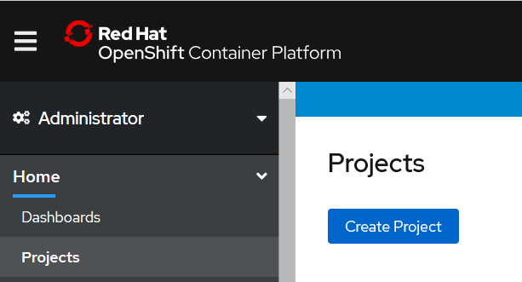

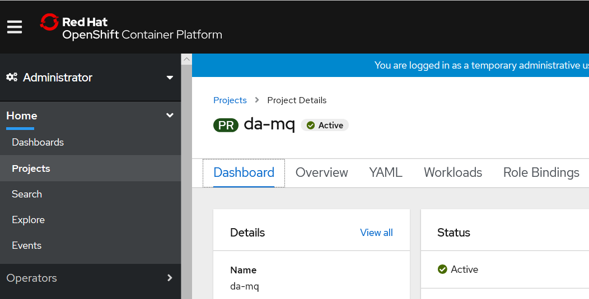

### access the OpenShift cluster via the oc command

Run the crc oc-env command to print the command needed to add the cached oc binary to your PATH:

### crc oc-env to set up the command line path

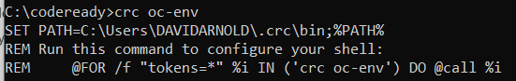

Run the printed command.

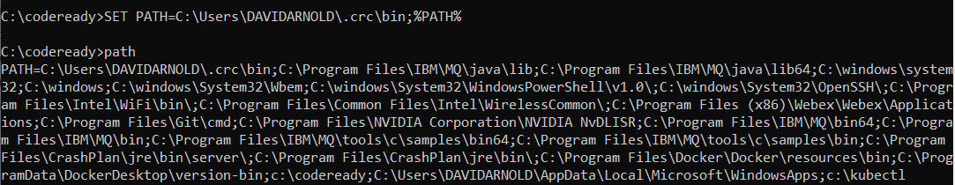

Log in as the developer user:

To login as a regular user, run 'oc login -u developer -p developer https://api.crc.testing:6443'.

To login as an admin, run 'oc login -u kubeadmin -p 7z6T5-qmTth-oxaoD-p3xQF https://api.crc.testing:6443'

oc login -u kubeadmin -p 7z6T5-qmTth-oxaoD-p3xQF <https://api.crc.testing:6443>

**oc login -u developer -p developer** [**https://api.crc.testing:6443**](https://api.crc.testing:6443)

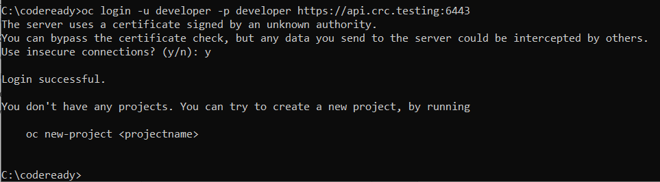

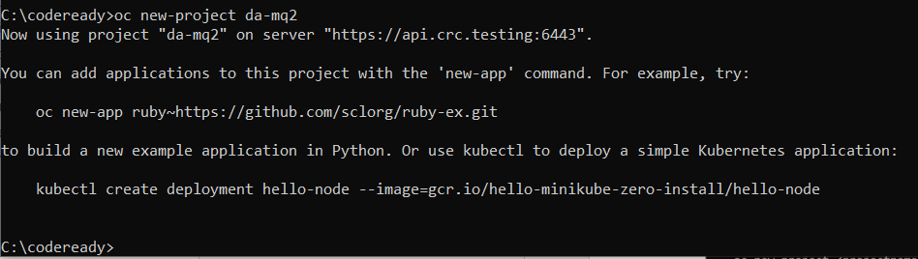

Observe new project in Web console

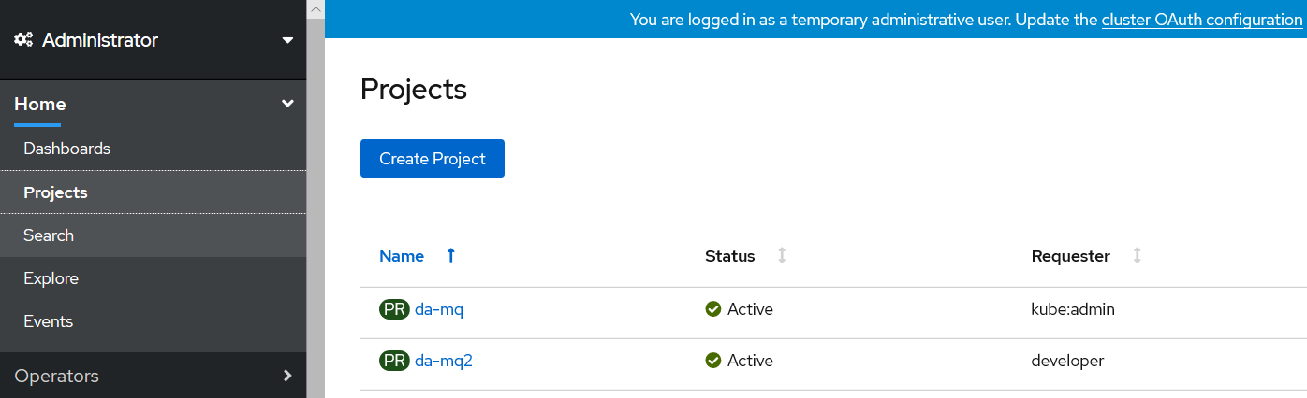

## Build, run and test IBM Middleware on code ready

### C:\codeready>oc projects

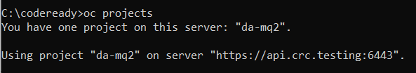

### C:\codeready>oc project da-mq2

(note oc new-project da-mq2 will create and change you to this project if you did not create one in the web ui console)



### YAML for create of input image stream

apiVersion: v1

kind: ImageStream

metadata:

name: ibm-mqadvanced-server-integration

spec:

tags:

- name: "9.1.3.0-r4-amd64"

from:

kind: DockerImage

name: davexacom/ibm-mqadvanced-server-integration:9.1.3.0-r4-amd64



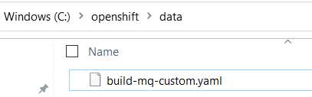

### C:\codeready>oc create -f c:\openshift\data\build-mq-custom.yaml

imagestream.image.openshift.io/ibm-mqadvanced-server-integration created



### Observe the “input” imagestream

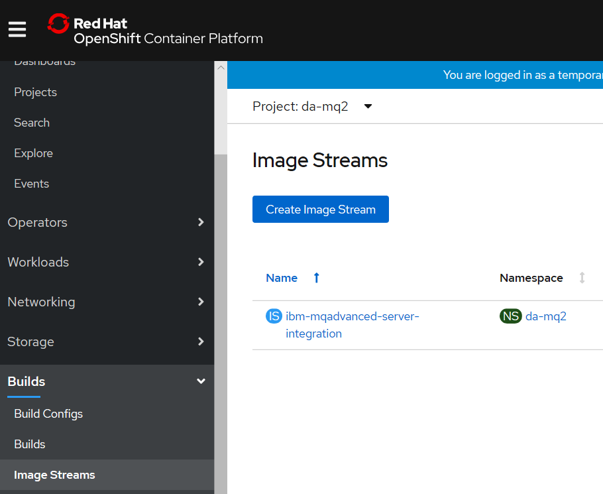

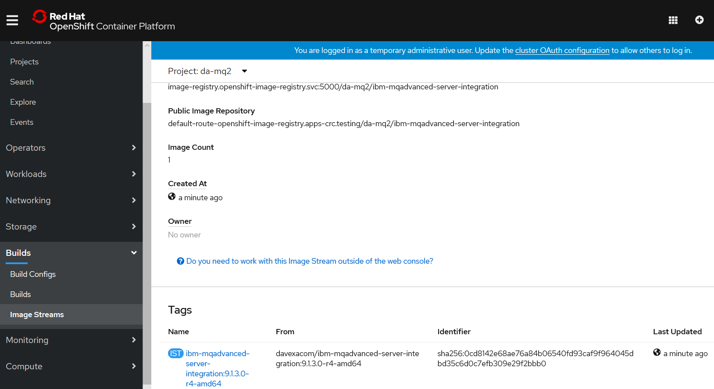

### C:\codeready>oc adm policy add-scc-to-user anyuid -z default



Need to execute as administrator

Open second command prompt and change to c:\codeready directory

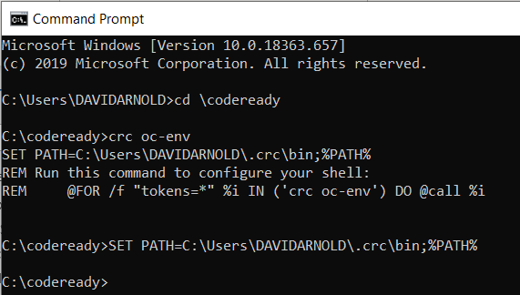

oc login -u kubeadmin -p 7z6T5-qmTth-oxaoD-p3xQF <https://api.crc.testing:6443>

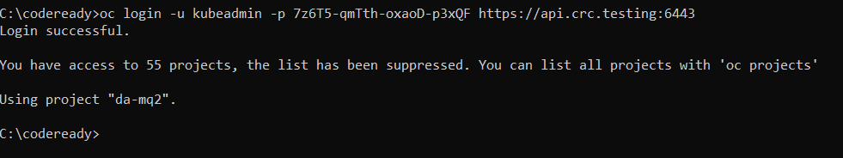

### C:\codeready>oc adm policy add-scc-to-user anyuid -z default

Run

scc "anyuid" added to: ["system:serviceaccount:da-mq:default"]

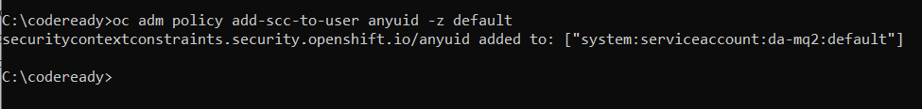

[note: above allows the MQ container to run as root]

Switch back to the developer command prompt

### C:\codeready>oc new-build <https://github.com/DAVEXACOM/ibm-mqadvanced-server-tls-build.git>

### Observe build in the Web console

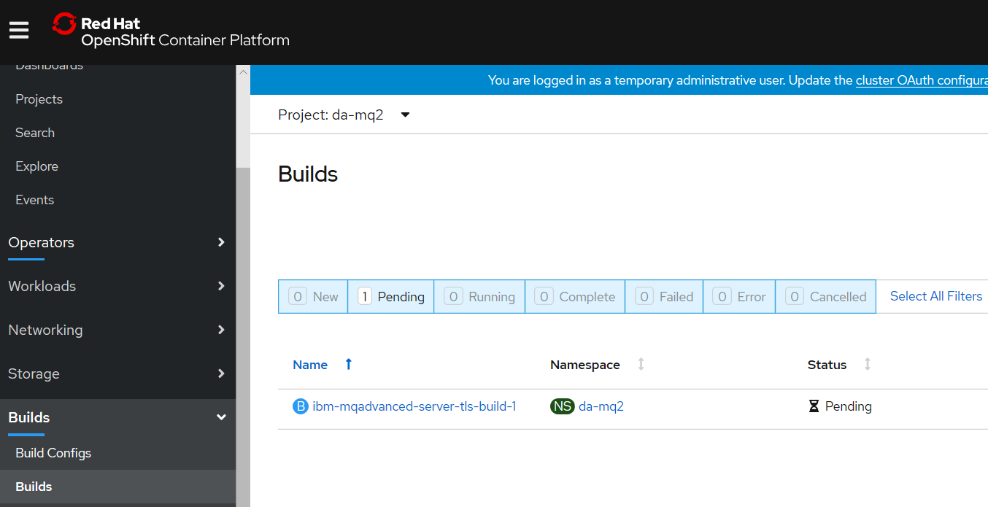

--> Found image ee41039 (3 months old) in image stream "da-mq/ibm-mqadvanced-server-integration" under tag "9.1.3.0-r4-amd64" for "ibm-mqadvanced-server-integration:9.1.3.0-r4-amd64"

IBM MQ Advanced Server

----------------------

Simplify, accelerate and facilitate the reliable exchange of data with a security-rich messaging solution — trusted by the world’s most successful enterprises

Tags: mq messaging

* A Docker build using source code from https://github.com/DAVEXACOM/ibm-mqadvanced-server-tls-build.git will be created

* The resulting image will be pushed to image stream tag "ibm-mqadvanced-server-tls-build:latest"

* Use 'start-build' to trigger a new build

--> Creating resources with label build=ibm-mqadvanced-server-tls-build ...

imagestream.image.openshift.io "ibm-mqadvanced-server-tls-build" created

buildconfig.build.openshift.io "ibm-mqadvanced-server-tls-build" created

--> Success

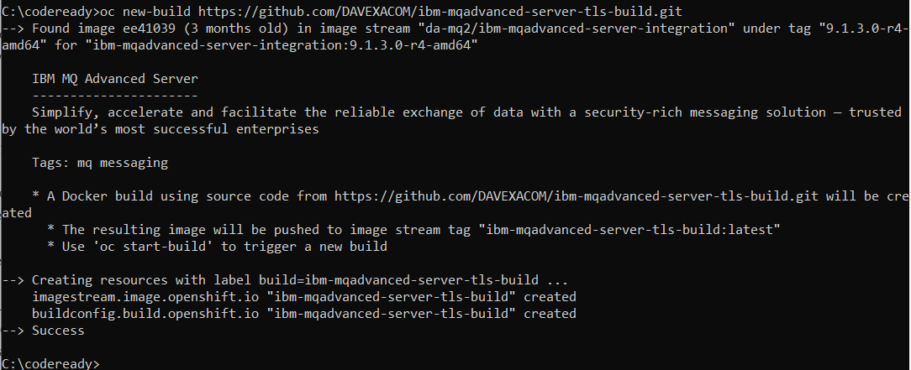

### Observe the Build config that is created

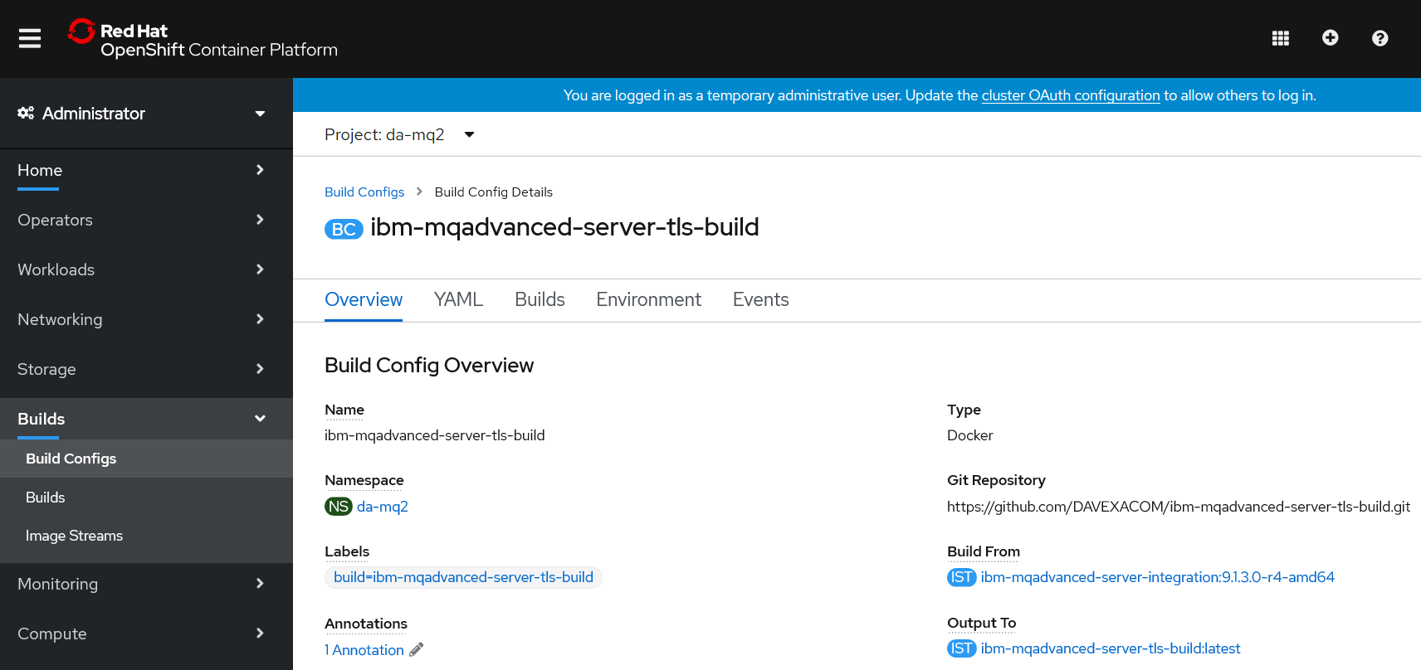

### Observe the build log

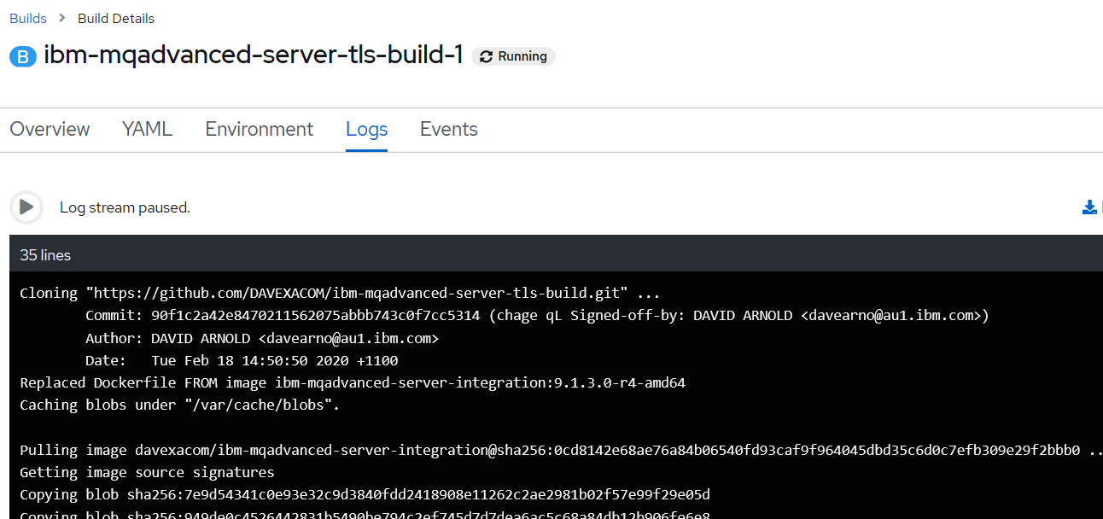

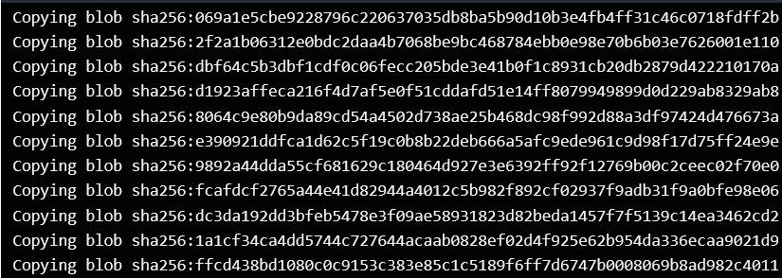

### Observe the “output” image stream



## Creating a “New App” – running up a container From the custom image

### C:\openshift>oc new-app ibm-mqadvanced-server-tls-build --env LICENSE=accept

--> Found image 2306b71 (3 minutes old) in image stream "da-mq/ibm-mqadvanced-server-tls-build" under tag "latest" for "ibm-mqadvanced-server-tls-build"

IBM MQ Advanced Server

----------------------

Simplify, accelerate and facilitate the reliable exchange of data with a security-rich messaging solution — trusted by the world’s most successful enterprises

Tags: mq messaging

* This image will be deployed in deployment config "ibm-mqadvanced-server-tls-build"

* Ports 1414/tcp, 9157/tcp, 9443/tcp will be load balanced by service "ibm-mqadvanced-server-tls-build"

* Other containers can access this service through the hostname "ibm-mqadvanced-server-tls-build"

--> Creating resources ...

deploymentconfig.apps.openshift.io "ibm-mqadvanced-server-tls-build" created

service "ibm-mqadvanced-server-tls-build" created

--> Success

Application is not exposed. You can expose services to the outside world by executing one or more of the commands below:

'oc expose svc/ibm-mqadvanced-server-tls-build'

Run 'oc status' to view your app.

### C:\openshift>oc status

In project Dave Arnold MQ (da-mq) on server https://api.cluster-4bfc.4bfc.sandbox890.opentlc.com:6443

svc/ibm-mqadvanced-server-tls-build - 172.30.48.136 ports 1414, 9157, 9443

dc/ibm-mqadvanced-server-tls-build deploys istag/ibm-mqadvanced-server-tls-build:latest <-

bc/ibm-mqadvanced-server-tls-build docker builds https://github.com/DAVEXACOM/ibm-mqadvanced-server-tls-build.git on istag/ibm-mqadvanced-server-integration:9.1.3.0-r4-amd64

deployment #1 deployed 22 minutes ago - 1 pod

## Testing the custom image

### C:\openshift>oc expose svc/ibm-mqadvanced-server-tls-build

route.route.openshift.io/ibm-mqadvanced-server-tls-build exposed

### C:\openshift>oc get routes

NAME HOST/PORT PATH SERVICES PORT TERMINATION WILDCARD

ibm-mqadvanced-server-tls-build ibm-mqadvanced-server-tls-build-da-mq.apps.cluster-4bfc.4bfc.sandbox890.opentlc.com ibm-mqadvanced-server-tls-build 1414-tcp None

## Connecting to MQ queue manager

### OCP 4.1 is like 4.2 so we need to modify the route for MQ TLS traffic

### C:\openshift\oc get routes

NAME HOST/PORT PATH SERVICES PORT TERMINATION WILDCARD

ibm-mqadvanced-server-tls-build ibm-mqadvanced-server-tls-build-da-mq.apps.cluster-4bfc.4bfc.sandbox890.opentlc.com ibm-mqadvanced-server-tls-build 1414-tcp None

Networking->routes->create route-> then there is a form



### Create route for TLS

**Tick the TLS secure route and set passthrough. Leave Insecure Traffic unset**

OCP 4.1





kind: Route

apiVersion: route.openshift.io/v1

metadata:

name: tls-tlsprqm1p

namespace: da-mq

selfLink: /apis/route.openshift.io/v1/namespaces/da-mq/routes/tls-tlsprqm1p

uid: 1cb7e145-536b-11ea-8e06-0a580a800077

resourceVersion: '148718'

creationTimestamp: '2020-02-19T22:56:49Z'

labels:

app: ibm-mqadvanced-server-tls-build

spec:

host: tlsprqm12e-svrconn.chl.mq.ibm.com

subdomain: ''

to:

kind: Service

name: ibm-mqadvanced-server-tls-build

weight: 100

port:

targetPort: 1414-tcp

tls:

termination: passthrough

wildcardPolicy: None

status:

ingress:

- host: tlsprqm12e-svrconn.chl.mq.ibm.com

routerName: default

conditions:

- type: Admitted

status: 'True'

lastTransitionTime: '2020-02-19T22:56:49Z'

wildcardPolicy: None

routerCanonicalHostname: apps.cluster-4bfc.4bfc.sandbox890.opentlc.com

### C:\openshift>oc get routes

NAME HOST/PORT PATH SERVICES PORT TERMINATION WILDCARD

ibm-mqadvanced-server-tls-build ibm-mqadvanced-server-tls-build-da-mq.apps.cluster-4bfc.4bfc.sandbox890.opentlc.com ibm-mqadvanced-server-tls-build 1414-tcp None

tls-tlsprqm1p tlsprqm12e-svrconn.chl.mq.ibm.com ibm-mqadvanced-server-tls-build 1414-tcp passthrough None

### Get the Queue Manager name

The queue manager name can be obtained from the new application log



### An MQSC file to create CLNTCONN in CCDT

Depending on the level of OCP will determine the exact CONNAME/PORT (1414 or 443)

DEFINE CHANNEL(TLSPRQM1.SVRCONN) +

CHLTYPE(CLNTCONN) +

TRPTYPE(TCP) +

CONNAME('ibm-mqadvanced-server-tls-build-da-mq.apps.cluster-4bfc.4bfc.sandbox890.opentlc.com(443)') +

CERTLABL('ibmmqarnold') +

QMNAME(' ibmmqadvancedservertlsbuild1mn26b') +

SSLCIPH(ANY_TLS12) +

REPLACE

### runmqsc -n < CUSTOMIMAGE.mqsc



### type c:\programdata\ibm\mq\AMQCLCHL.TAB



### set MQSSLKEYR=C:\Program Files\IBM\MQ\arnold

[note: connecting over TLS so need to set the keystore location]

You will need the client side (your laptop with MQ on it) keystore files that match those baked into the image. Ge them from Github below.

<https://github.com/DAVEXACOM/Exploring-ICP4i-RHOS/tree/master/MQ%20TLS%20and%20Custom%20Layer%20Image-311and42/clientside%20TLS%20files>

### runmqsc -c ibmmqadvancedservertlsbuild1mn26b



## Stopping codeready (virtual machine)

The crc stop command stops the running CodeReady Containers virtual machine and OpenShift cluster. The stopping process will take a few minutes while the cluster shuts down.

**Procedure**

* Stop the CodeReady Containers virtual machine and OpenShift cluster:

$ crc stop

# Building and running MQ and ACE Custom images on RHOS (ICP4i)

## MQ custom from certified base image on RHOS

### oc login --token=WM4a6Lj9Vj67U626gJ8Z897Cijr-OnjG-KcVxPhPk1Q --server=https://api.cloudpak.ocp4.cloudnativekube.com:6443

### oc project da-build-project

### oc create -f c:\openshift\data\build-mq-custom.yaml

apiVersion: v1

kind: ImageStream

metadata:

name: ibm-mqadvanced-server-integration

spec:

tags:

- name: "9.1.3.0-r4-amd64"

from:

kind: DockerImage

name: davexacom/ibm-mqadvanced-server-integration:9.1.3.0-r4-amd64

### oc adm policy add-scc-to-user anyuid -z default

### oc new-build https://github.com/DAVEXACOM/ibm-mqadvanced-server-tls-build.git

### oc new-app ibm-mqadvanced-server-tls-build --env LICENSE=accept

### oc expose svc/ibm-mqadvanced-server-tls-build

### oc status

### oc create -f c:\openshift\data\create-mq-route.yaml

kind: Route

apiVersion: route.openshift.io/v1

metadata:

name: tls-tlsprqm1p

namespace: da-build-project

labels:

app: ibm-mqadvanced-server-tls-build

spec:

host: tlsprqm12e-svrconn.chl.mq.ibm.com

subdomain: ''

to:

kind: Service

name: ibm-mqadvanced-server-tls-build

weight: 100

port:

targetPort: 1414-tcp

tls:

termination: passthrough

wildcardPolicy: None

### oc get routes

NAME HOST/PORT PATH SERVICES PORT TERMINATION WILDCARD

ibm-mqadvanced-server-tls-build ibm-mqadvanced-server-tls-build-da-build-project.apps.cloudpak.ocp4.cloudnativekube.com ibm-mqadvanced-server-tls-build 1414-tcp None

get the CONNANE from the host/port of the route above

get the queue manager name from the logs workload->pods

### CLNTCONN Channel definition

DEFINE CHANNEL(TLSPRQM1.SVRCONN) +

CHLTYPE(CLNTCONN) +

TRPTYPE(TCP) +

CONNAME('ibm-mqadvanced-server-tls-build-da-build-project.apps.cloudpak.ocp4.cloudnativekube.com(443)') +

CERTLABL('ibmmqarnold') +

QMNAME('ibmmqadvancedservertlsbuild147zgm') +

SSLCIPH(ANY_TLS12) +

REPLACE

### runmqsc -n < CUSTOMIMAGE.mqsc

### Observe the AMQCLCHL.TAB

type c:\programdata\ibm\mq\AMQCLCHL.TAB

### set MQSSLKEYR=C:\Program Files\IBM\MQ\arnold

### runmqsc -c ibmmqadvancedservertlsbuild147zgm

5724-H72 (C) Copyright IBM Corp. 1994, 2019.

Starting MQSC for queue manager ibmmqadvancedservertlsbuild147zgm.

DIS QL(M*)

AMQ8409I: Display Queue details.

QUEUE(MY.LOCAL.Q1) TYPE(QLOCAL)

end

### Adding a webhook for the MQ custom image build

Goto the build configs

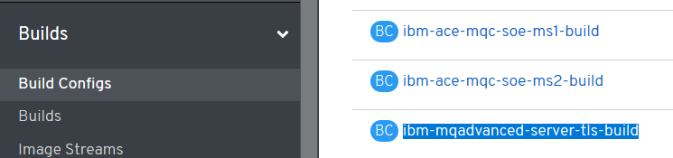

Select ibm-mqserver-server-tls-build and page down to webhooks – copy the url with secret

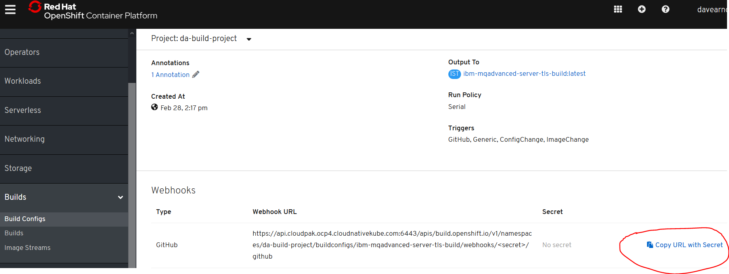

Goto github (your clone of the repos below)

<https://github.com/DAVEXACOM/ibm-mqadvanced-server-tls-build>

select settings->webhooks and paste into the Payload URL

The set the content type and disable SSL

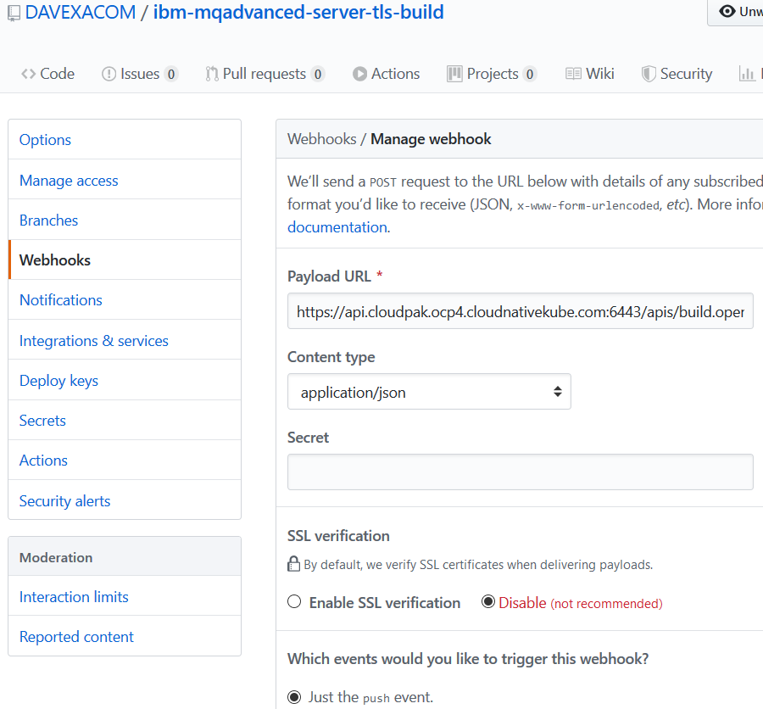

Hit the add webhook button at the bottom and then check for the tick below

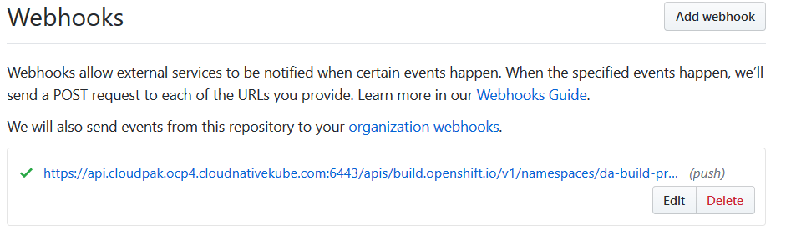

### Push MQSC file change to Github

Add some user queues

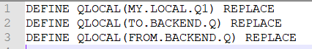

Push to Git

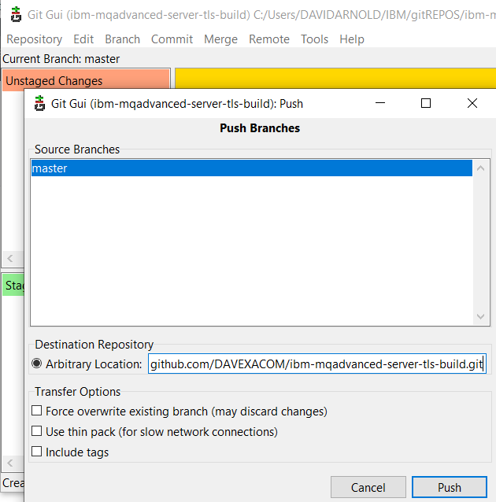

### Observer triggered build in RHOS

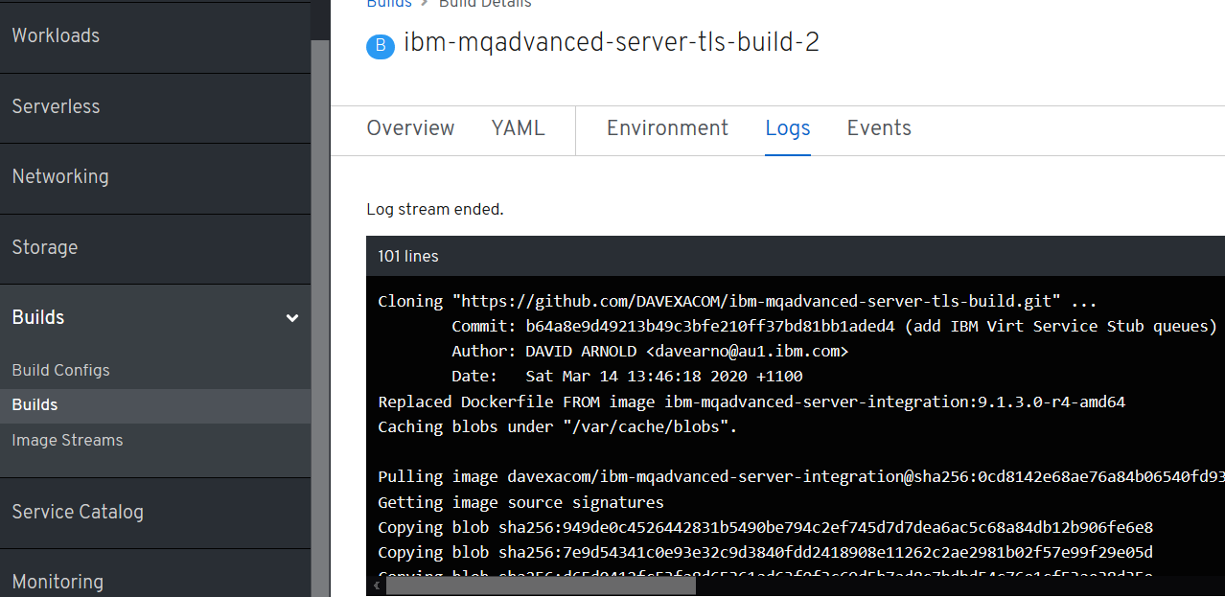

Check the deployment config for Rolling and trigger on image change

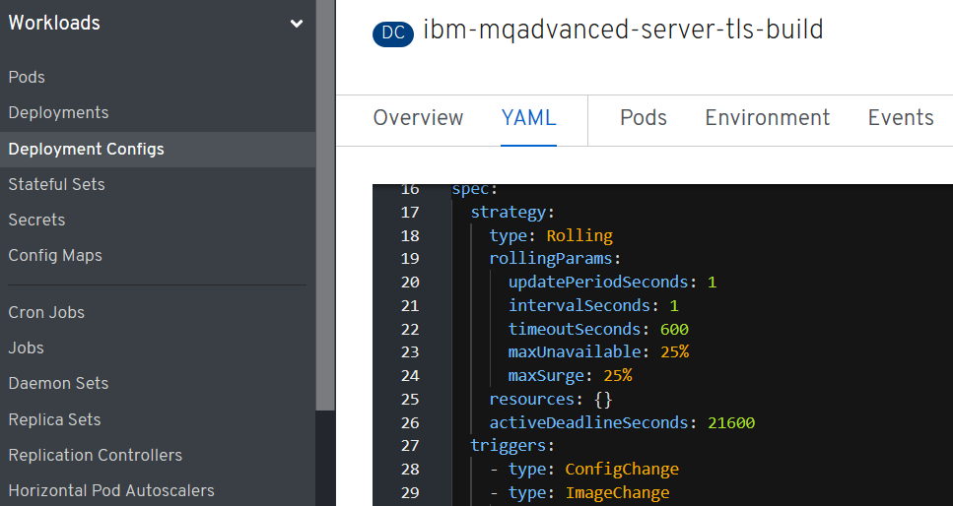

### Observer Pod has updated based on the new build

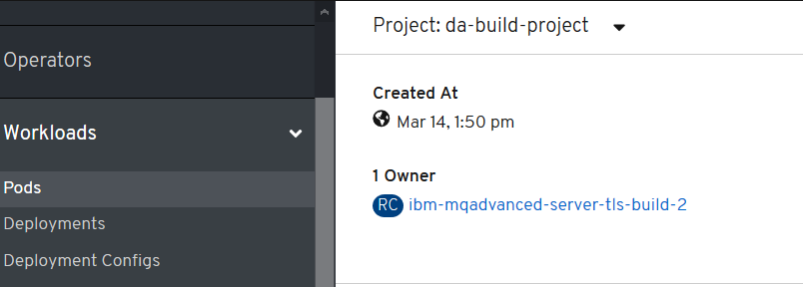

## Test the new MQ deployment for new queues

### Obtain the queue manager name in latest build

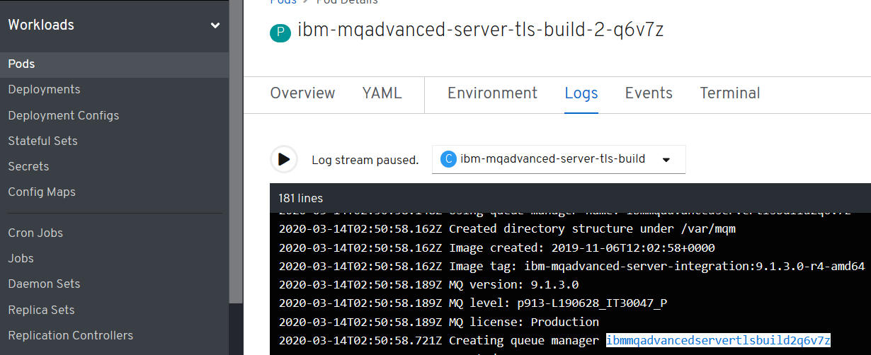

In this example ibmmqadvancedservertlsbuild2q6v7z

### Open command prompt as administrator

get the queue manager name from the logs workload->pods

### CLNTCONN Channel definition

DEFINE CHANNEL(TLSPRQM1.SVRCONN) +

CHLTYPE(CLNTCONN) +

TRPTYPE(TCP) +

CONNAME('ibm-mqadvanced-server-tls-build-da-build-project.apps.cloudpak.ocp4.cloudnativekube.com(443)') +

CERTLABL('ibmmqarnold') +

QMNAME('ibmmqadvancedservertlsbuild2q6v7z') +

SSLCIPH(ANY_TLS12) +

REPLACE

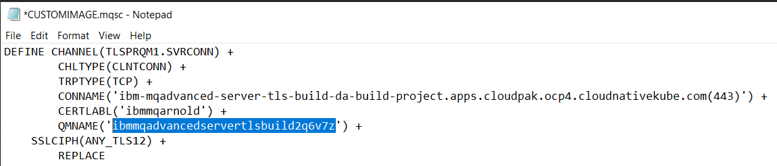

runmqsc -n < CUSTOMIMAGE.mqsc

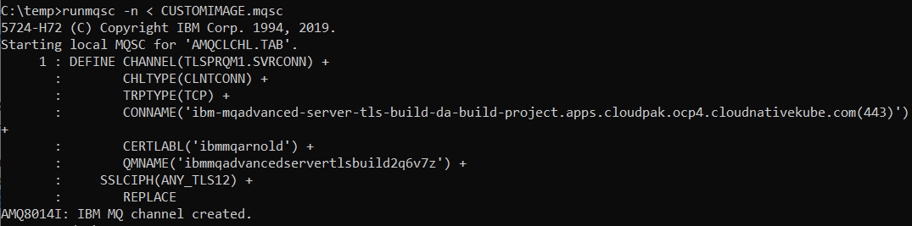

### Check the AMQCLCHL.TAB

type c:\programdata\ibm\mq\AMQCLCHL.TAB

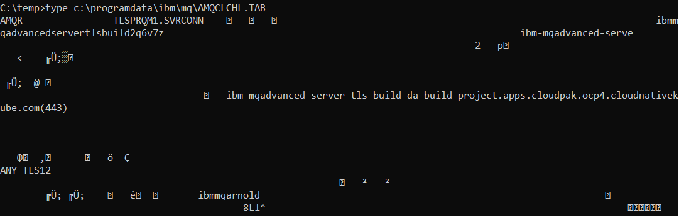

set MQSSLKEYR=C:\Program Files\IBM\MQ\arnold

runmqsc -c ibmmqadvancedservertlsbuild2q6v7z

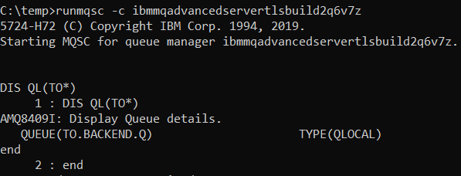

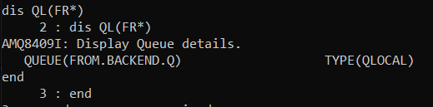

## Build and Run ACE Microservice 1 from SoE on RHOS

### Creds for ICP4i

RHOCP console:

<https://console-openshift-console.apps.cloudpak.ocp4.cloudnativekube.com/dashboard>

davearno

passw0rd1234

Kubeadmin

UqJrM-aKo2y-VYnYi-QiuBV

### Github/dockerhub

<https://github.com/DAVEXACOM/ibm-ace-mqc-soe-ms1-build>

<https://hub.docker.com/repository/docker/davexacom/ace11002mqc91soe>

<https://hub.docker.com/repository/docker/davexacom/ibm-mqadvanced-server-integration>

Build from <https://hub.docker.com/repository/docker/davexacom/ace11002mqc91soe>

Using a version of <https://github.com/DAVEXACOM/ACEonICPIntMicSrv1Img>

Which is at https://github.com/DAVEXACOM/ibm-ace-mqc-soe-ms1-build

Should be able to test using curl against liveliness probe , ace ms1 won’t work without ms2 or a stub behind it.

### Code for ACE Microservice1

<https://github.com/DAVEXACOM/ACEonICPIntMicSrv1>

### Code for ACE Liveliness probe

<https://github.com/DAVEXACOM/ACEonICPIntMicSoE>

### Building the ACE MS1 image

#### oc login --token=WM4a6Lj9Vj67U626gJ8Z897Cijr-OnjG-KcVxPhPk1Q --server=https://api.cloudpak.ocp4.cloudnativekube.com:6443

#### oc project da-build-project

#### oc create -f c:\openshift\data\build-ace-custom.yaml

### Observe the image stream

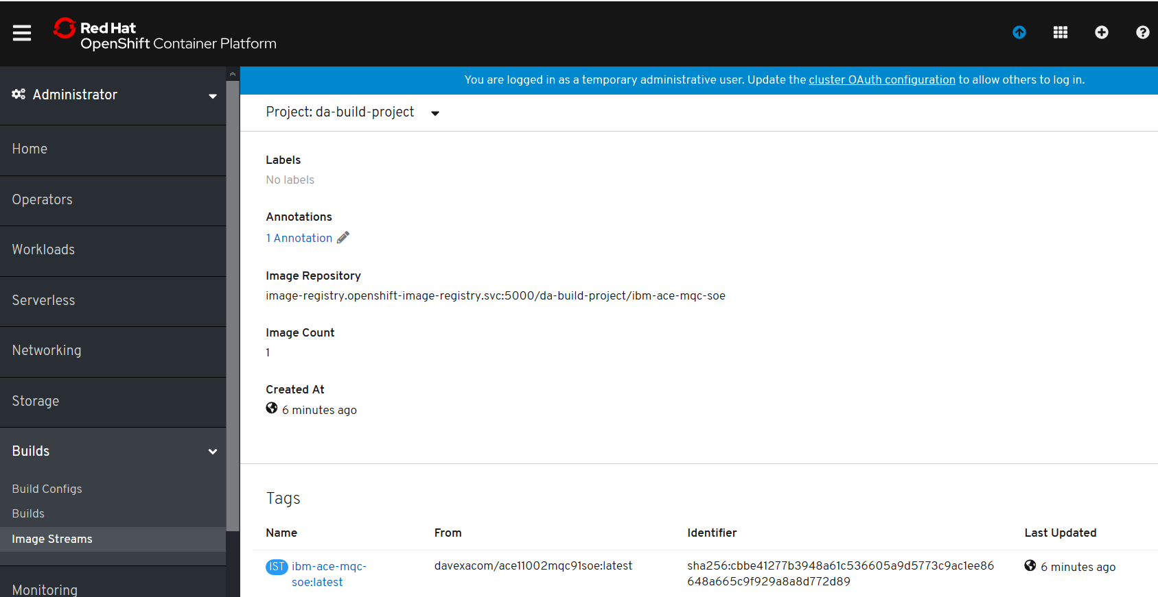

#### oc new-build <https://github.com/DAVEXACOM/ibm-ace-mqc-soe-ms1-build.git>

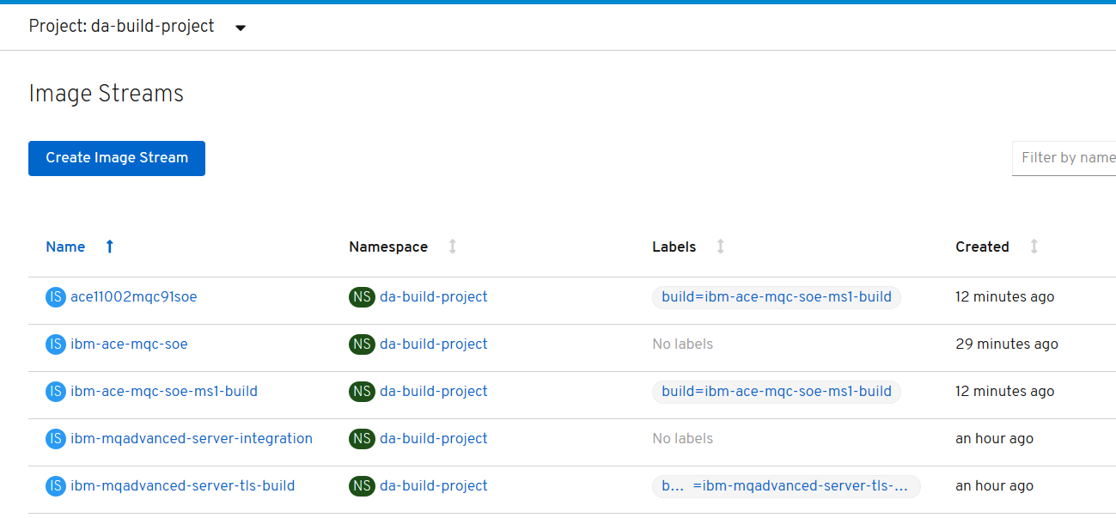

### Observe the build

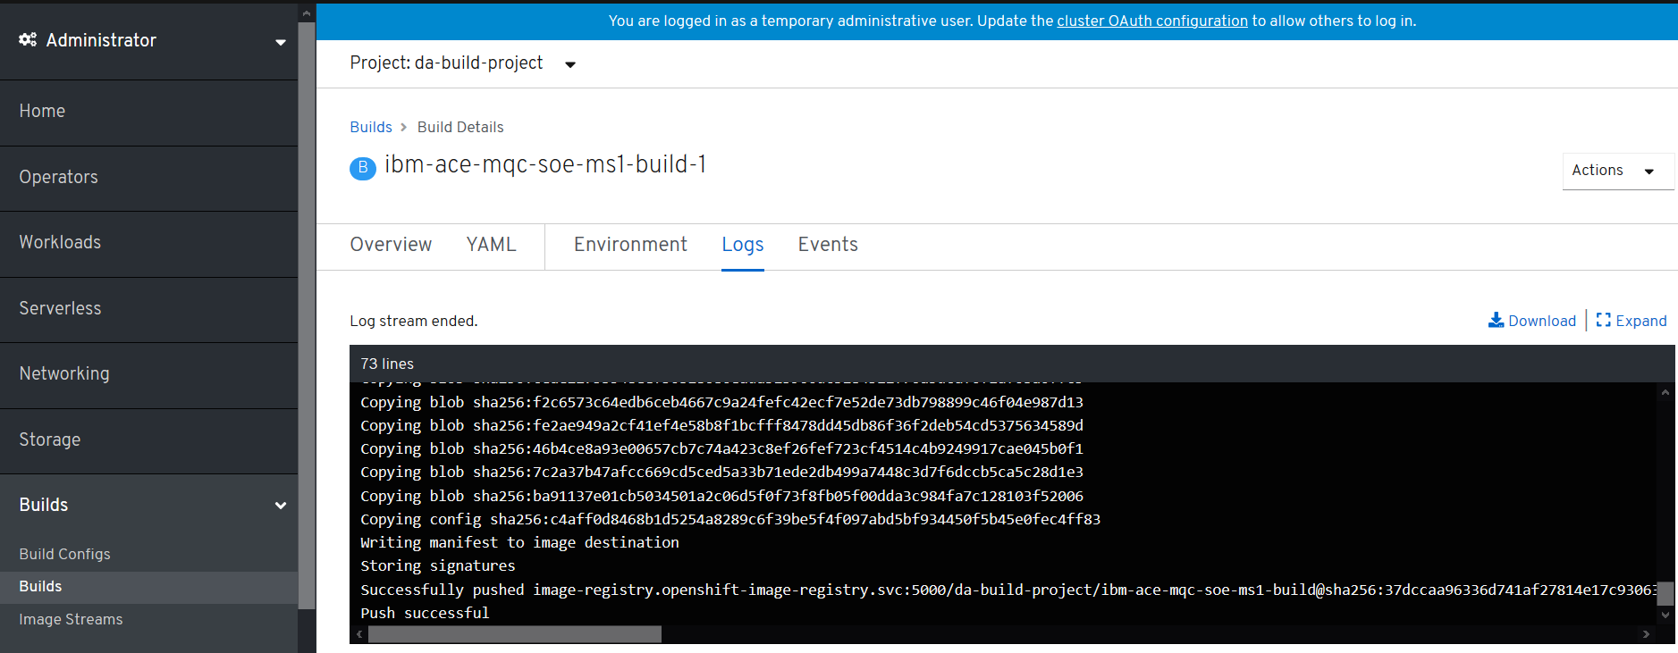

#### oc new-app ibm-ace-mqc-soe-ms1-build --env LICENSE=accept

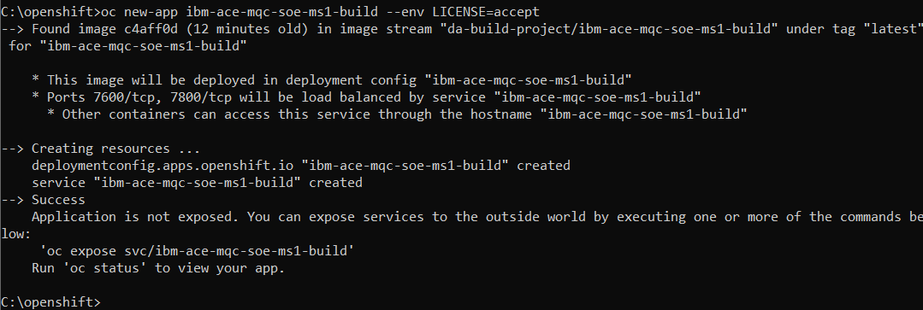

NOTE: If you use oc expose you will get a route (URL) that exposes 7600 the WebUI and not the 7800 for HTTP connection to the deployed services. So recommend using the oc create route, jump to @DA1@ below

#### oc expose svc/ibm-ace-mqc-soe-ms1-build – note better to use oc create



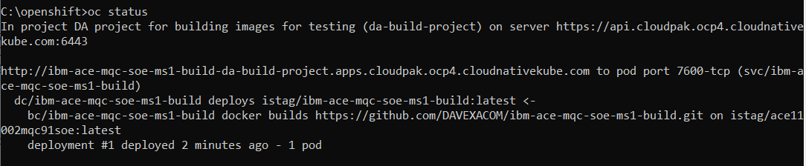

#### oc get routes



NAME HOST/PORT PATH SERVICES PORT TERMINATION WILDCARD

ibm-ace-mqc-soe-ms1-build ibm-ace-mqc-soe-ms1-build-da-build-project.apps.cloudpak.ocp4.cloudnativekube.com ibm-ace-mqc-soe-ms1-build 7600-tcp

### Testing the running application

#### Test the webUI

http://ibm-ace-mqc-soe-ms1-build-da-build-project.apps.cloudpak.ocp4.cloudnativekube.com/

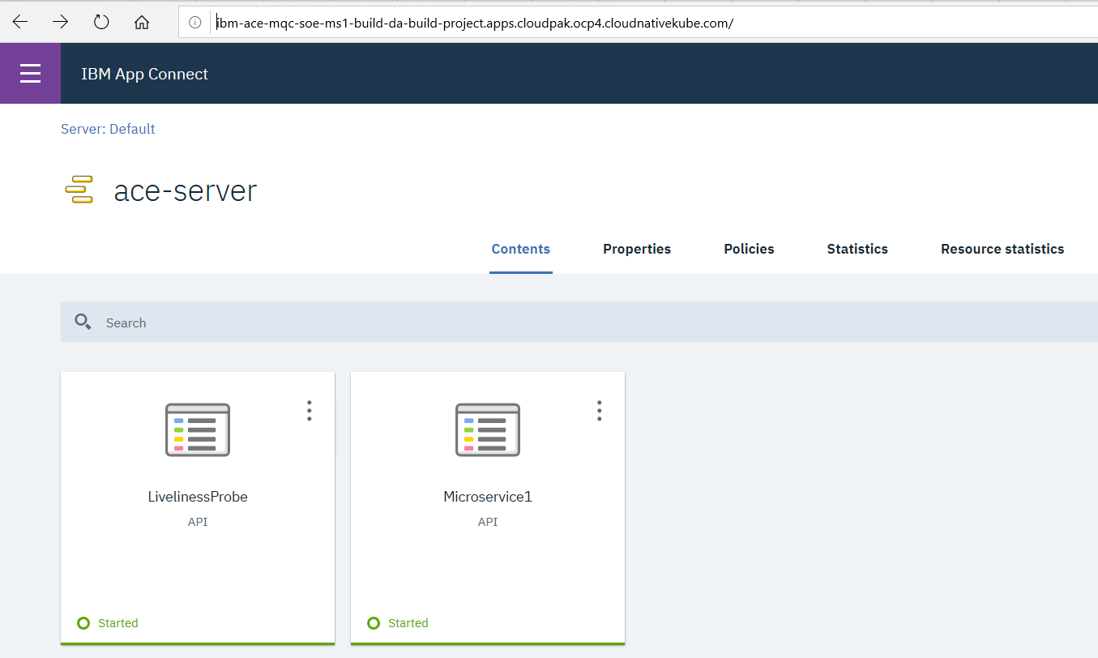

Below is the route. Note it is leveraging port 7600 – hence the WebUI works

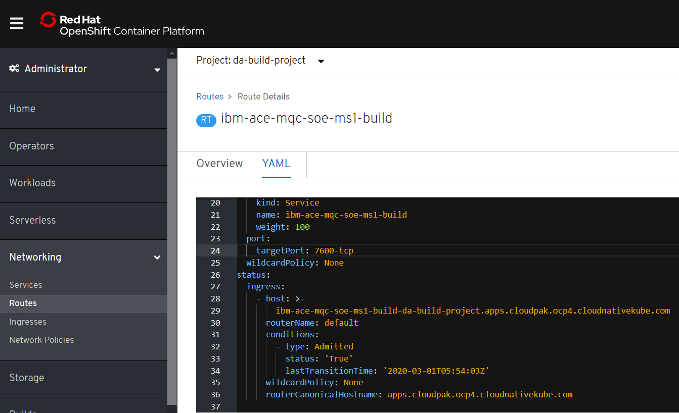

@DA1@ below

### Changing the route 7600 to 7800 for target port

save and reload

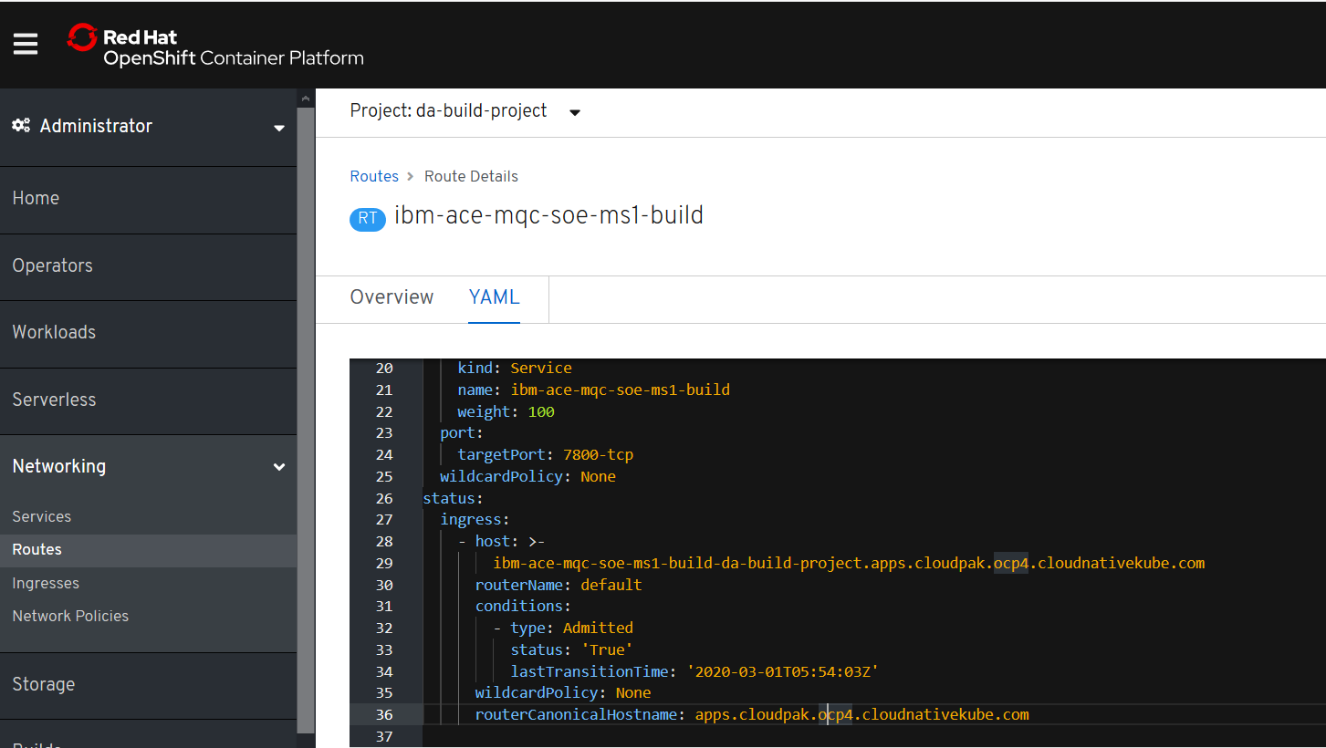

### Test the deployed Liveliness probe service

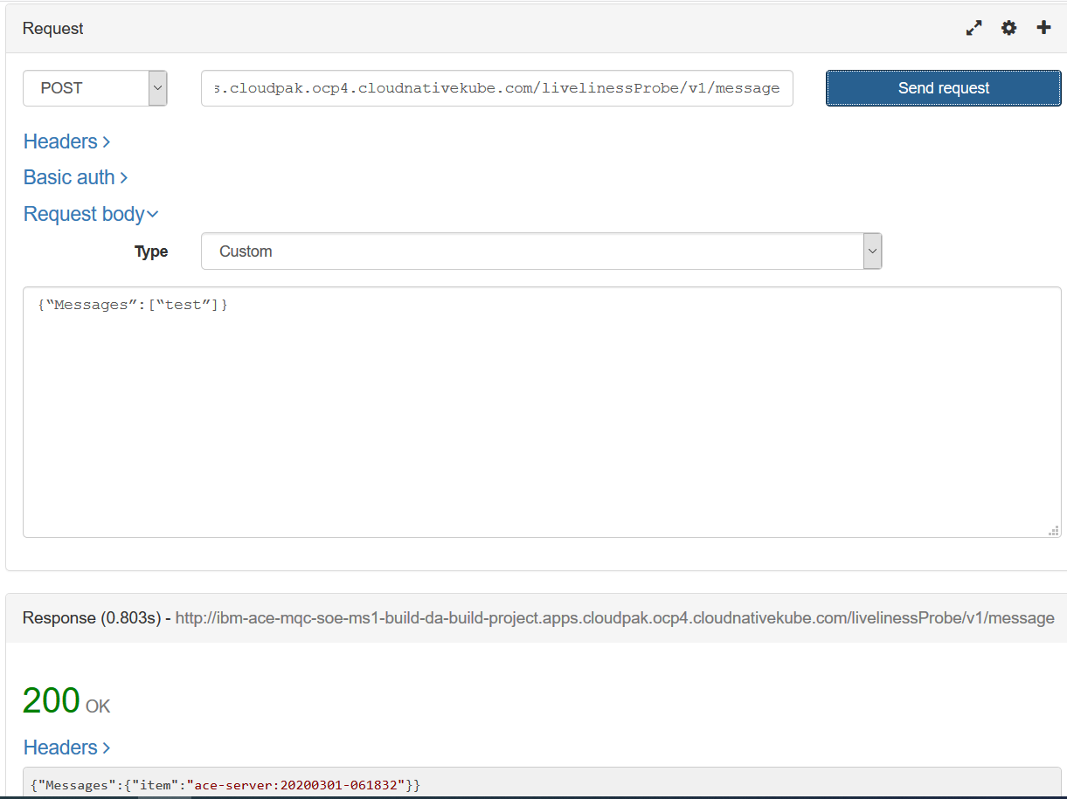

### Alternative – using oc create to create the route instead of expose

#### oc create -f c:\openshift\data\create-ace-route.yaml

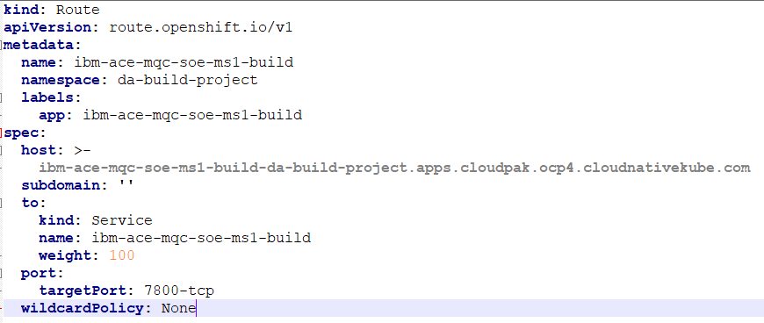

kind: Route

apiVersion: route.openshift.io/v1

metadata:

name: ibm-ace-mqc-soe-ms1-build

namespace: da-build-project

labels:

app: ibm-ace-mqc-soe-ms1-build

spec:

host: >-

ibm-ace-mqc-soe-ms1-build-da-build-project.apps.cloudpak.ocp4.cloudnativekube.com

subdomain: ''

to:

kind: Service

name: ibm-ace-mqc-soe-ms1-build

weight: 100

port:

targetPort: 7800-tcp

wildcardPolicy: None

#### oc get routes



### Test the liveliness probe service again

<http://ibm-ace-mqc-soe-ms1-build-da-build-project.apps.cloudpak.ocp4.cloudnativekube.com/livelinessProbe/v1/message>

{“Messages”:[“test”]}

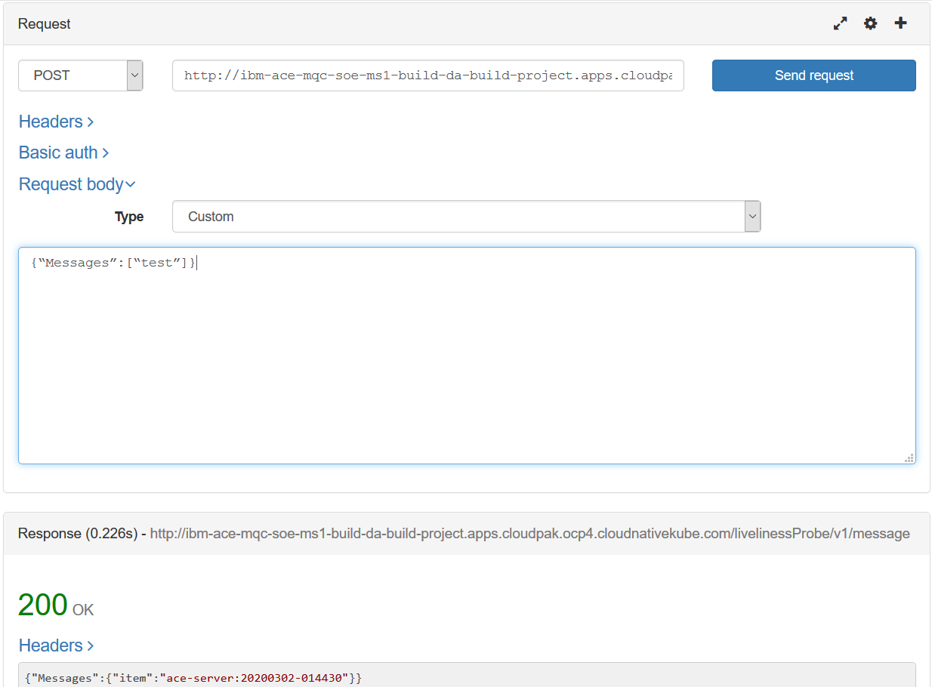

### Create a webhook to trigger builds

#### Obtain the web hook URL from the build config

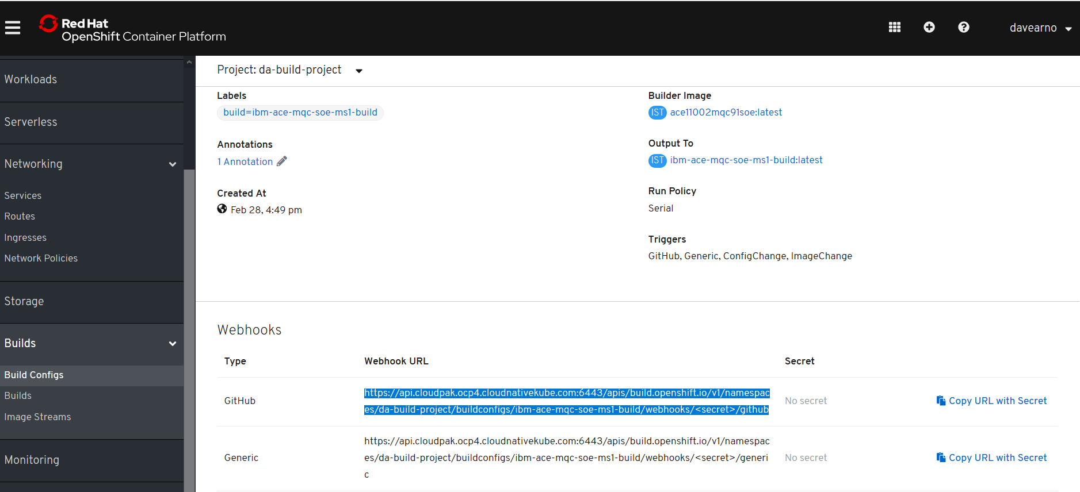

https://api.cloudpak.ocp4.cloudnativekube.com:6443/apis/build.openshift.io/v1/namespaces/da-build-project/buildconfigs/ibm-ace-mqc-soe-ms1-build/webhooks/<secret>/github

<https://api.cloudpak.ocp4.cloudnativekube.com:6443/apis/build.openshift.io/v1/namespaces/da-build-project/buildconfigs/ibm-ace-mqc-soe-ms1-build/webhooks/nuDTe2L6Wv_XpQB4Jd1v/github>

### Create webhook in github

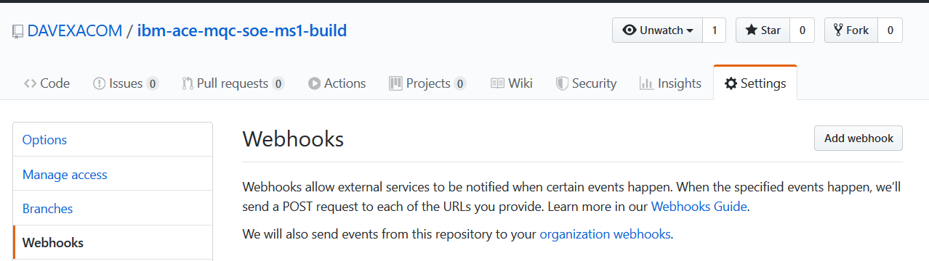

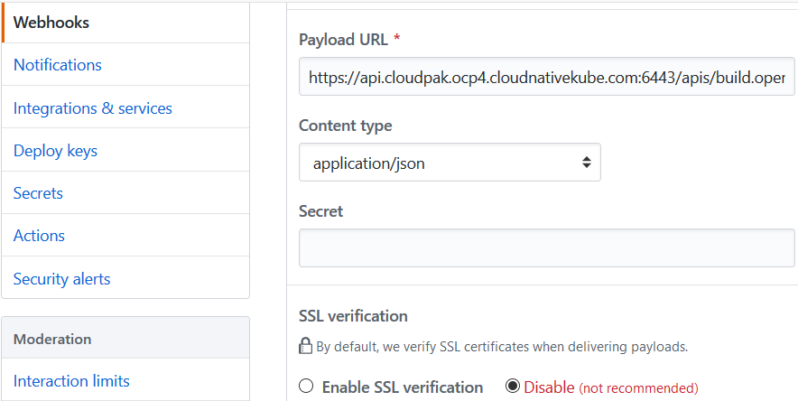

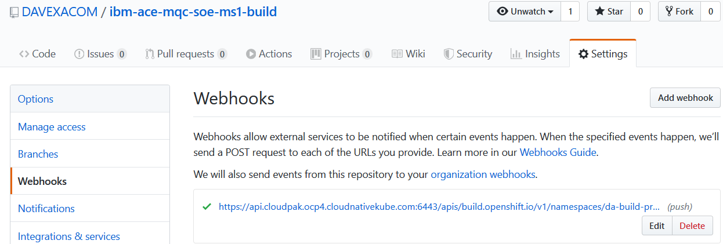

### Push a README.MD update to Test trigger fires

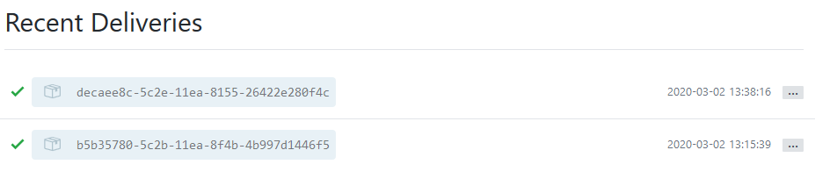

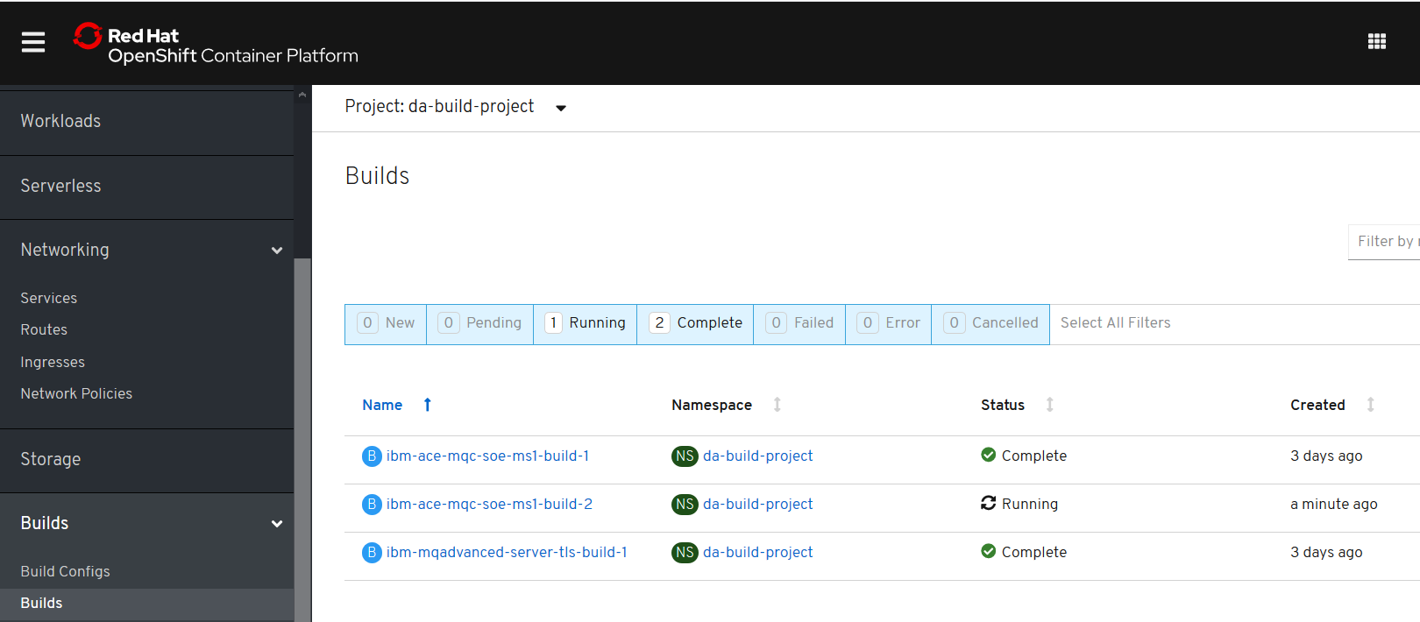

## Build and run ACE Microservice 2 from ACE SoE on RHOS

### Creds for ICP4i

RHOCP console:

<https://console-openshift-console.apps.cloudpak.ocp4.cloudnativekube.com/dashboard>

davearno

passw0rd1234

Kubeadmin

UqJrM-aKo2y-VYnYi-QiuBV

### Github/dockerhub

<https://github.com/DAVEXACOM/ibm-ace-mqc-soe-ms2-build>

<https://hub.docker.com/repository/docker/davexacom/ace11002mqc91soe>

Build from <https://hub.docker.com/repository/docker/davexacom/ace11002mqc91soe>

Using a version of <https://github.com/DAVEXACOM/ACEonICPIntMicSrv2Img>

Which is at <https://github.com/DAVEXACOM/ibm-ace-mqc-soe-ms2-build>

### Code for ACE Microservice2

[https://github.com/DAVEXACOM/ACEonICPIntMicSrv2](https://github.com/DAVEXACOM/ACEonICPIntMicSrv21)

### Code for ACE Liveliness probe

<https://github.com/DAVEXACOM/ACEonICPIntMicSoE>

## Deploying to RHOS

#### oc login --token=WM4a6Lj9Vj67U626gJ8Z897Cijr-OnjG-KcVxPhPk1Q --server=https://api.cloudpak.ocp4.cloudnativekube.com:6443

#### oc project da-build-project

@DA2@ I don’t think you need the oc create of the image stream for the input. The oc new-build seem to take care of that via the FROM

~~oc create -f c:\openshift\data\build-ace-custom.yaml~~

#### oc new-build <https://github.com/DAVEXACOM/ibm-ace-mqc-soe-ms2-build.git>

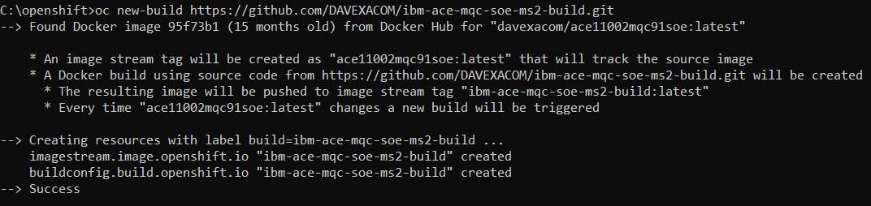

### Review image streams

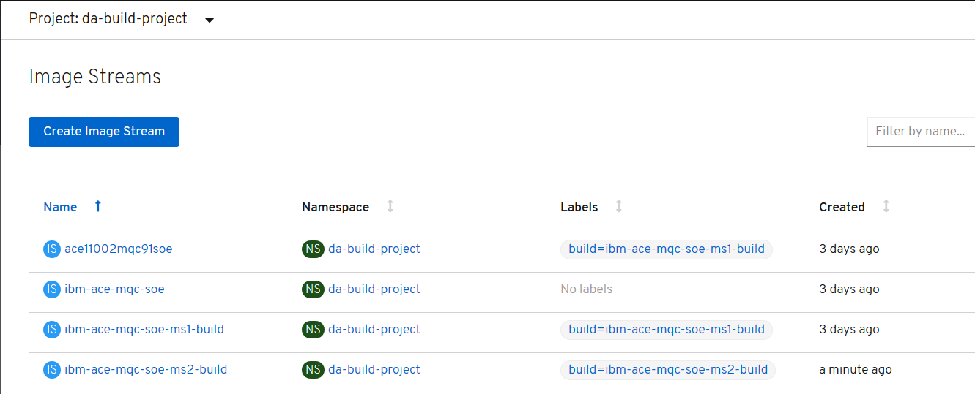

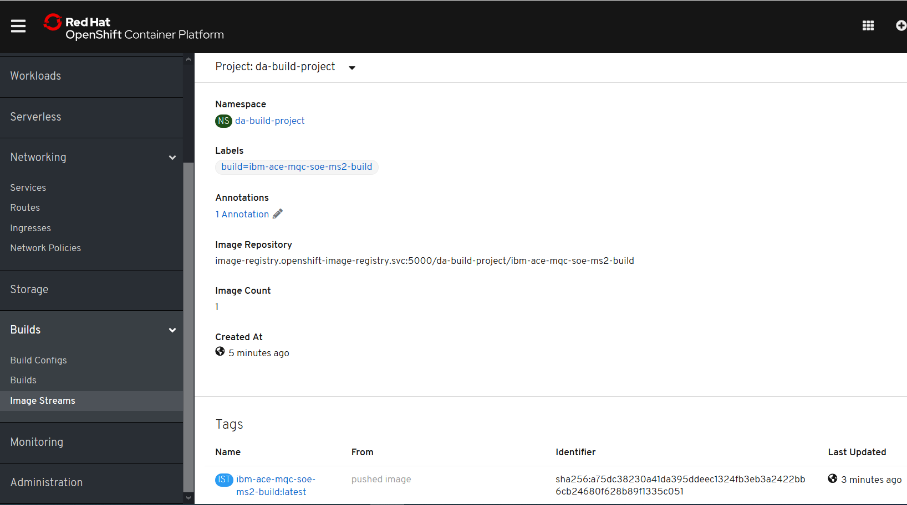

### Review builds

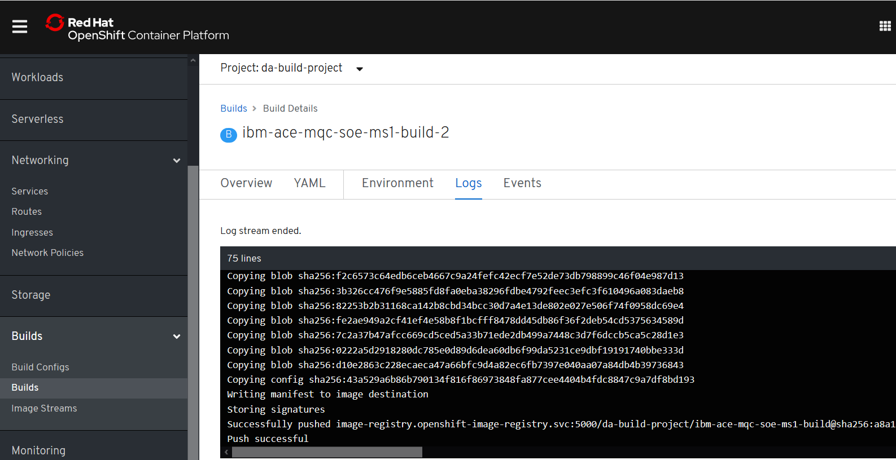

#### oc new-app ibm-ace-mqc-soe-ms2-build --env LICENSE=accept

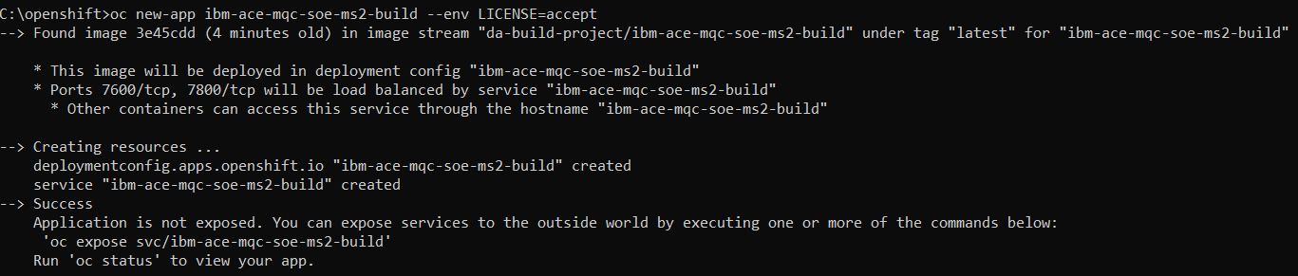

### Review service

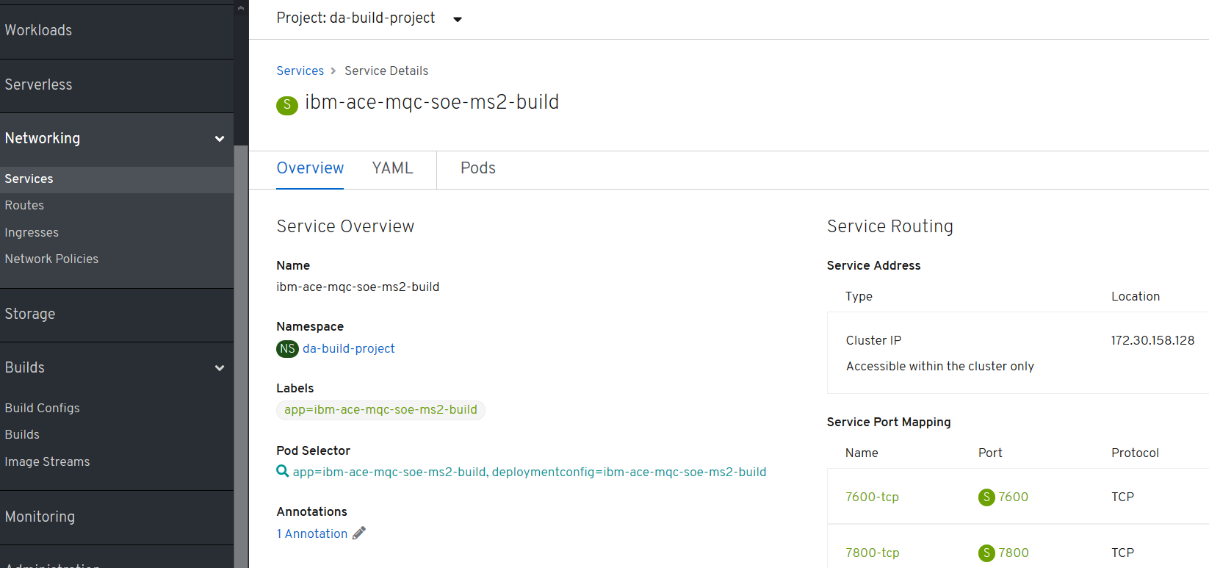

### Review deployment config

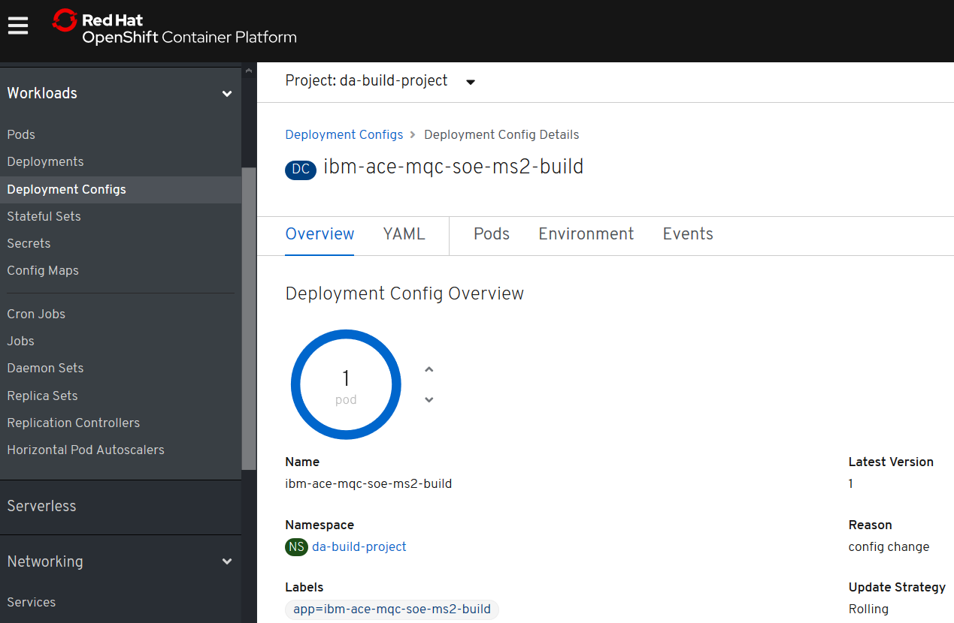

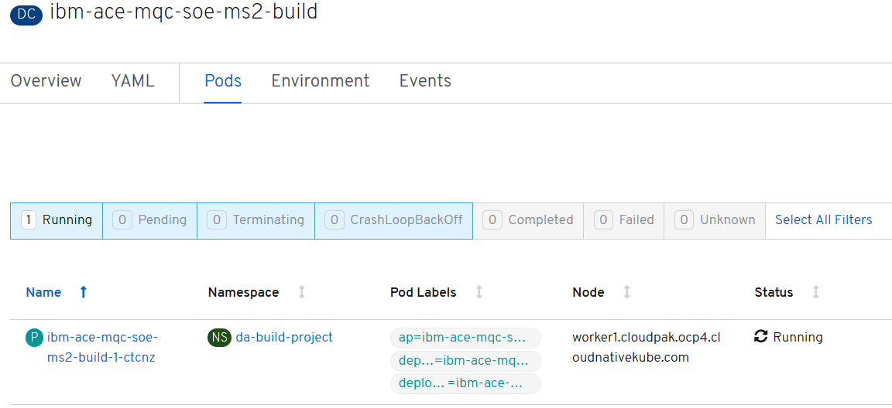

#### oc create -f c:\openshift\data\create-acems2-route.yaml



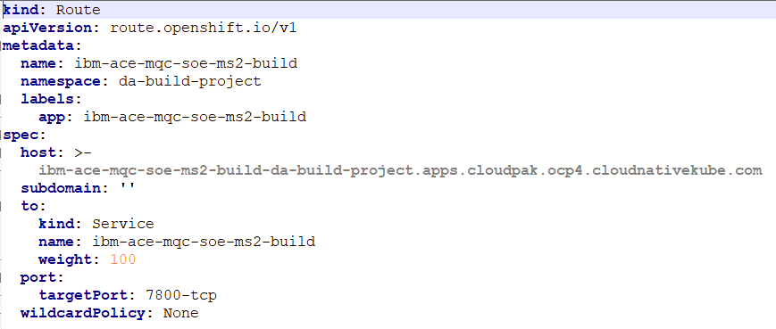

kind: Route

apiVersion: route.openshift.io/v1

metadata:

name: ibm-ace-mqc-soe-ms2-build

namespace: da-build-project

labels:

app: ibm-ace-mqc-soe-ms2-build

spec:

host: >-

ibm-ace-mqc-soe-ms2-build-da-build-project.apps.cloudpak.ocp4.cloudnativekube.com

subdomain: ''

to:

kind: Service

name: ibm-ace-mqc-soe-ms2-build

weight: 100

port:

targetPort: 7800-tcp

wildcardPolicy: None

#### oc get routes



## Test the services

### Test the liveliness probe in the MS2 container

<http://ibm-ace-mqc-soe-ms2-build-da-build-project.apps.cloudpak.ocp4.cloudnativekube.com/livelinessProbe/v1/message>

{“Messages”:[“test”]}

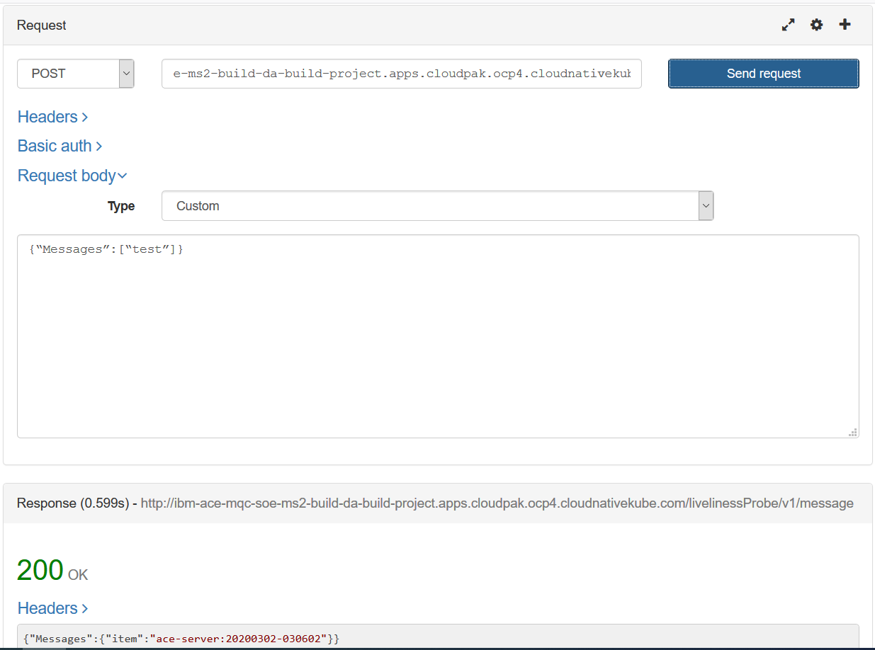

### Test microservice 2 in the MS2 container

### <http://ibm-ace-mqc-soe-ms2-build-da-build-project.apps.cloudpak.ocp4.cloudnativekube.com/microservice2/v1/message>

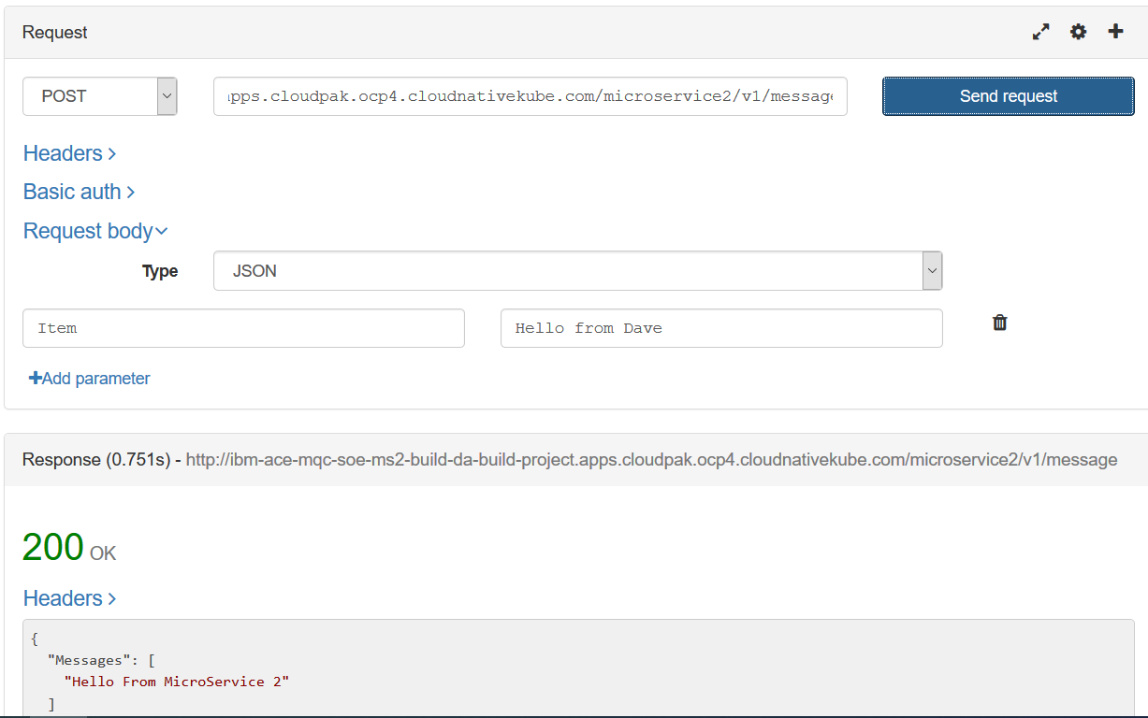

### Create the webhook trigger in Github

### Get Webhook details from the build config

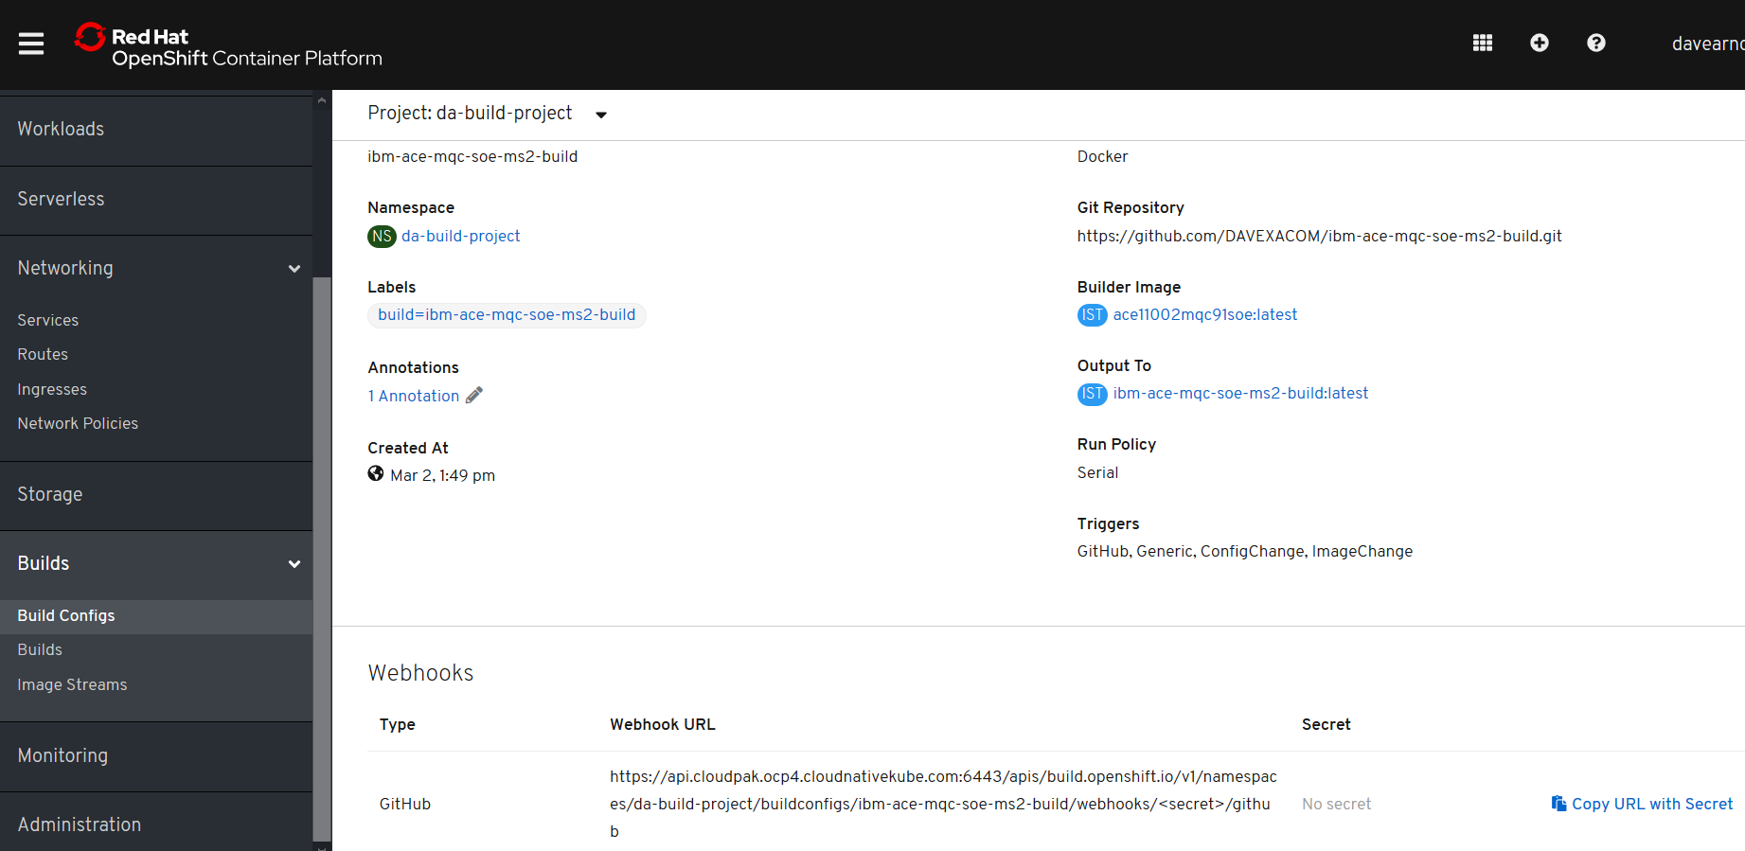

[https://api.cloudpak.ocp4.cloudnativekube.com:6443/apis/build.openshift.io/v1/namespaces/da-build-project/buildconfigs/ibm-ace-mqc-soe-ms2-build/webhooks/<secret>/github](https://api.cloudpak.ocp4.cloudnativekube.com:6443/apis/build.openshift.io/v1/namespaces/da-build-project/buildconfigs/ibm-ace-mqc-soe-ms2-build/webhooks/%3csecret%3e/github)

<https://api.cloudpak.ocp4.cloudnativekube.com:6443/apis/build.openshift.io/v1/namespaces/da-build-project/buildconfigs/ibm-ace-mqc-soe-ms2-build/webhooks/PJyT27d09q73G2hl71JB/github>

### Create webhook in github

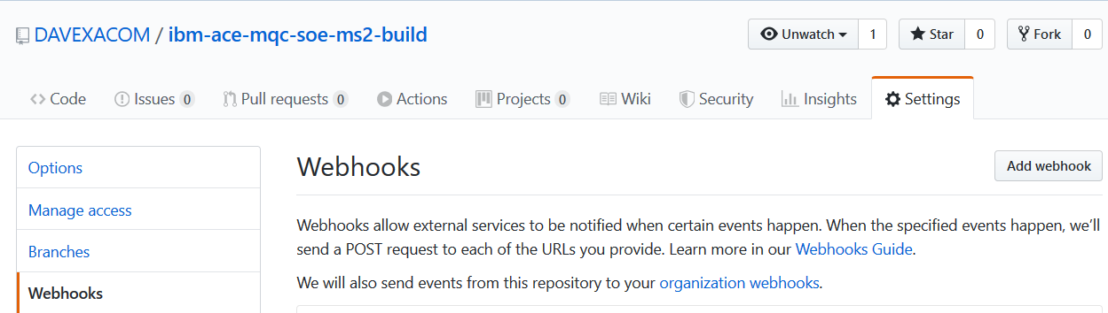

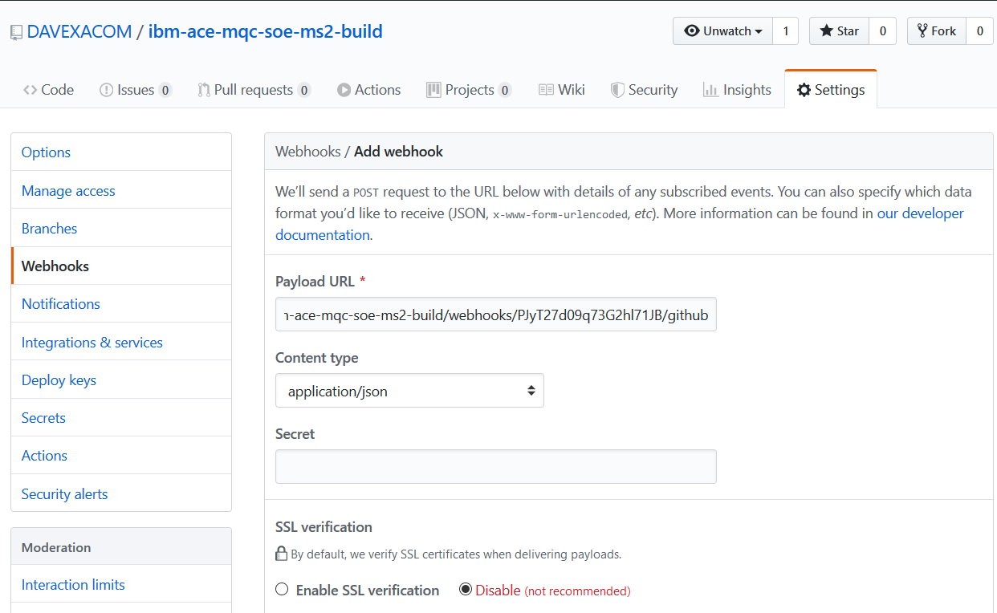



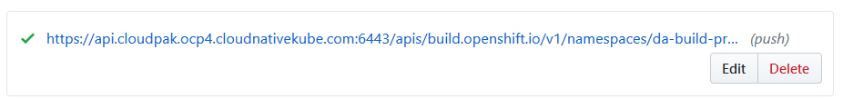

### Update Microservice2 and trigger a new build

#### Change ACE MS2 service in ACE Toolkit

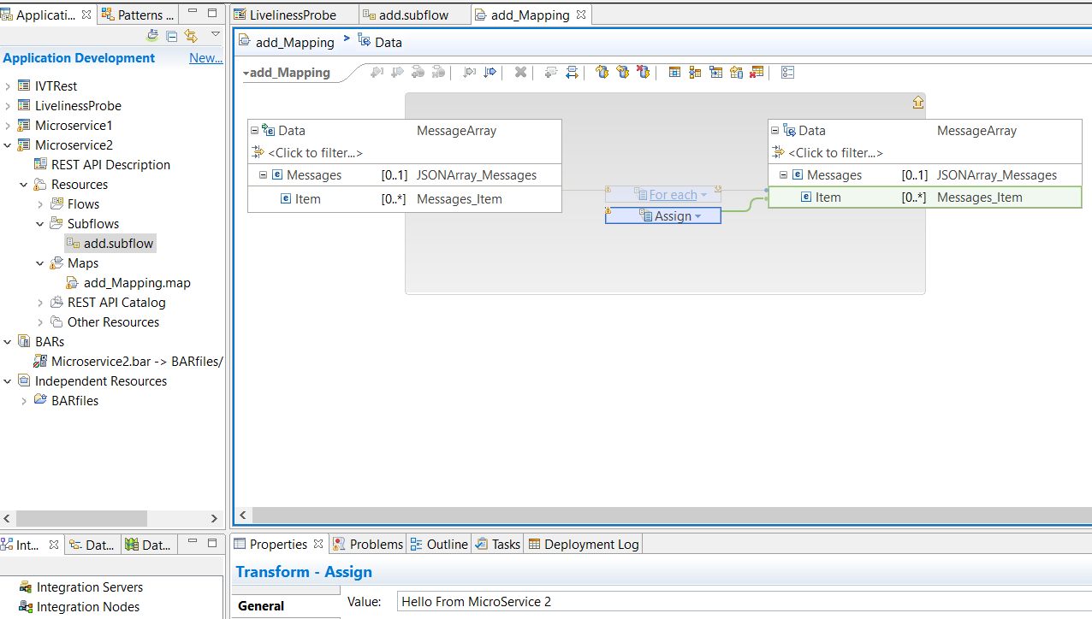

Change the test in the value property for the assign

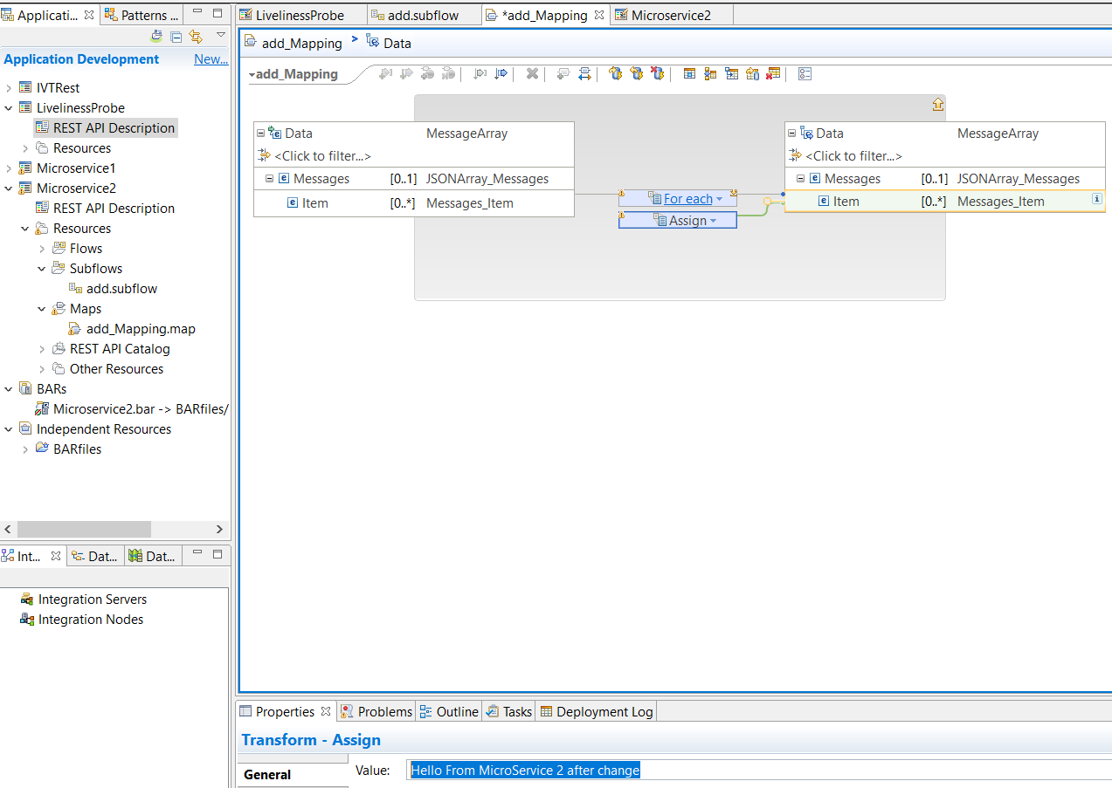

#### Save and update BAR

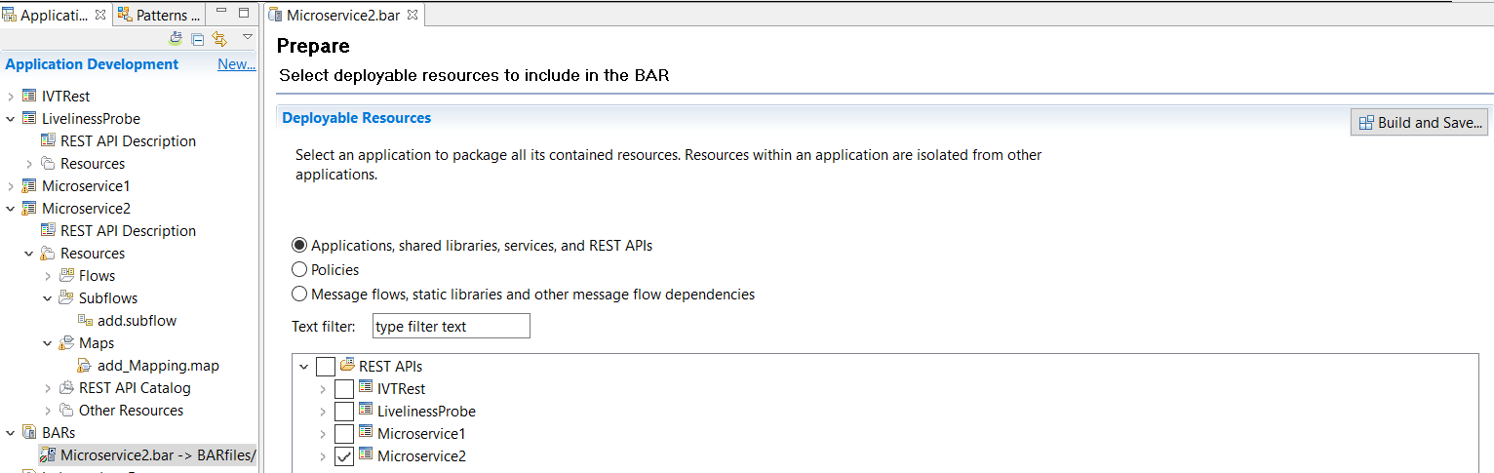

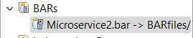note its updated

#### Export the BAR to the local Git repos

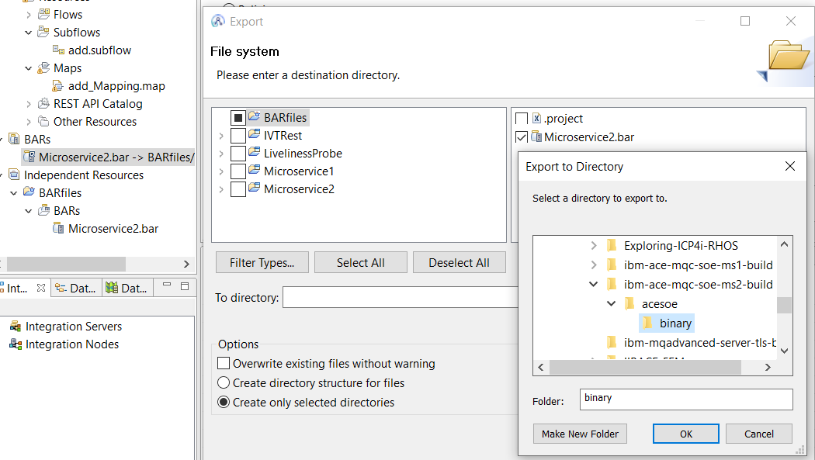

### Git client rescan – pick up the change

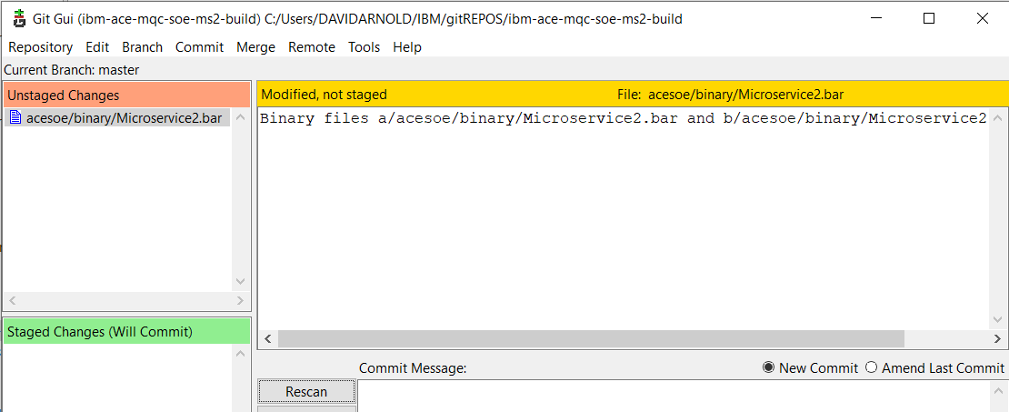

### Push to github

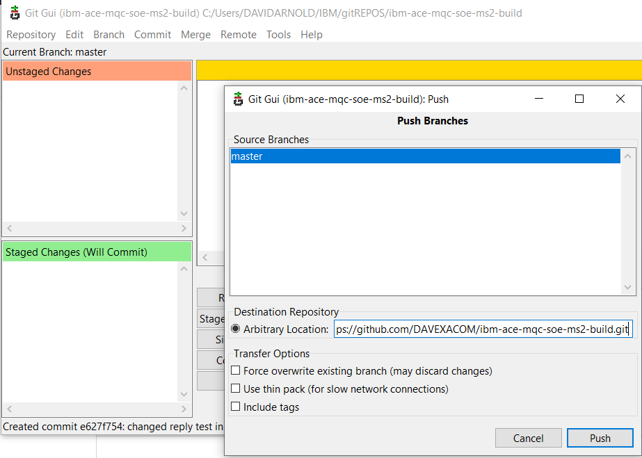

### Observe webhook fire in github

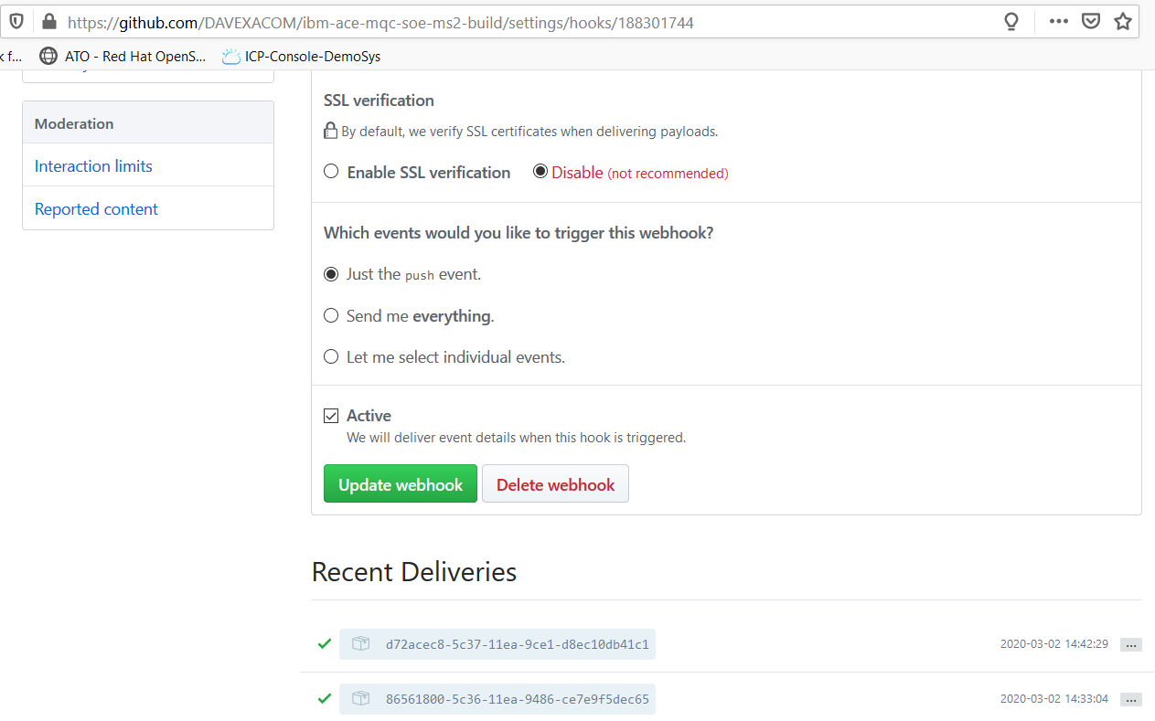

### Observe new build in RHOS

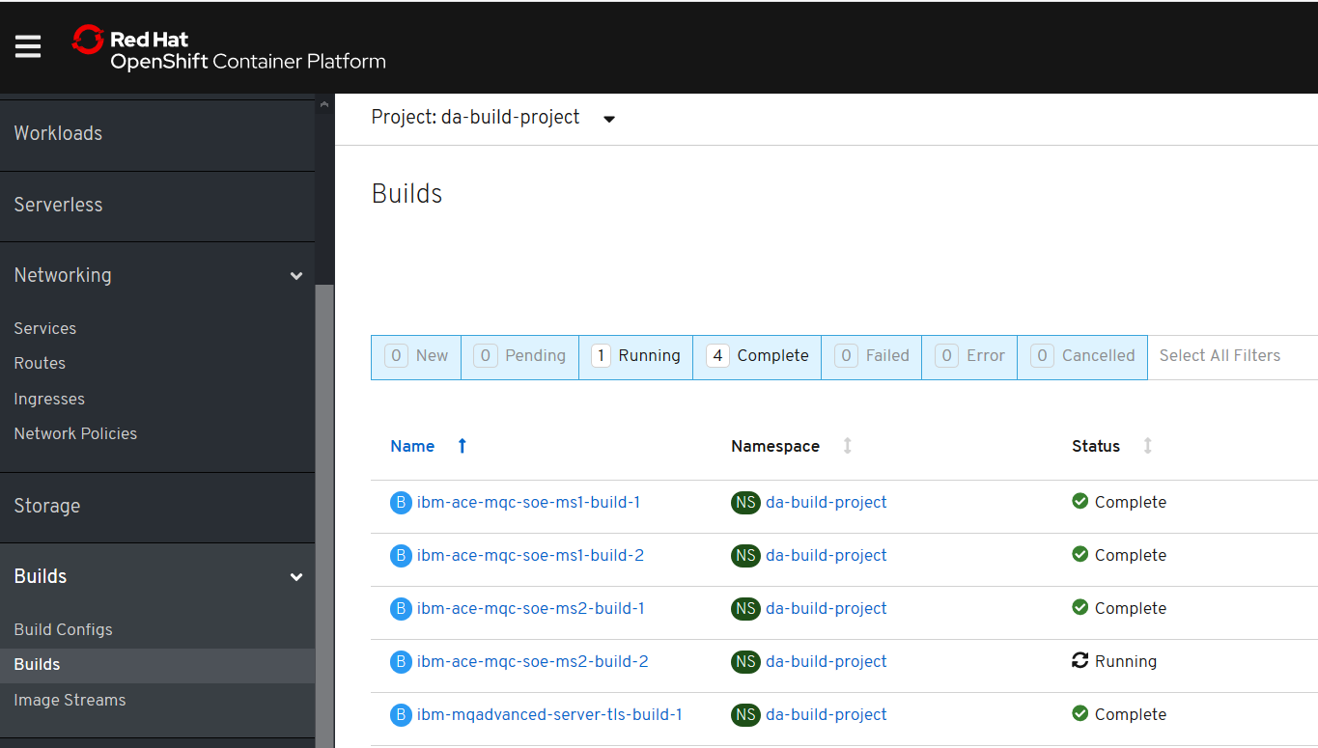

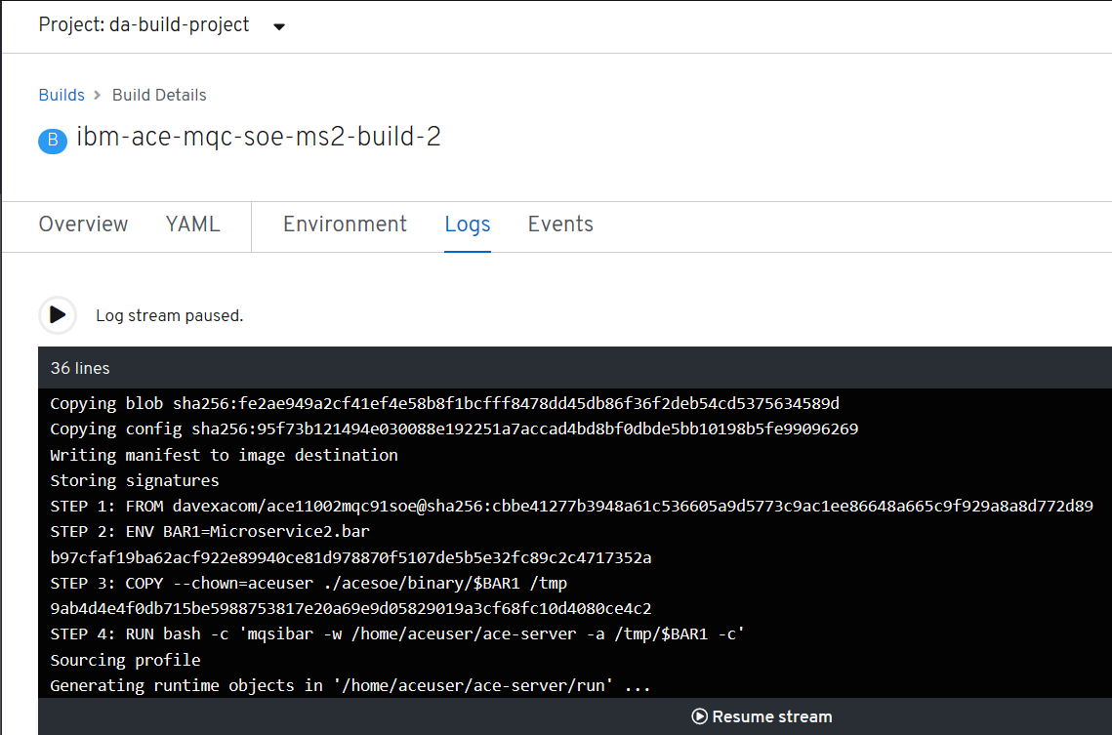



### Retest the ACE MS2 service

#### Navigate to the running pod for ace MS2

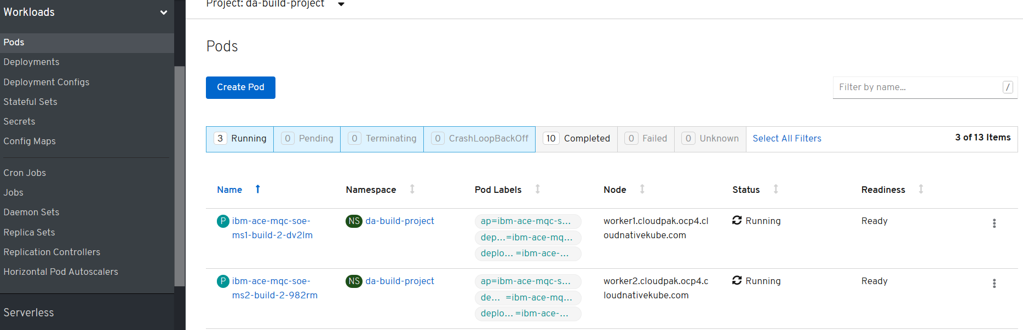

### New Version of Container via Deployment Configuration – Rolling trigger on image change

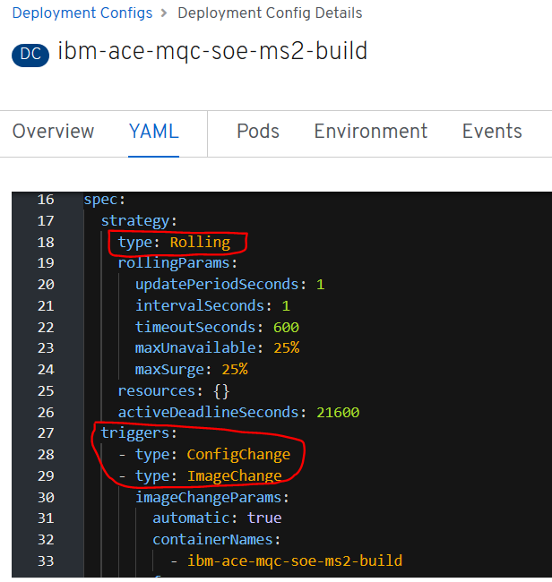

#### New version of the container via manual pod restart

Delete the pod for [ibm-ace-mqc-soe-ms2-build-2-m7b68](https://console-openshift-console.apps.cloudpak.ocp4.cloudnativekube.com/k8s/ns/da-build-project/pods/ibm-ace-mqc-soe-ms2-build-2-m7b68)

Can be done through the UI or oc get pods, oc delete pod

### Test the rest service

<http://ibm-ace-mqc-soe-ms2-build-da-build-project.apps.cloudpak.ocp4.cloudnativekube.com/microservice2/v1/message>

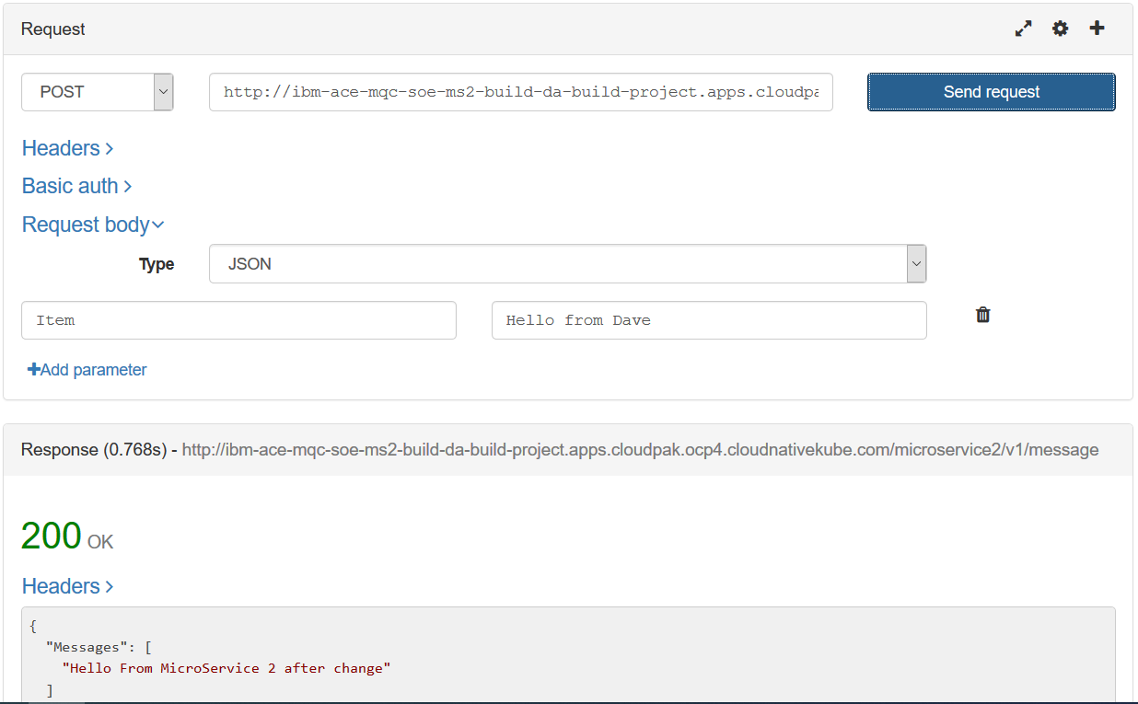

## Connecting ACE MS1 to ACE MS2 in the cluster

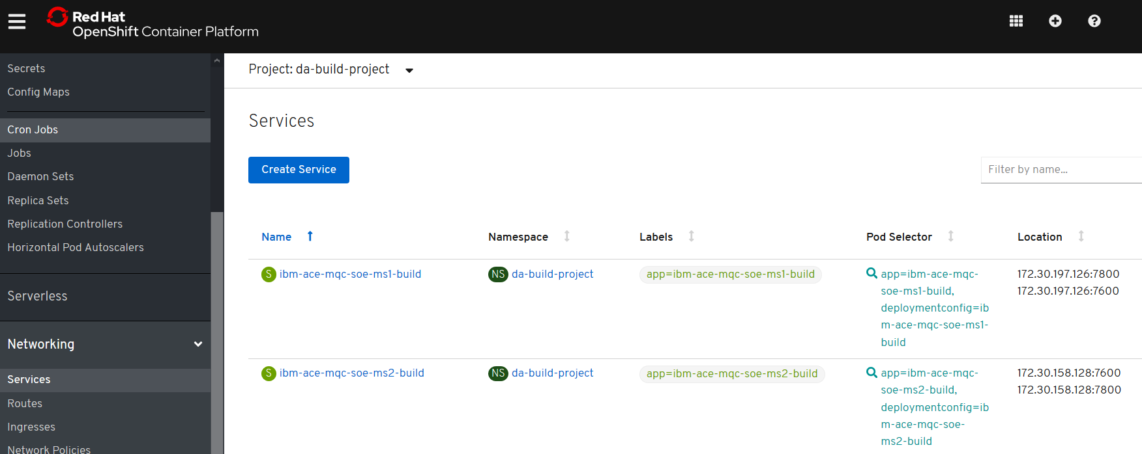

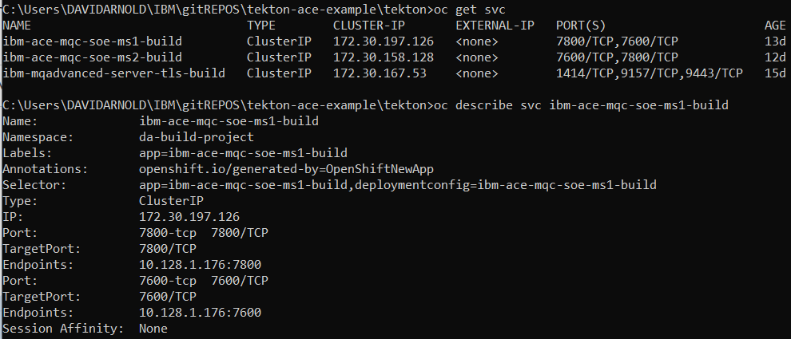

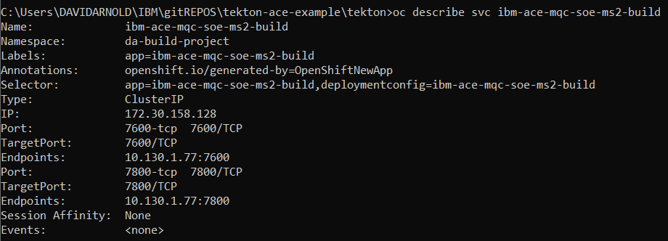

### Cluster IPs for ACE microservices

Cluster IP for ibm-ace-mqc-soe-ms1-build = 172.30.197.126:7800

Cluster IP for ibm-ace-mqc-soe-ms2-build = 172.30.158.128:7800

### K8s DNS names for ACE microservices

Intra cluster use the service name.

DNS = ibm-ace-mqc-soe-ms1-build

DNS = ibm-ace-mqc-soe-ms2-build

### Public IP for ACE microservice 1 – rest requesst

**POST to:**

<http://ibm-ace-mqc-soe-ms1-build-da-build-project.apps.cloudpak.ocp4.cloudnativekube.com/microservice1/v1/message>

**with data:**

{"Messages":["Hello From Test Client"]}

### Calling ms2 from ms1

<http://ibm-ace-mqc-soe-ms2-build:7800/microservice2/v1>

Source code change

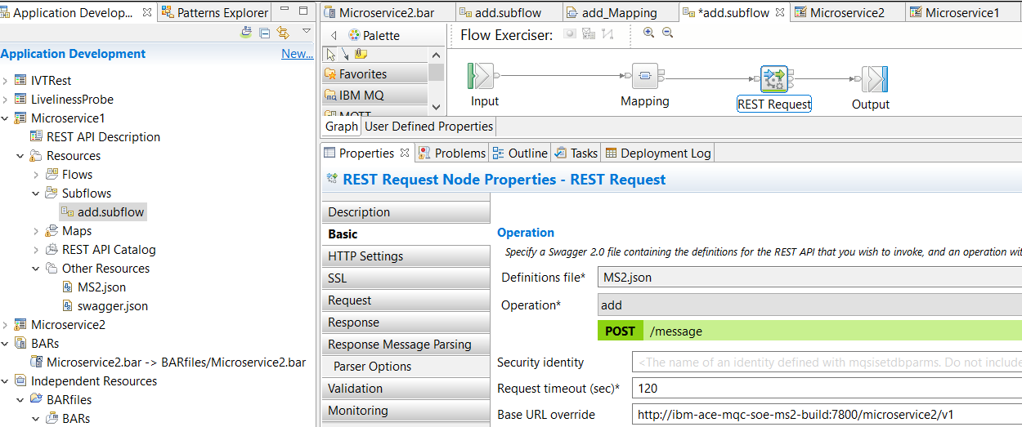

OR BAR deployment descriptor override

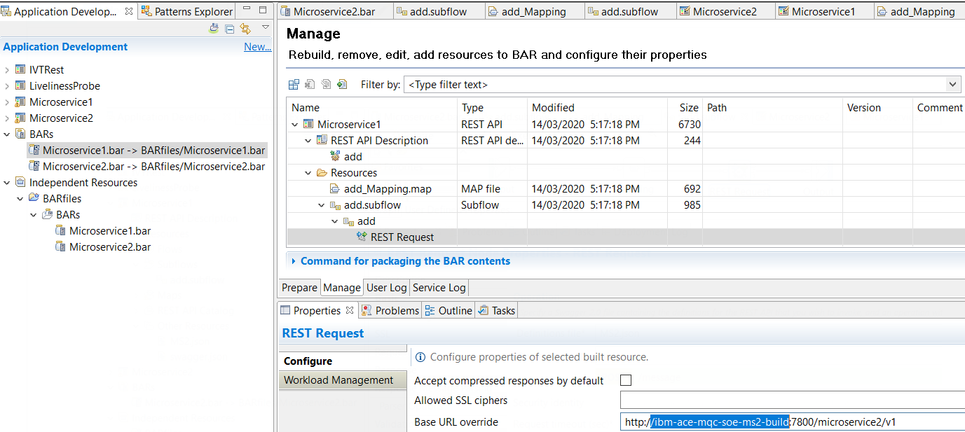

Export to local GitRepo

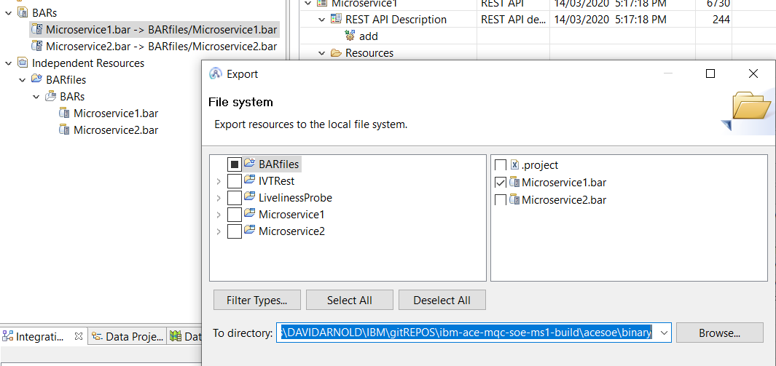

Git push

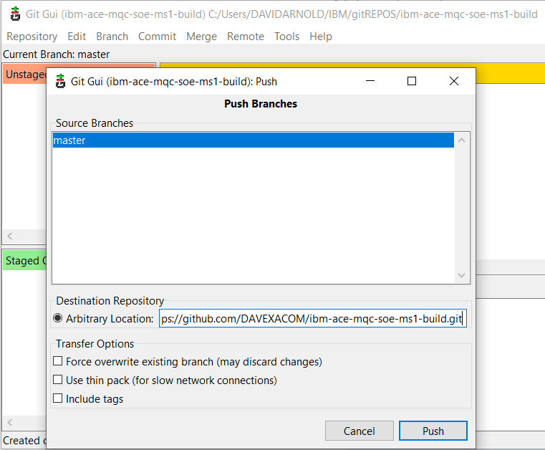

Check the build

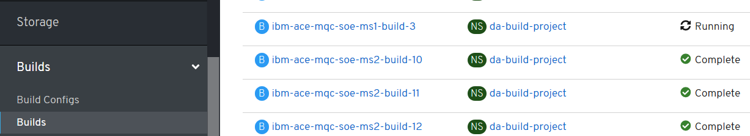

### Test ACE MS2 calling ACE MS2

POST

### <http://ibm-ace-mqc-soe-ms1-build-da-build-project.apps.cloudpak.ocp4.cloudnativekube.com/microservice1/v1/message>

Data

### {"Messages":["Hello From Test Client"]}

Using REST Client

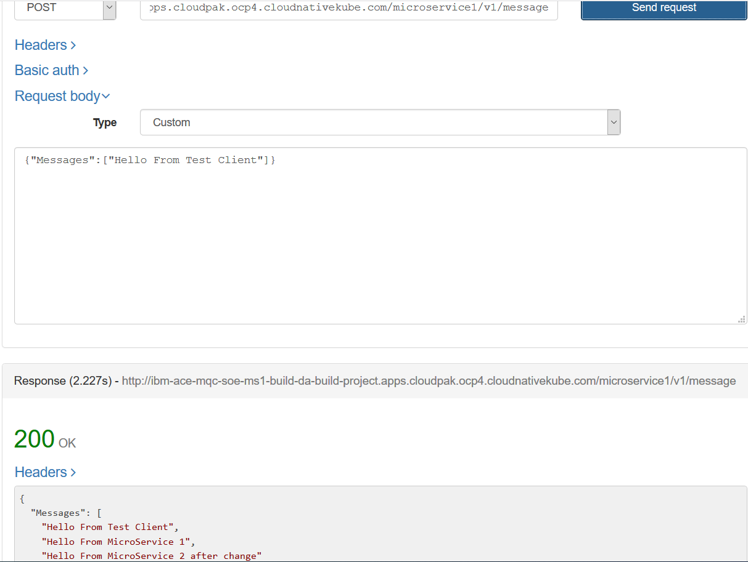

# OpenShift Pipelines - Tekton

## Catalog

Add the pipelines operator – it installs and manages the upgrade etc of pipelines

## Pipeline operator

Installs pipelines

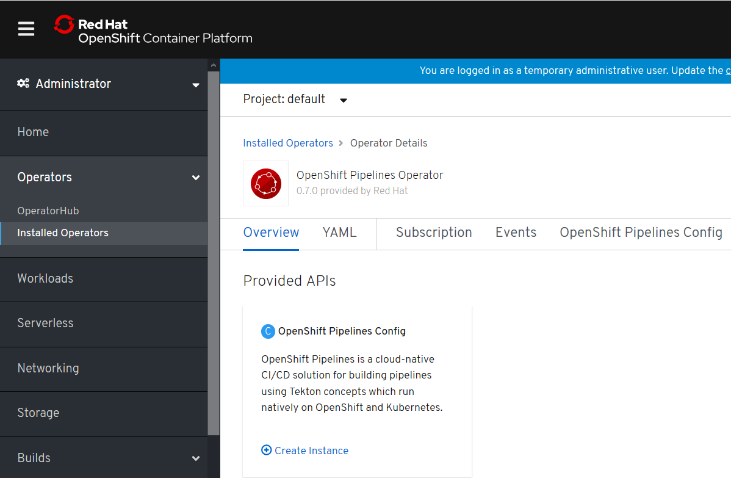

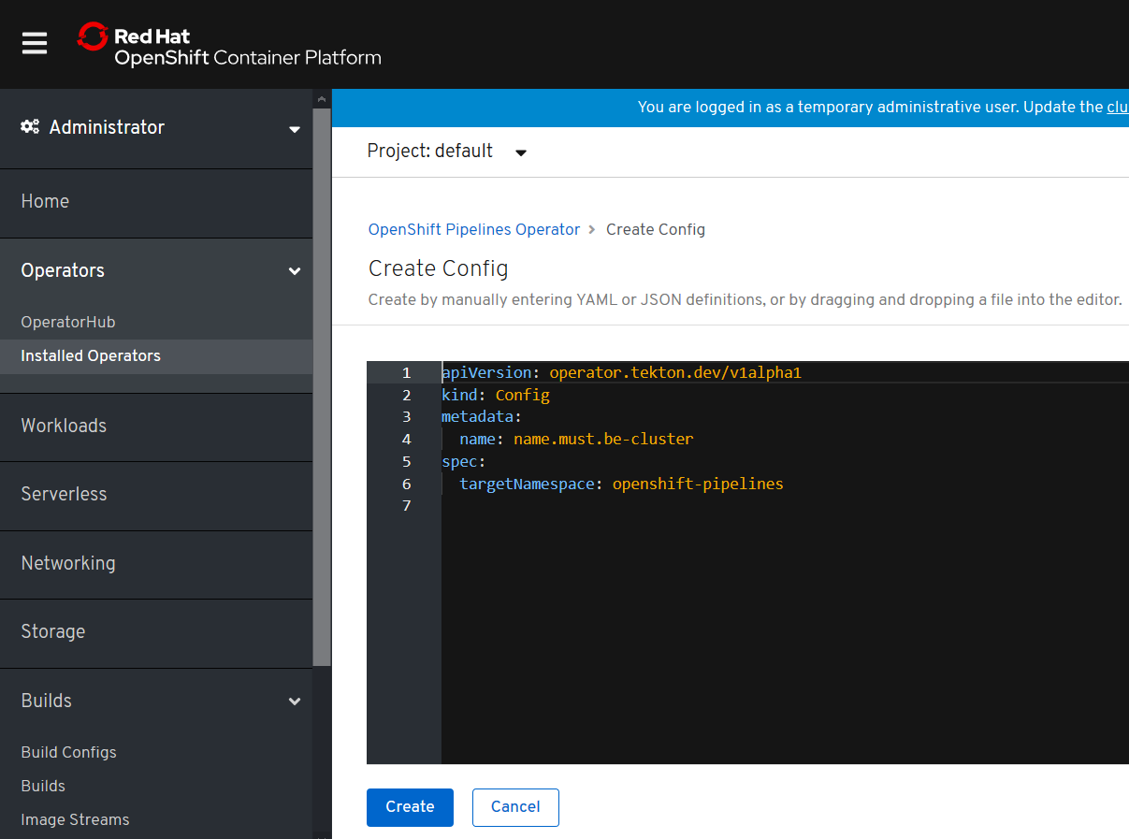

# Tekton ACE Example

## Example Environment

RHOS 4.2 on IBM Cloud – ICP4i is installed.

Namespace: da-build-project

## GIT Repos for Tekton ACE Artifacts

<https://github.com/DAVEXACOM/tekton-ace-example>

## GIT Repos for ACE microservice to be tested

<https://github.com/DAVEXACOM/ibm-ace-mqc-soe-ms2-build>

## Tekton YAML files to be used

### Resources

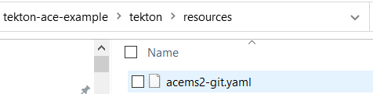

### Tasks

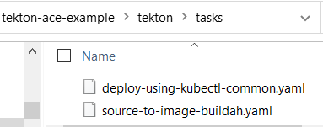

### Pipeline

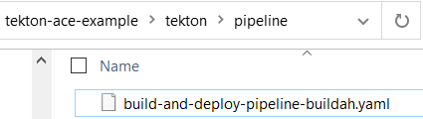

### PipelineRun

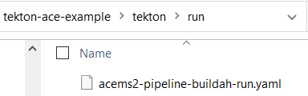

### Deployment Config YAML

This file is edited by the tekton deploy task so also exists (has a copy in) in the ace ms 2 respository

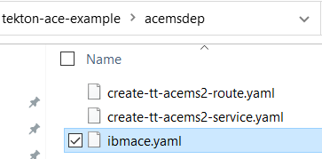

## Commands to create/replace(update)/delete artifacts in Tekton on RHOS

Use OC CREATE commands to load the tekton artifacts into your RHOS environment

resources.yaml

source-to-image-buildah.yaml

deploy-using-kubectl-common.yaml

build-and-deploy-pipeline-buildah.yaml

acems2-pipeline-buildah-run.yaml

oc create -f c:\users\DAVIDARNOLD\IBM\gitREPOS\tekton-ace-example\tekton\run\acems2-pipeline-buildah-run.yaml - this is the last command - it creates the "run" which starts the pipeline

USE OC REPLACE if you change and files

oc replace -f c:\users\DAVIDARNOLD\IBM\gitREPOS\tekton-ace-example\tekton\tasks\source-to-image-buildah.yaml

USE OC DELETE -f c:\temp\tempyaml.yaml to remove any artifacts from RHOS - use a yaml snippet in a file to identify kind: , name: and namespace: see example tempyaml.yaml below

apiVersion: tekton.dev/v1alpha1

kind: Task

metadata:

creationTimestamp: '2020-03-03T00:27:03Z'

generation: 3

name: source-to-image

namespace: da-build-project

## Creating the Service and Routes

### tt ace ms2 service

created manually at this point and not automated in the pipeline (but it could be in the same manner as the ibmace.yaml deployment config in the pipeline)

**oc create -f C:\openshift\data\create-tt-acems2-service.yaml**

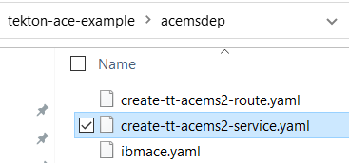

### Tt ace ms2 route

created manually at this point and not automated in the pipeline (but it could be in the same manner as the ibmace.yaml deployment config in the pipeline)

**oc create -f C:\openshift\data\create-tt-acems2-route.yaml**

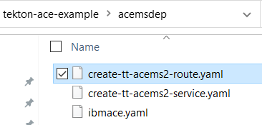

## Exploring the RHOS environment

### Tekton dashboard -resources

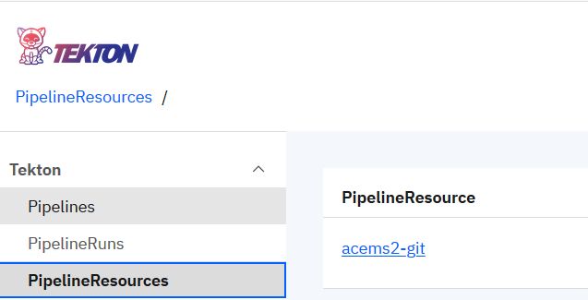

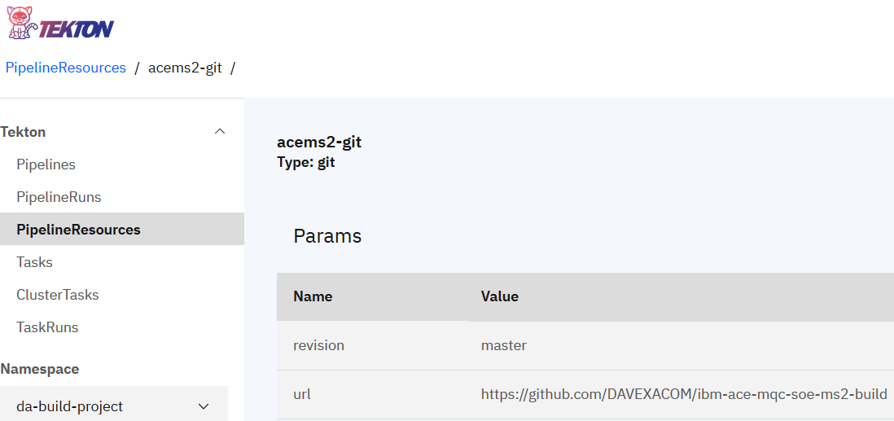

### Tekton dashboard -tasks

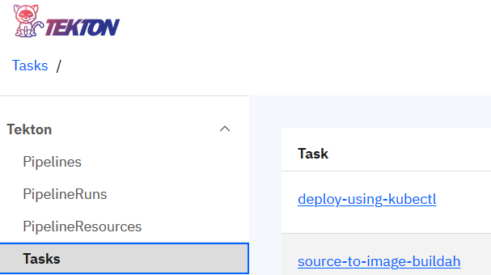

### Tekton dashboard -pipeline

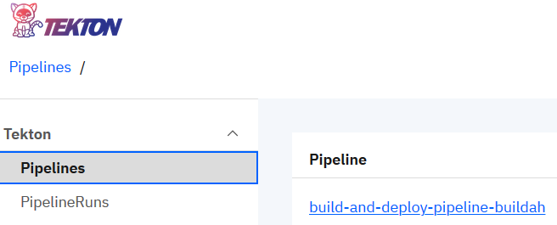

### Tekton dashboard -pipeline-run

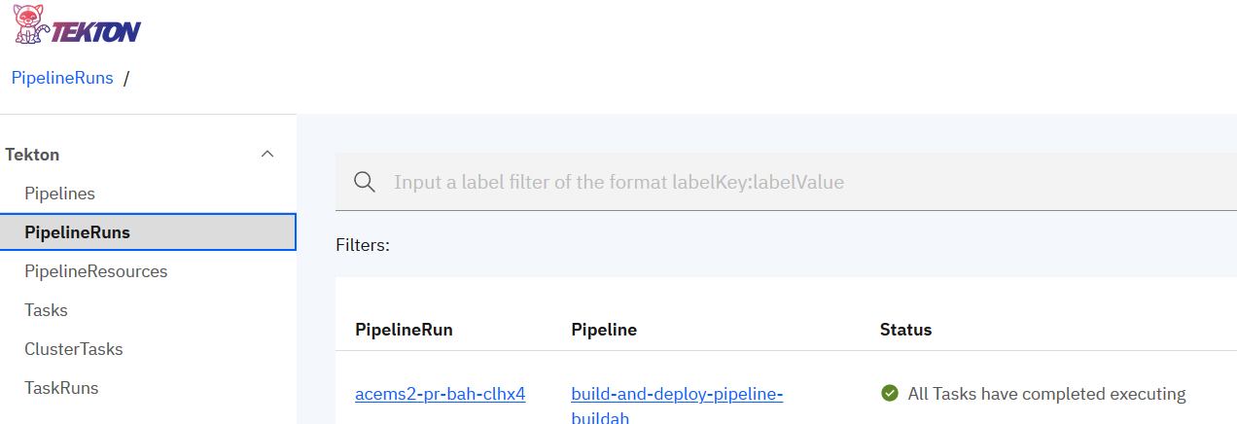

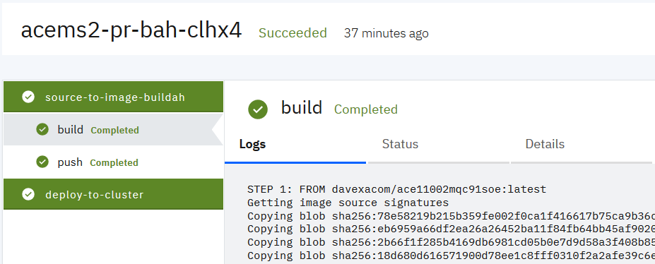

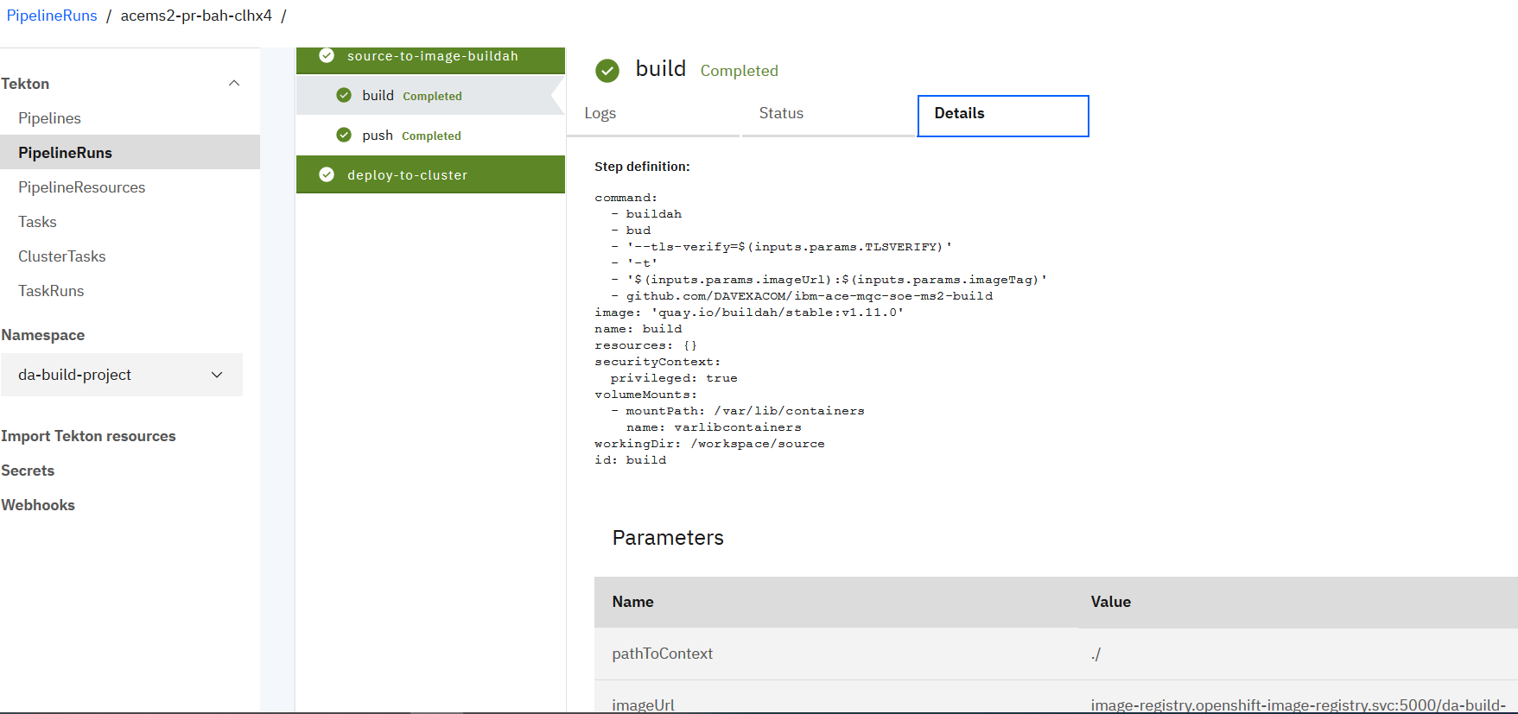

## RHOS Console

### Service

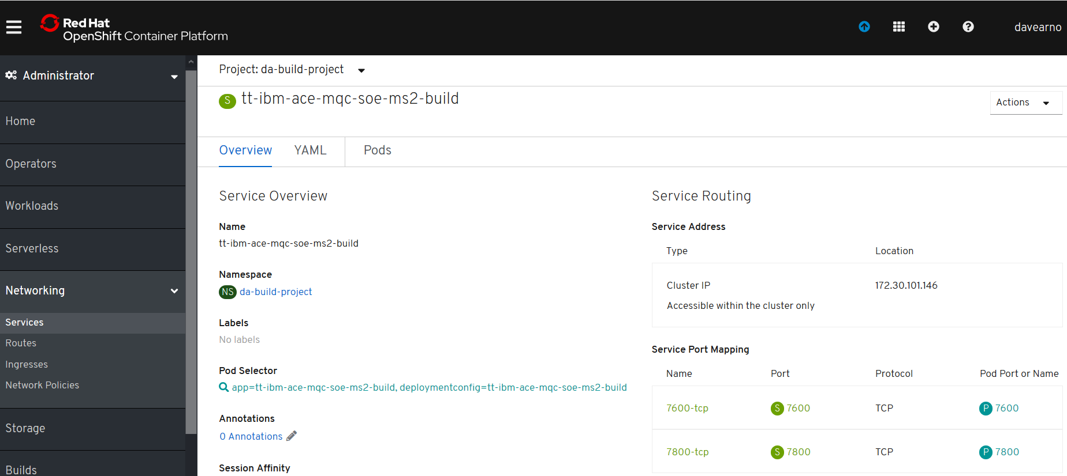

### Route

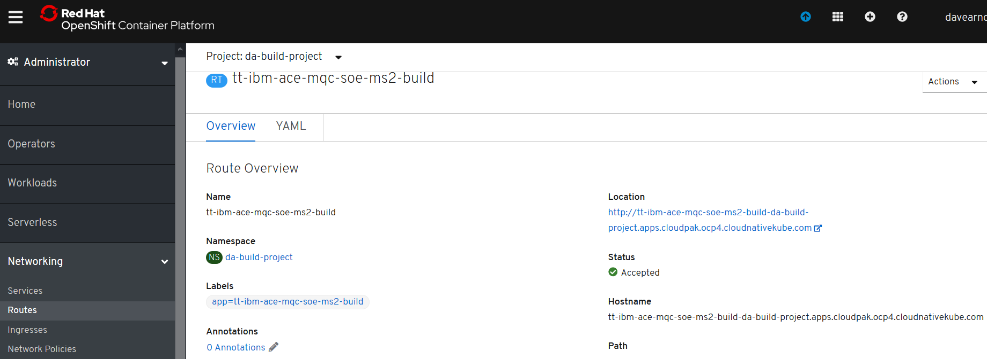

### Image Stream

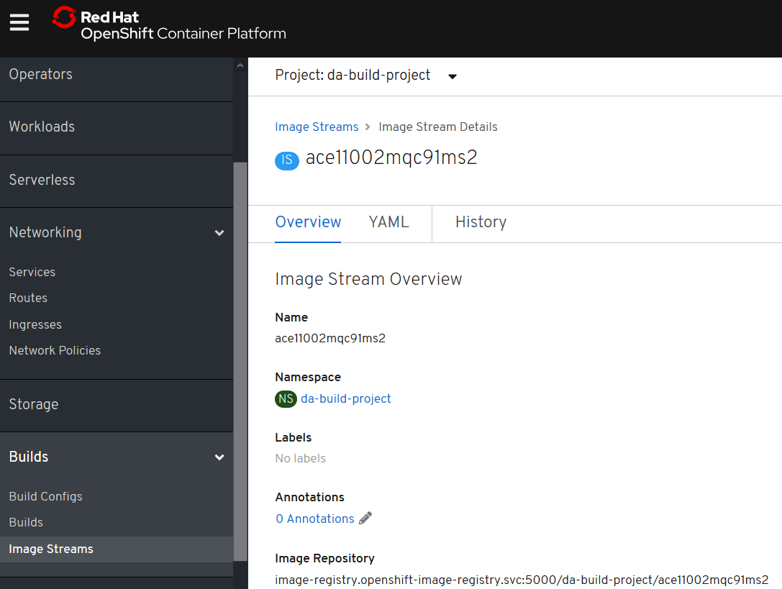

### Deployment - Config PipelineRun Created

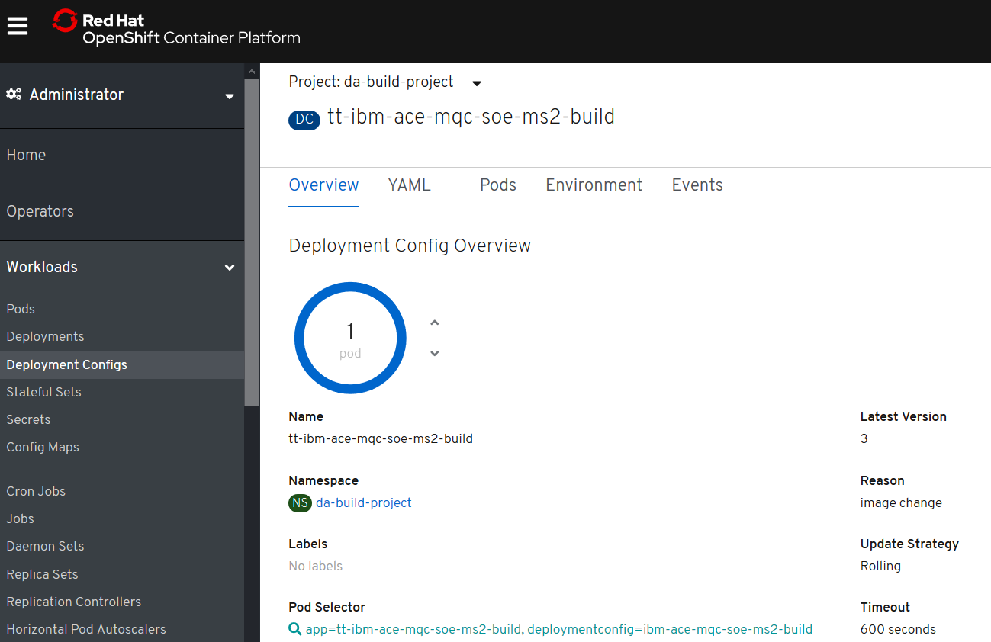

Note: Restarts the pod if the image is updated

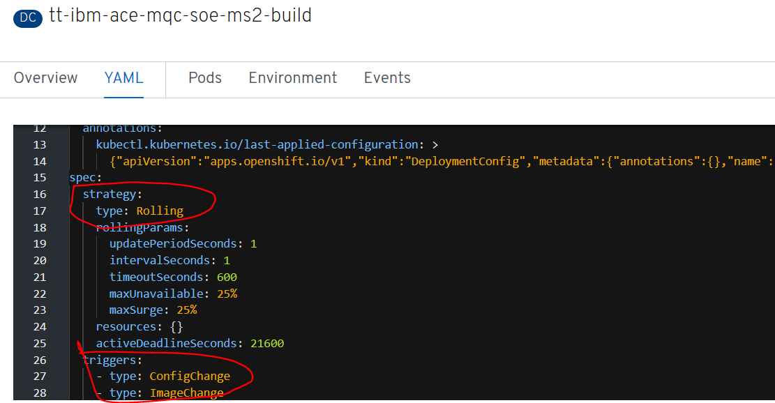

### Pod - PipelineRun Created

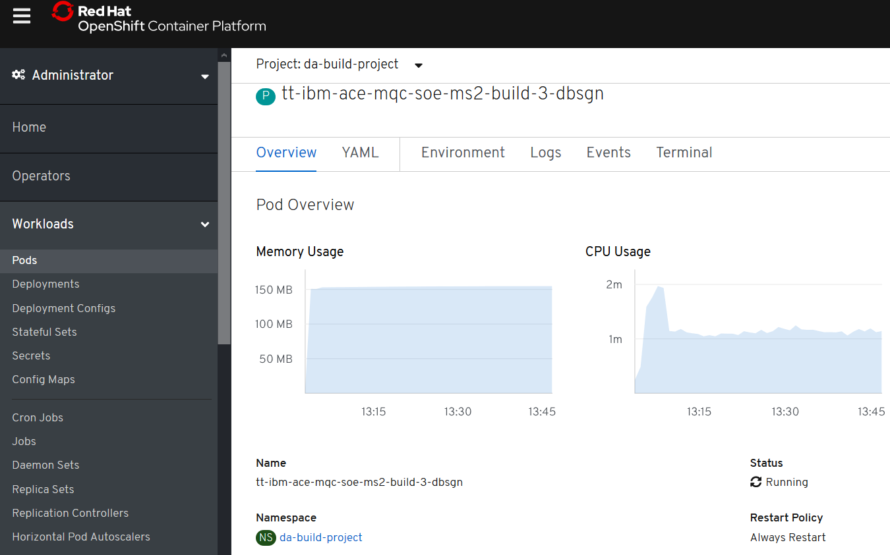

## Testing ACE Micro Service 2

POST

http://tt-ibm-ace-mqc-soe-ms2-build-da-build-project.apps.cloudpak.ocp4.cloudnativekube.com/microservice2/v1/message

with data

{"Messages":["Hello From Test Client"]}

should return

{"Messages":["Hello From Test Client","Hello From MicroService 2 after change tekton test"]}

